electronic Customs management system
System Admin
User Guide

Version: 1.1
Date: 12.9.2022

About CrimsonLogic
CrimsonLogic Pte Ltd delivers world-class eGovernment solutions by leveraging on best-practice technologies, quality human capital and global experiences. Our proven track record of end-to-end eGovernment solutions spans across trade facilitation and customs, judiciary, tax, healthcare, and IT security domains. With 20 years of experience in developing and managing nationwide, mission-critical IT systems and services in a Public-Private Partnership model, CrimsonLogic has set industry standards with world-first eGovernment solutions such as TradeNet, eStamping, eJudiciary and CertOfOrigin. For more information, visit www.crimsonlogic.com

About Yang Khor Pvt Ltd

Yang Khor IT Solutions is a leading In-country Technology Solutions Provider providing solution in terms of hardware, software, support and services as its complete package.
Yang Khor IT Solutions has been serving its purpose since 2005, it now has emerged to be unprecedented leader as a Solution Integrator with a differentiated vertical approach providing innovative solutions. Yang Khor uses its solution integration capabilities to integrate best of breed products through its key technology alliance partners to provide “End to End” solutions. Provide customized business solutions that help organizations accelerate revenue growth, increase market penetration, optimize operating costs and improve employee productivity, by embedding communication in their business processes.

Yang Khor IT Solutions has achieved to be the Gold Partner of HPE, Service One Partner of HPE, Microsoft Silver Partner and VMWARE Professional Partner and having this Partnership we are able to serve the best of solution to our Clients. Yang Khor IT Solution initially focuses on providing the best solution in terms of hardware and software, to serve the purpose of making life better with the Advance Technology which the world is moving forward with.

DOCUMENT HISTORY
S.No | Date | Version. No | Description | Approved By
1 | 12/09/2022 | 1.0 | First Release

Table of Contents
- chapter 1 - About this Guide 7
Purpose and Audience 7
Document Conventions 7
- Chapter 2 - Getting Started 8
End-user experience of the self-service process 8
1. Logging In 8
2. Logging Out 9
Common Icons and Buttons 10
- Chapter 3-Party Management 11
TPN Master 11
Creating Party 13
Searching Party 16
Viewing Party Details 17
Updating Party Details 17
- Chapter 4-Role Management 18
Creating Roles 18
Searching Roles 20
Viewing Role Details 21
Updating Role Details 24
- Chapter 5-User Management 25
Creating CMS User 25
Searching CMS Users 28
Viewing CMS User Details 30
Updating CMS User Details 32
Creating RRCO User 33
Searching Front End Users 36
Viewing FRONT END User Details 38
Updating FRONT END User Details 41
- Chapter 7- Code Maintenance 43
Active Type 43
Agency Type 45
Agreement Code 46
Aircraft 49
Bank 51
Branch 53
Charge 54
Code maintenance 56
Code Master 58
Currency Code 60
Customs Office Code 63
Document Type Code 66
Freight Type Code 69
IMDG Code 72
Incoterm Code 75
Offense Code 78
Payment Mode Code 81
Port Code 84
Public Holiday Code 87
Regime Code 90
Shipment Type Code 93
Transit Route Code 96
Transport Mode Code 99
UOM Code 102
Vessel/Aircraft Code 105
Warehouse Code 110
Warehouse Type Code 113
Notification 117
Creating Notification Template Details 117
Search Notification Template Details 119
View Notification Details 121
Quick View Notification Details 121
Edit Notification Details 122
Search Transaction Details 123
View Transaction Details 125
Quick View Transaction Details 125
Edit Transaction Details 126
Creating Email Setting Form 127
Search Email Setting Form Details 129
View Email Setting Details 130
Quick View Email Setting Details 131
Edit Email Setting Details 132
System Parameters and Rules File Deployment 134
System Parameters 134
Rules File Deployment 141
BPM 142
Process Definitions 142
Process Instances 147

chapter 1 - About this Guide

Welcome to the Electronic Customs Management System (eCMS) user guide for System Administrators! This user guide aims to enumerate the process and steps involved in using eCMS.
This user guide is divided into different topics and sub-topics. Each topic discusses and shows the steps of the modules that the System Administrators can do in eCMS.

Purpose and Audience
This user guide will help the user to get a quick reference on usage of the system.

Document Conventions
Refer to this section to familiarise yourself with the visual aids used throughout the user guide.
Navigation
To assist you with accessing screens, pages, or windows, refer to the following navigation format:
Click User Registration>>Users
Buttons, fields, and other system elements
All system elements are highlighted in Bold text.
Hyperlinks
All topics mentioned in the user guide’s content are hyperlinked. Click on the hyperlink to view the referenced topic.
Callouts
Callouts are presented differently from the original CONTENTS and highlight certain information.
There are two types of callouts: tips and warnings.

@ | A Tip provides useful information that helps you complete a task or procedure.

! | A Warning refers to information that may be critical to the system’s functionality and might affect data or system stability.

Chapter 2 - Getting Started
Refer to this chapter to familiarize yourself with the eCMS System; how to log in and log off from the system.

End-user experience of the self-service process
- Logging In
To log in to the eCMS:
- Type in URL ecms.gov.bt your Internet browser to access the eCMS System.
- CMS user landing page will display.

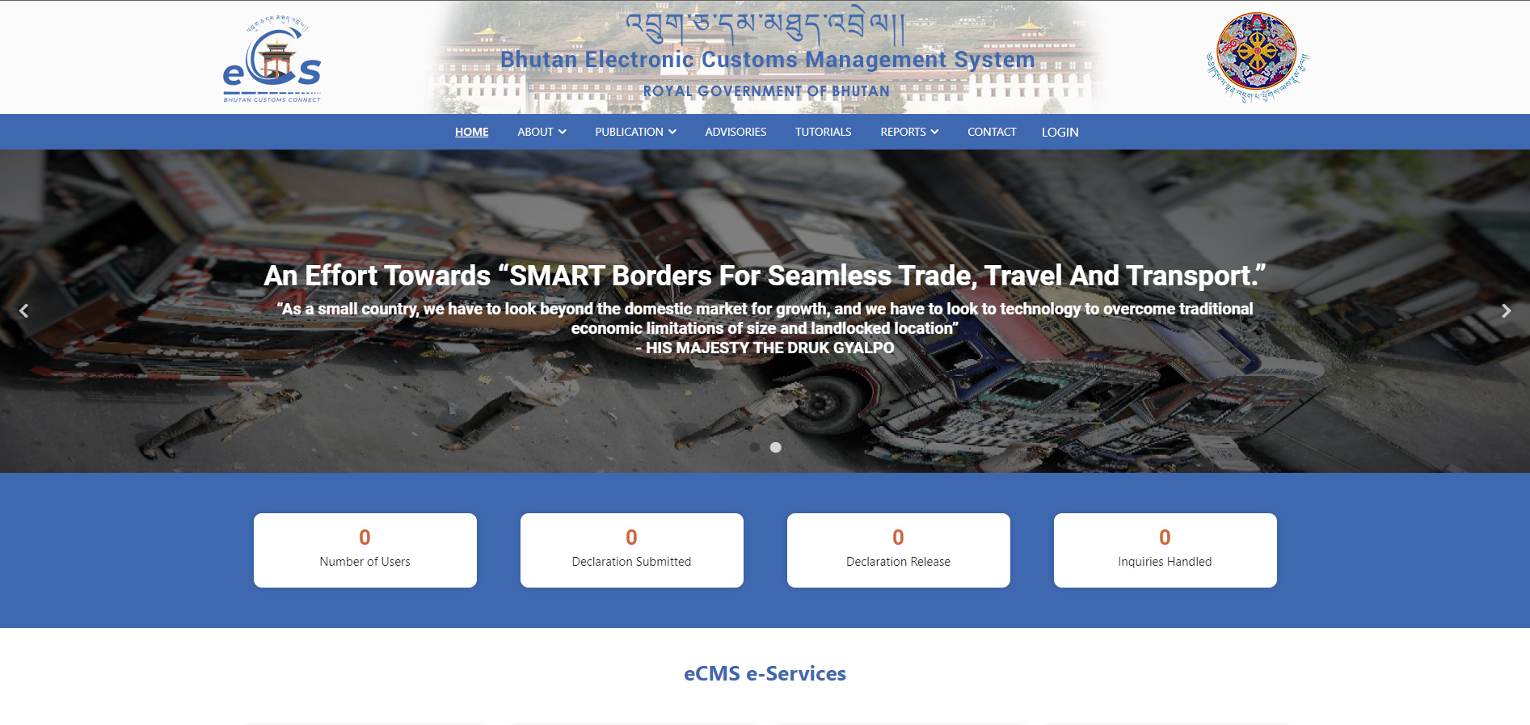

- Click on Login and provide the necessary credentials

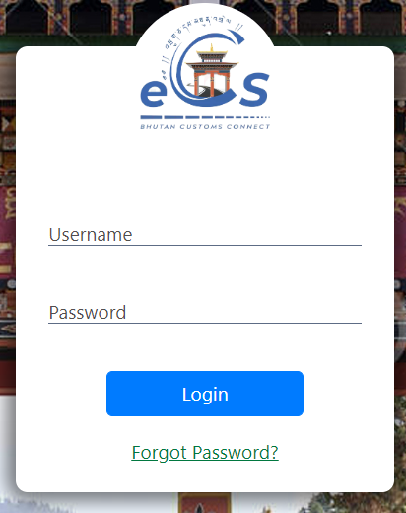
eCMS Login Page

- Enter the USERNAME and the PASSWORD in the fields provided and Click button. Upon successful login the Electronic Customs Management System Home Page will be displayed.

- On the login page, the user clicks the Forgot Password? , if the user forget their password. Then they will need to provide the required information and then default password will be send to their mail.

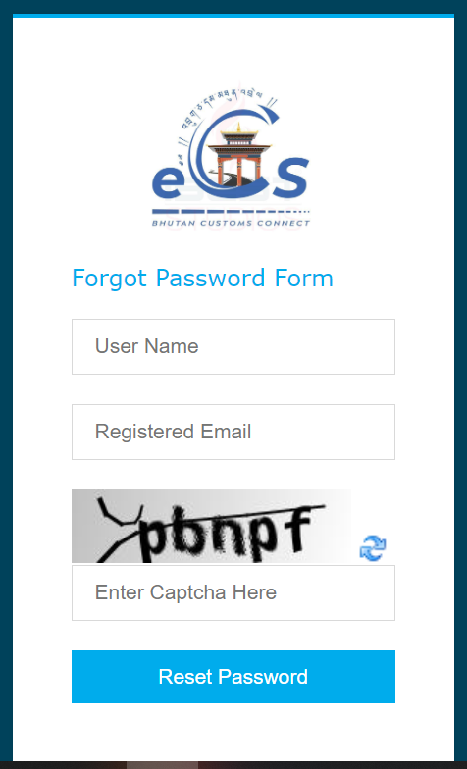

- Dashboard Page
- Logging Out
- This function allows the user to log out from the application any time. User can sign out from the TFB System any time by simply clicking the button available at the upper right corner of the user logged-in window.

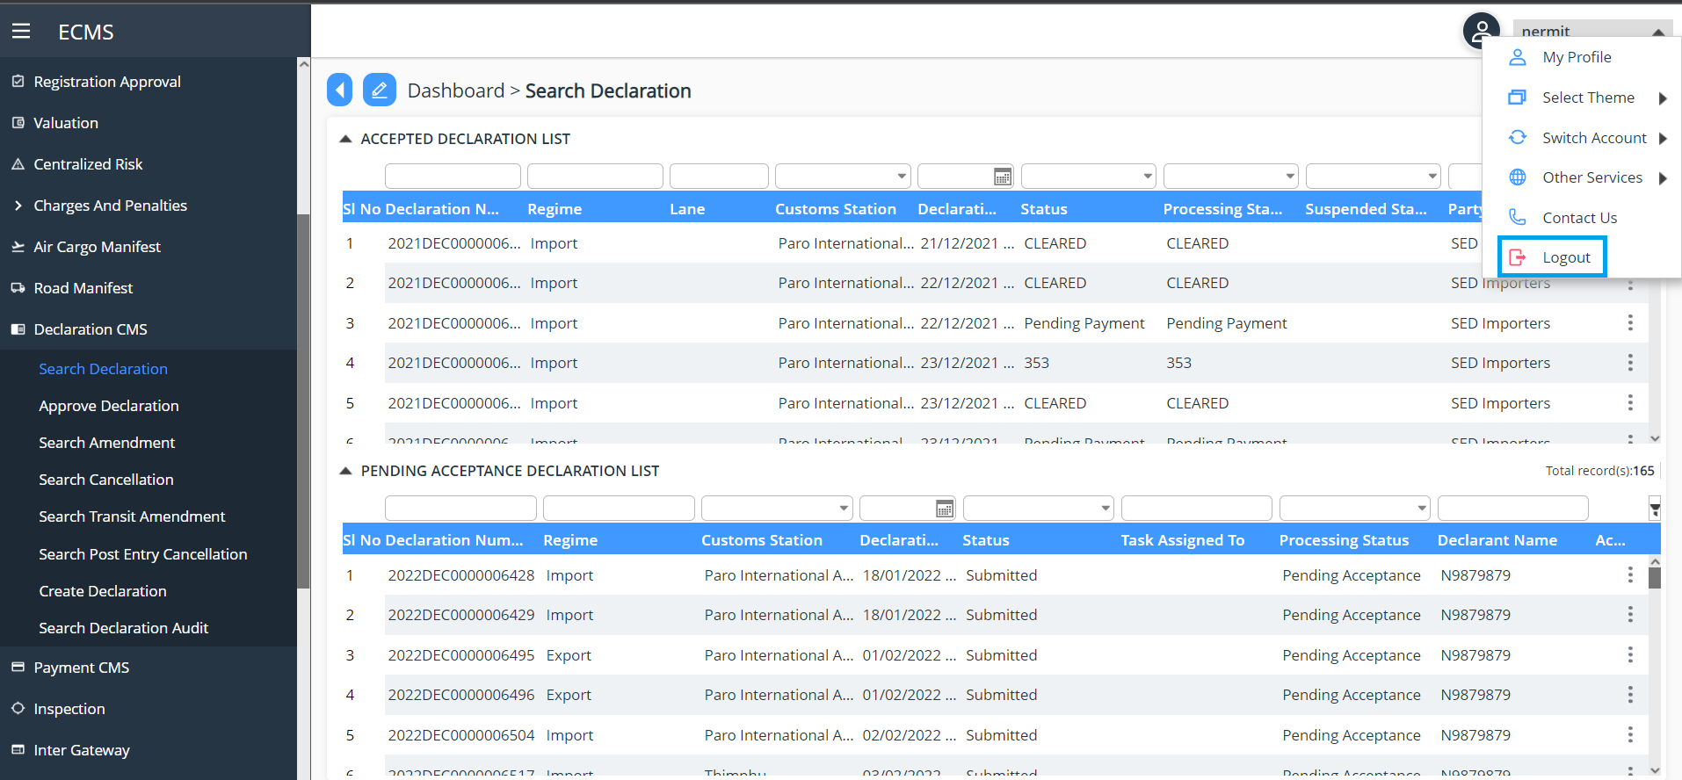
Log Out Page

Common Icons and Buttons
The following are the list of icons and buttons referenced across screens and their functionality.
Field/Button description | Action/Input Required
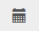 | - Click  to view the calendar.  - Specify the required date and time from the respective portions of the calendar.  - Click Apply.  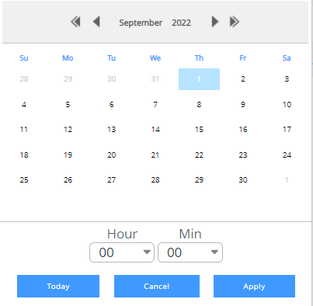
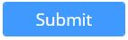 | Click this button to submit the relevant details.
 | Click this button to close the relevant tab details.
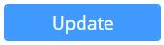 | Click this button to update the modified details relevant to the respective tab.
 | Click this button to save the details of that particular tab.
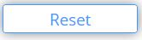 | Click this button to clear the entered details and re-enter the field values.
 | Click this icon to search for the exact search results from the available details.
 | Click this icon to add a new record relevant to the respective tab.
 | Click this icon to print the relevant tab details.

Chapter 3-Party Management
This functionality allows the eCMS Admin to create and update the party for CMS and Front End users in the eCMS system.

TPN Master
This function allows you to view the list of TPN that has been transfer to eCMS from the RAMIS system when the user register into the RAMIS and also the data will be updated when the operator register themselves into the eCMS and also a party will be allocated to the registered user. TPN is applicable for Clearing Agent and Importer and Exporter during creation of Party.
To view TPN Master:
- Login to eCMS application and Click Registration >> TPN Master. The subsequent screen will be displayed.
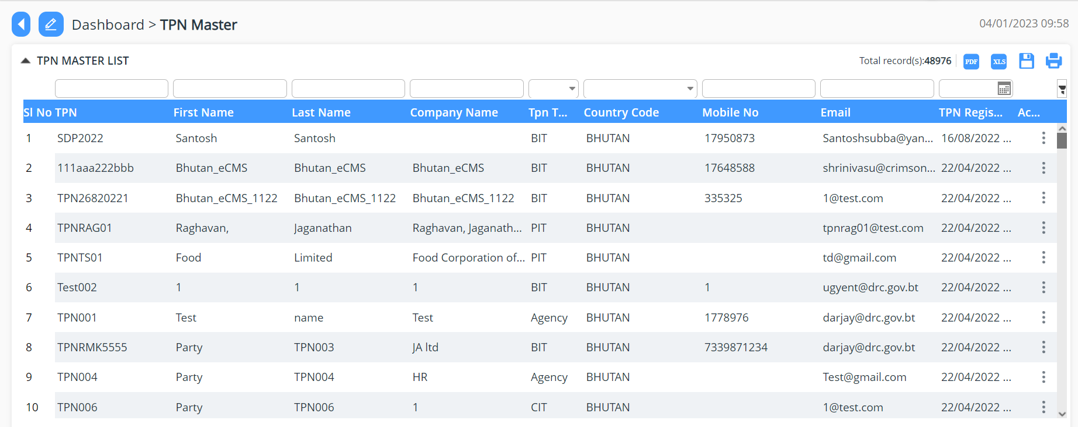

- Details of TPN Master are as follows:

- TPN details:

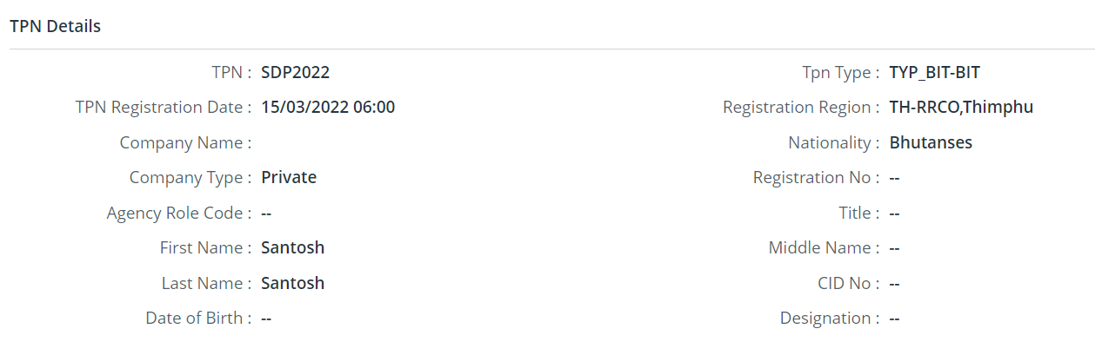
- License Details:

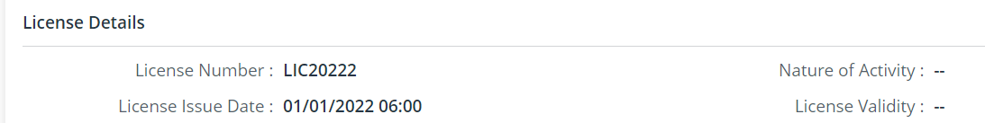

- Contact Details:

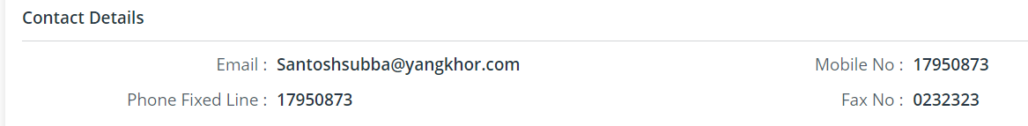

- Permanent Address:

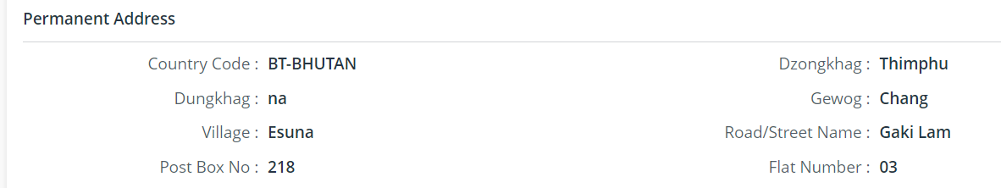

- Present Address:

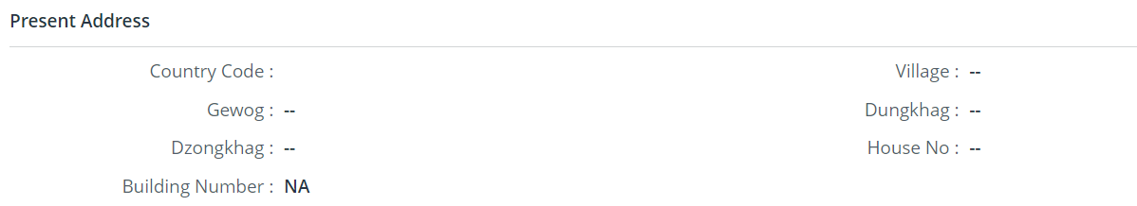

- Bank Details:

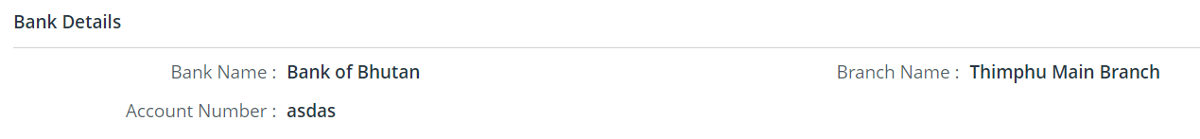

Creating Party
This section allows the Company Admin to create the party for CMS and FRONT END users in the eCMS system.
To create a party:
- Login to eCMS application as a CMS admin.
- Click Registration >> Party. The subsequent screen will be displayed.
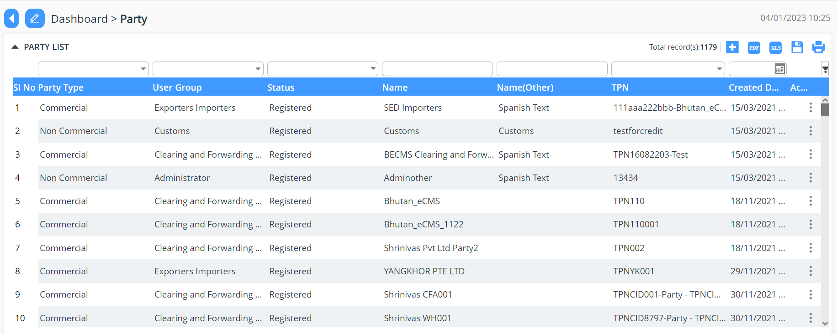

Party Detail Page
- Click add icon to create new party.
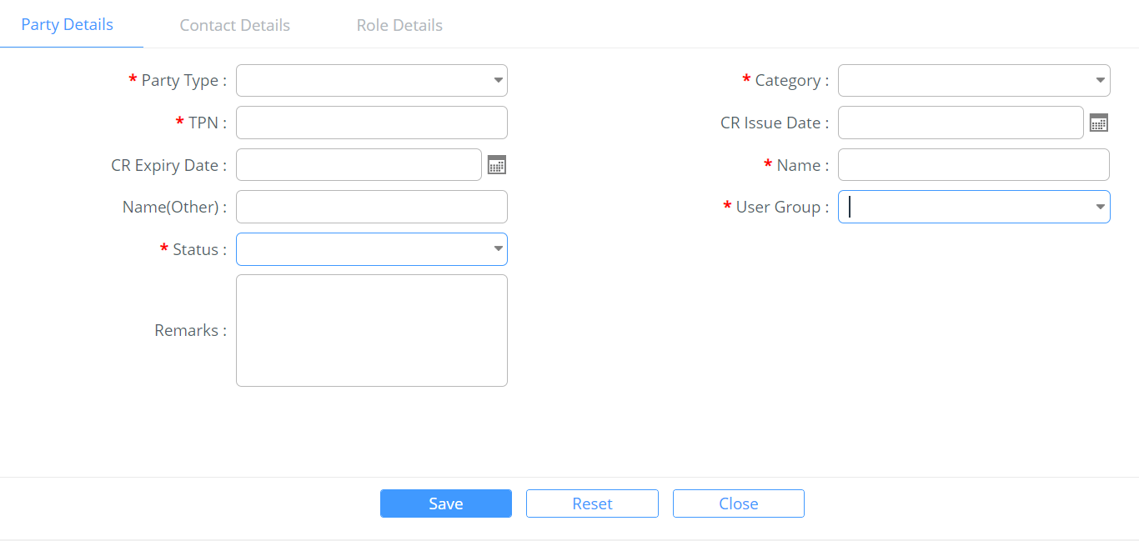

Party Details Tab
- Enter information in the Party Details fields.
Field/Button description | Action/Input Required
Party Type | Select part type from the drop-down list.
Category | Select category of party from the drop-down list.
TPN
CR Issue Date | Select CR issue date from date window.
CR Expiry Date | Select CR expiry date from date window.
Name | Enter name of the party.
Name(Other) | Enter other name of the party.
User Group | Select user group of party from the drop-down list.
Status | Select status of party from the drop-down list.
Remarks | If any additional remarks

- Click Save button to save the Party details.
- Click Ok button to close the confirmation message.
- Click on Contact Details Tab. The subsequent screen will be displayed.
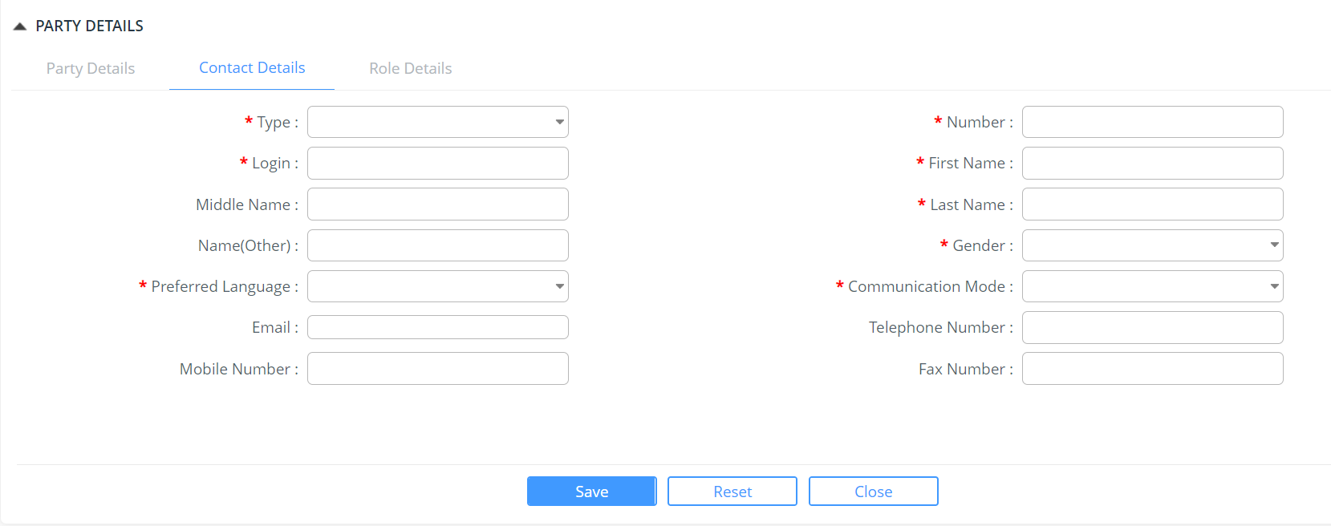

Contact Details Tab
- Enter information in the Contact Details fields.
Field/Button description | Action/Input Required
Type | Select the Identification type from the drop-down list.
Number | Enter the identification number of the party.
Login
First Name | Enter the first name of the party.
Middle Name | Enter the middle name of the party.
Last Name | Enter the last name of the party.
Name(Other) | Enter the other name of the party.
Gender | Select the gender from the dropdown list.
Preferred Language | Select the desired language from the drop-down list.
Communication Mode | Select the Mode of Communication from the drop-down list.
E-mail | Enter the email id of the party.
Telephone Number | Enter the land line number of the party
Mobile Number | Enter the Ten Digit Mobile number of the party.
Fax Number | Enter the Fax number of the party.
- Click Save button to save the Contact details.
- Click Reset button to reset the data entered if incorect.
- Click Close to close the working page

Searching Party
This section allows the Company Admin to search, edit, view and print the party for CMS and FRONT-END users in the eCMS.
To search the party:
- Click Registration >> Party. The subsequent screen will be displayed.


Party Search List Page
- Enter any one of the search criteria to view the party details. Following are the field and button descriptions of the Search User Page.
Field/Button description | Action/Input Required
Party Type | Select part type from the drop-down list.
User Group | Select category of party from the drop-down list.
Status | Select status of party from the drop-down list.
Name | Enter name of party.
Name (Other) | Enter the other name of party.
TPN | Enter the code.
Created Date | Creation date of the party

@ | - If you do not know the complete search phrase (words) for any criterion, enter partial search phrase (words) and click the Search icon.  - To get an exact search result, you must enter the following search criteria:  - Name (Other)  - Code

Viewing Party Details
This functionality allows the Company Admin to view the party details.
To view the party details:
- From the search results, click the  icon to view the party details.
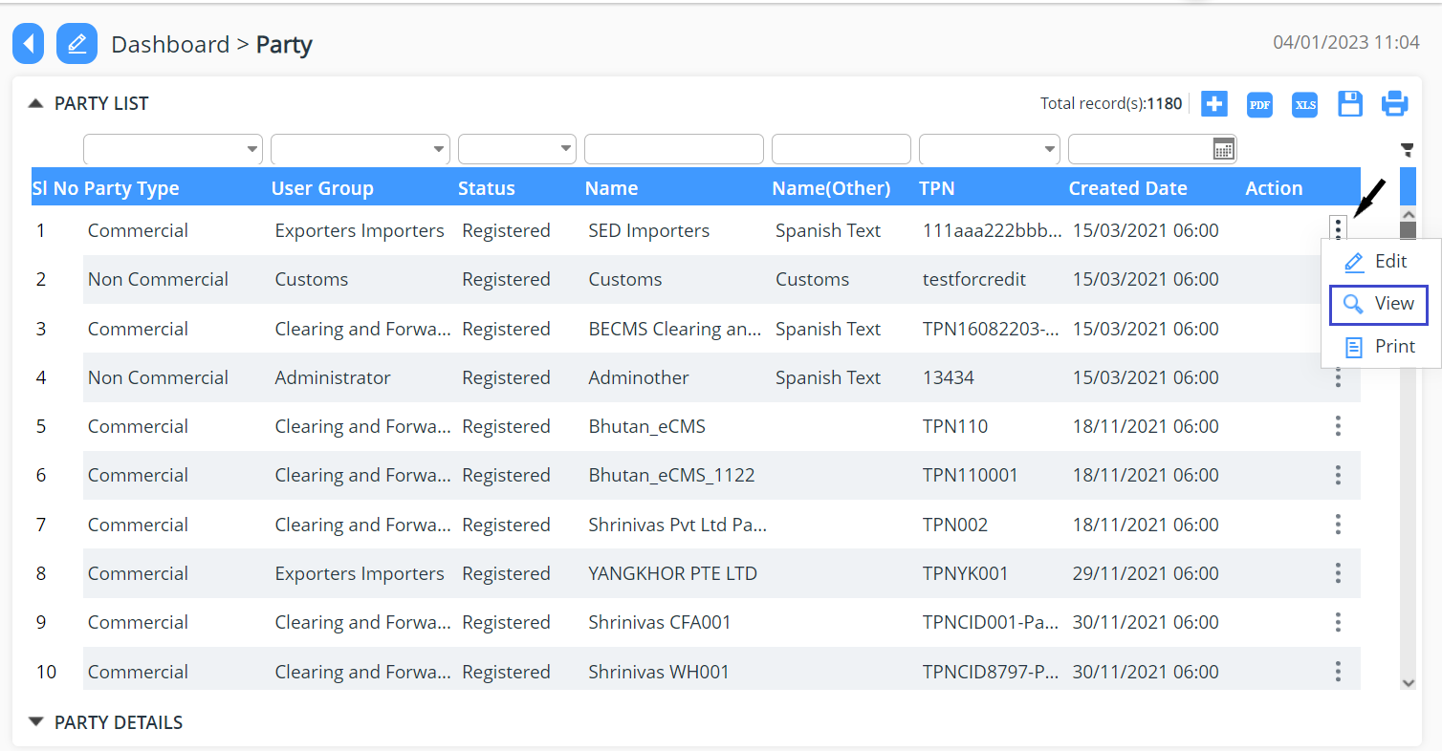
- Party Details can be saved in different forms PDF, XLS and Save by clicking the icon as shown


- Click the  icon to print preview the party details.
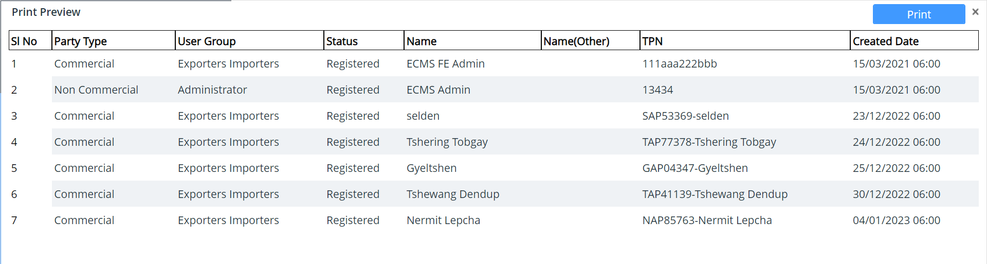
Print Preview Popup

Updating Party Details
This section allows the Company Admin to search and edit the party in the eCMS system.
To update the party:
- From search result, click the edit icon to update the party details. The following screen will be displayed.
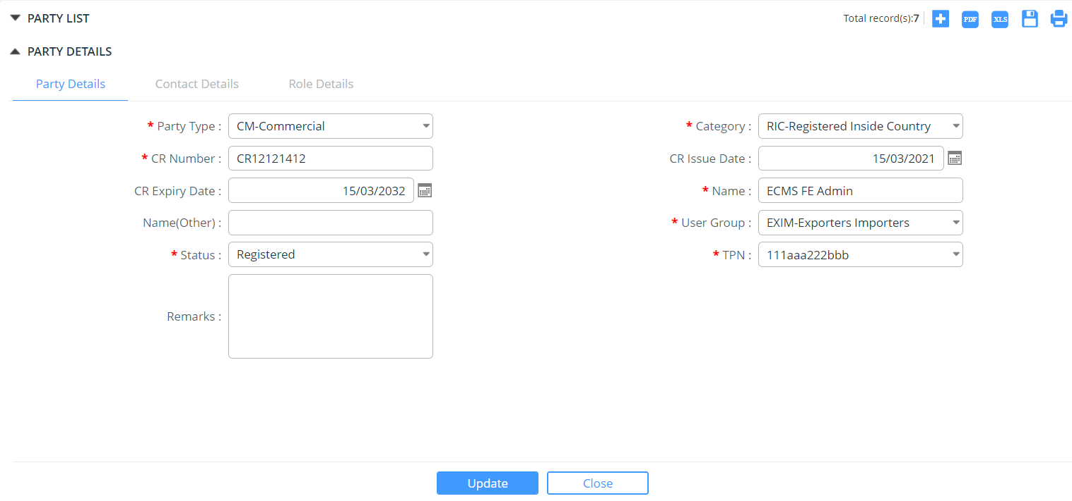
Party Details Edit Tab
- Modify the field values and click  button.
- Click Ok button to close the confirmation message. The changes get reflected in the search party grid.

Chapter 4-Role Management
This functionality allows the eCMS Admin to create and update the roles for CMS and FRONT END users in the eCMS.

Creating Roles
This section allows the Company Admin to create roles for CMS and FRONT END users in the eCMS.
To create a role:
- Login to eCMS application as a CMS admin.
- Click Registration >> Role. The subsequent screen will be displayed.
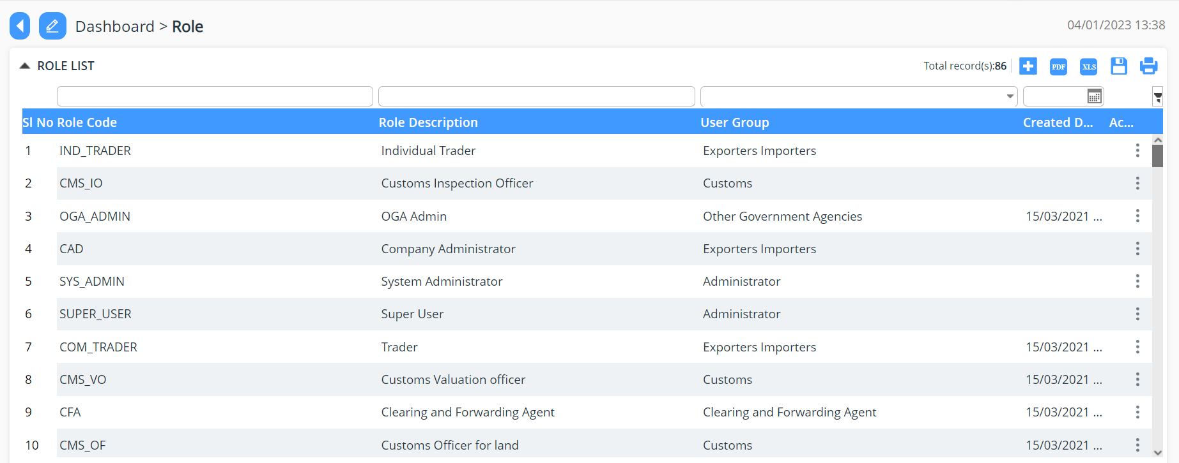
Role List Page
- Click Add icon to create new user. The Following screen will be displayed.
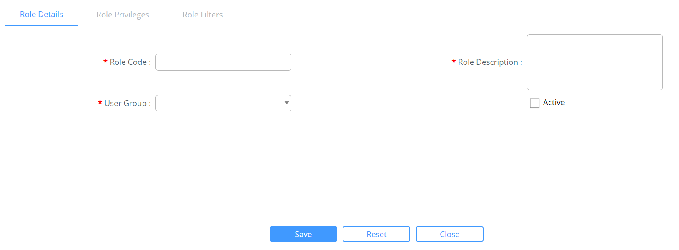
Role Details Tab
- Enter information in the Role Details fields.
Field/Button description | Action/Input Required
Role Code | Enter the role code of the user.
Role Description | Enter the description for the role.
User Group | Select user group of role from the drop-down list.
Active | Tick the check box if the role is in active state.

- Click Save button to save the Role details.
- Click Ok button to close the confirmation message.
- Click Reset button to clear the role details fields.
- Click on Role Privileges Tab. The subsequent screen will be displayed.

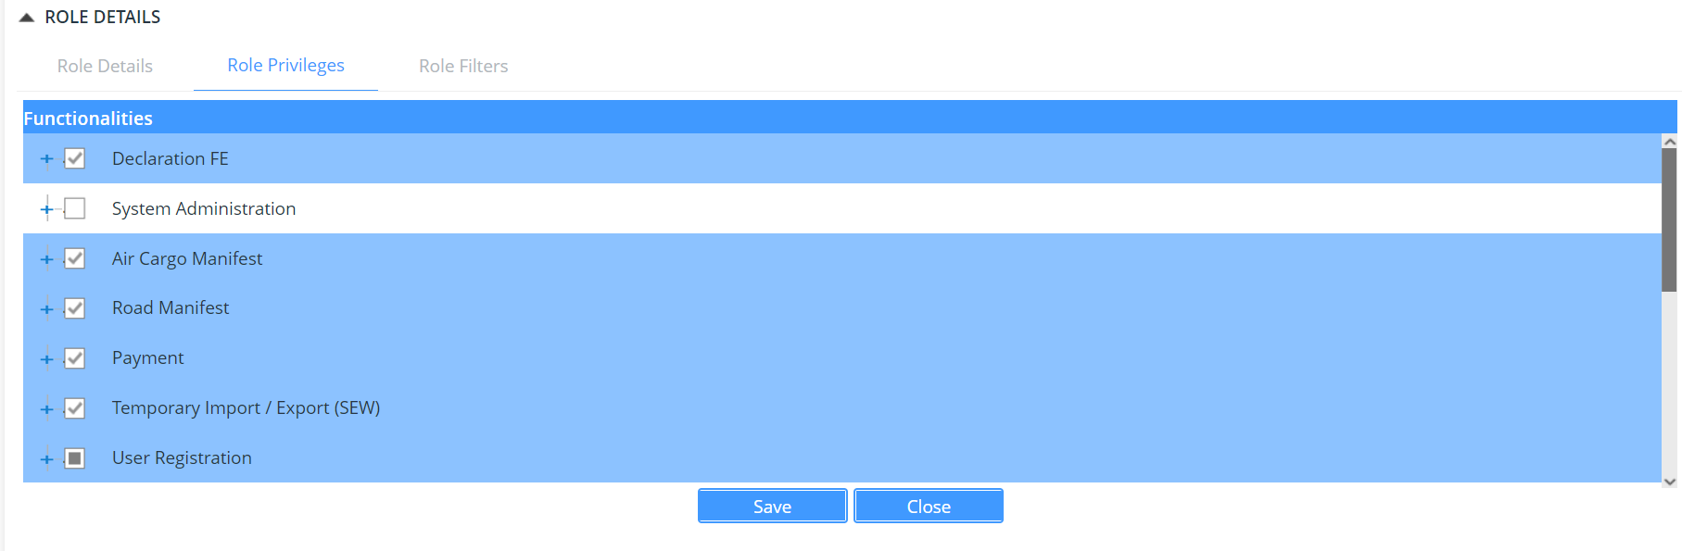
Role Privileges Tab
- Select the functionality to provide the access rights to the role.
- Click Save button to save the Role Privileges details.
- Click Ok button to close the confirmation message.
- Click Role Filters Tab. The subsequent screen will be displayed.
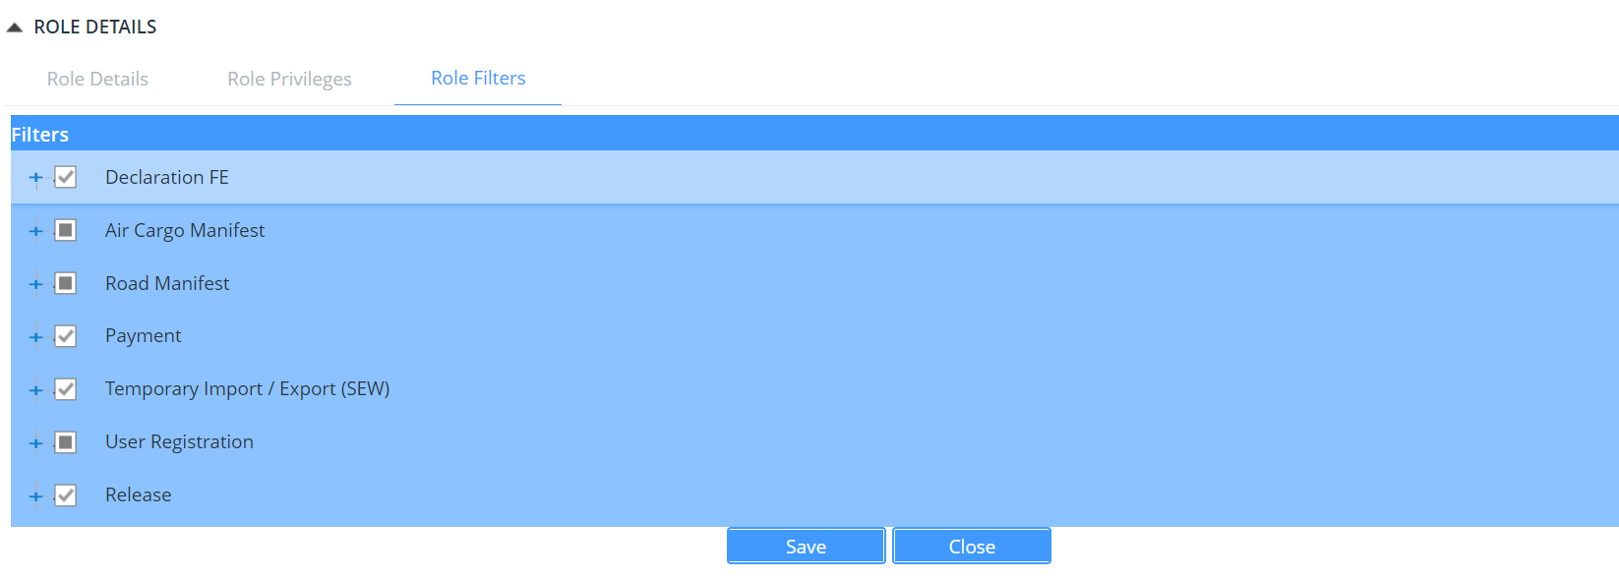
Role Filter Tab
- Click Save button to save the role filters details.

Searching Roles
This section allows the Company Admin to search, edit, view and print the roles for CMS and FRONT END users in the eCMS.
To search the role:
- Click Registration>>Role. The subsequent screen will be displayed.

Role Search List Page
- Enter any one of the search criteria to view the role details. Following are the field and button descriptions of the Search User Page.
Field/Button description | Action/Input Required
Role Code | Enter the role code of the user.
Role Description | Enter the description for the role.
User Group | Select user group of role from the drop-down list.

@ | - If you do not know the complete search phrase (words) for any criterion, enter partial search phrase (words) and click the Search icon.

- Enter the search criteria and click icon to view the matching results in the Search Results Page.
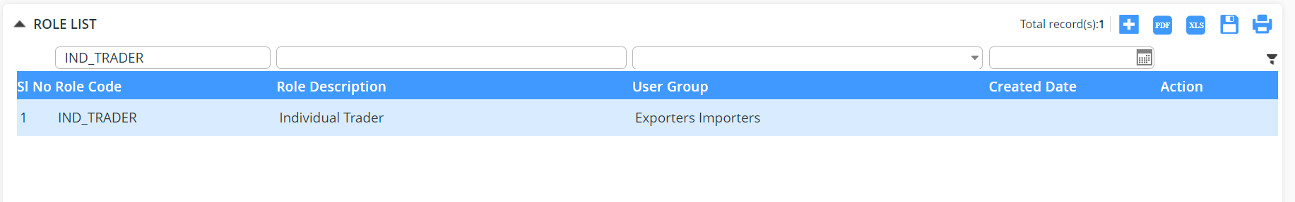
Role List Search Result Page

Viewing Role Details
This functionality allows the Company Admin to view the role details.
To view the role details:
- From the search results, click the 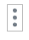 icon to view the role details and then click on view for viewing the details
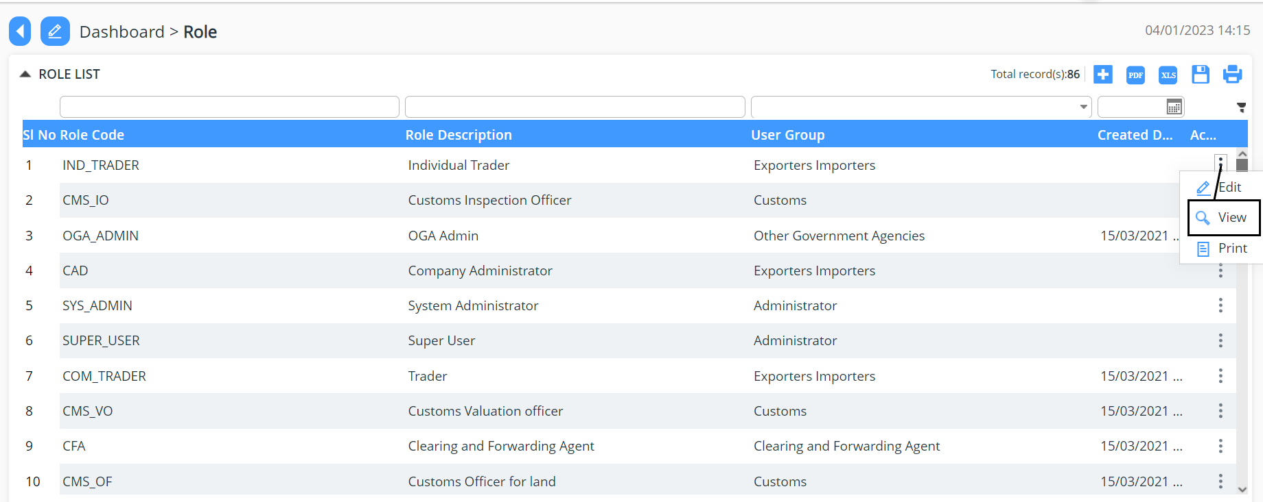
Role Detail Tab
- Click Role Privileges tab to view the Role Privileges assigned.

Role Privilege Tab
- Click Role Filter tab to view the Role Filters done.

Role Filter Tab
- Click the icon to print preview the role details.
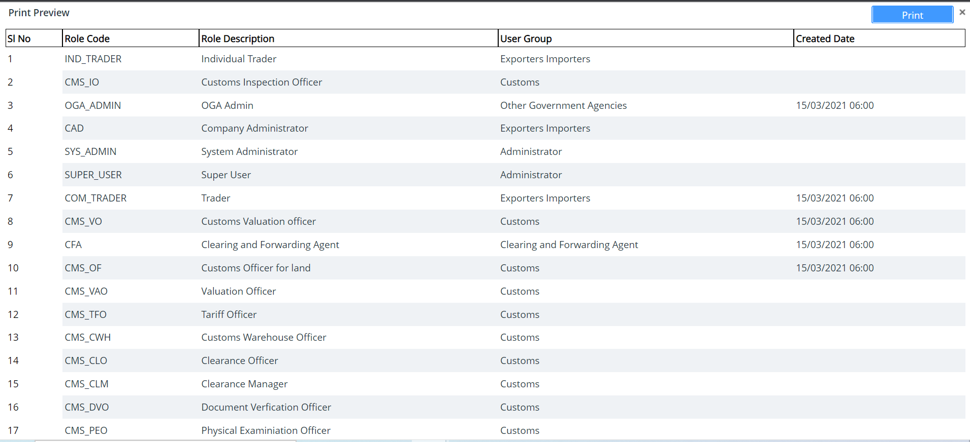
Print Preview Popup

Updating Role Details
This section allows the Company Admin to search and edit the roles in the TFB system.
To update the roles:
- From search result, click the  edit icon to update the role details. The following screen will be displayed.
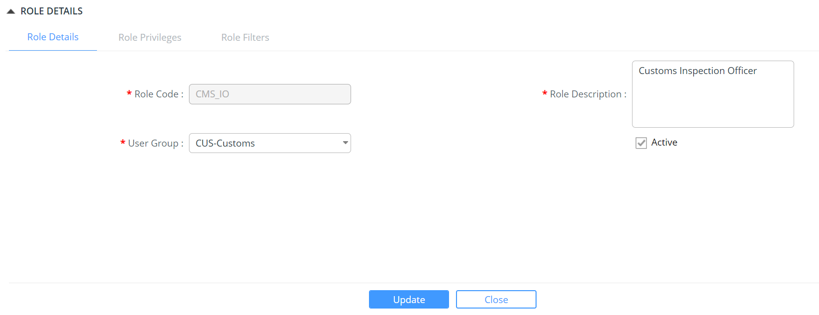
Role Details Edit Tab
- Modify the field values and click  button.
- Click Ok button to close the confirmation message. The changes get reflected in the search role grid.

Chapter 5-User Management
This functionality allows the TFB CMS Admin to create and update the CMS user, FRONT END user, roles and party as well as defining the roles to the respective users.

Creating CMS User
The Company Administrator creates the CMS users using the TFB Application.
To create a CMS user:
- Login to eCMS application and click CMS Users.

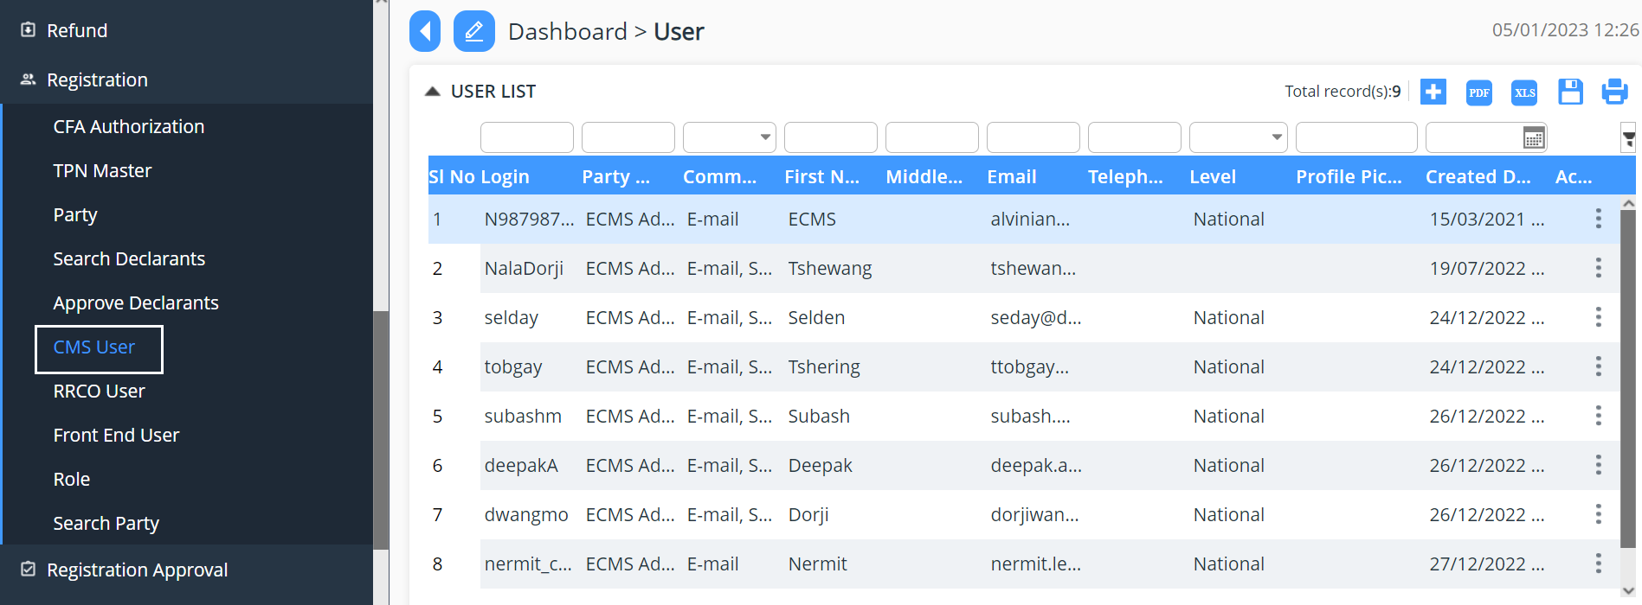
CMS User List Page

@ | The users can perform the transaction only if he is a registered user in the system.

- Click icon to create a new CMS user.
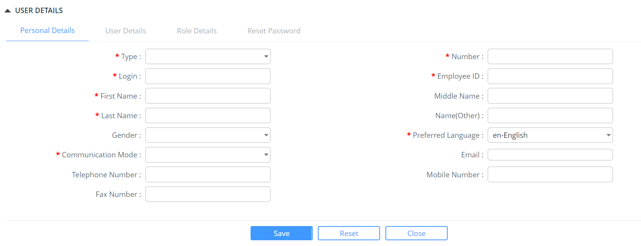
CMS User Personal Details Tab

- Enter information in the Personal Details fields.

Field/Button description | Action/Input Required
Type | Select the Identification type from the drop-down list.
Number | Enter the identification number of the user
Login
Employee ID
First Name | Enter the first name of the user.
Middle Name | Enter the middle name of the user.
Last Name | Enter the last name of the user
Name (Other) | Enter the other name of the user.
Gender | Select the gender from the dropdown list
Preferred Language | Select the desired language from the drop-down list.
Communication Mode | Select the Mode of Communication from the drop-down list.
E-mail | Enter the email id of the user.
Telephone Number | Enter the land line number of the user.
Mobile Number | Enter the Ten Digit Mobile number of the user.
Fax Number | Enter the Fax number of the user.

- Click Save button to save the user details.
- Click Close button to close the confirmation message.
- Click Reset button to clear the user personal details.
- Click User Details Tab. The subsequent screen will be displayed.

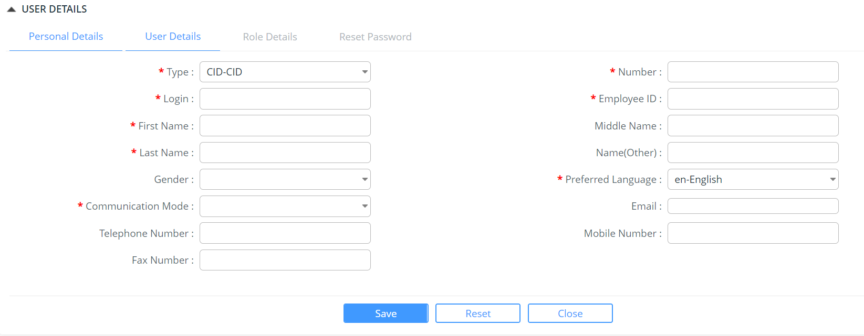
User Details Tab

- Enter information in the User Details fields.
Field/Button description | Action/Input Required
Party | Select the Party to which the user belongs to from the drop-down list.
Level | Select the Level of user from the drop-down list.
Province | Select the Province of a user from drop-down list.
Customs Station | Select the customs office from the drop-down list.
Department | Enter the Department of the user
Communication Mode | Select the Communication Mode from the drop-down list.
E-mail | Enter the email id of the user.
Telephone Number | Enter the land line number of the user.
Mobile Number | Enter the Ten-digit mobile number of the user.
Fax Number | Enter the Fax number of the user.
Designation | Enter the designation of the user.
Position level | Enter the position of the user
Status | Select the status as registered or de-registered from the dropdown list.
Regime | Select the regime from the drop-down list.
Resource Management Modules | Select the resource management module from the drop-down list

- Click Save button to save the user details.
- Click Ok button to close the confirmation message.
- Click Reset button to clear the user details tab fields.
- Click Role Details Tab. The subsequent screen will be displayed.
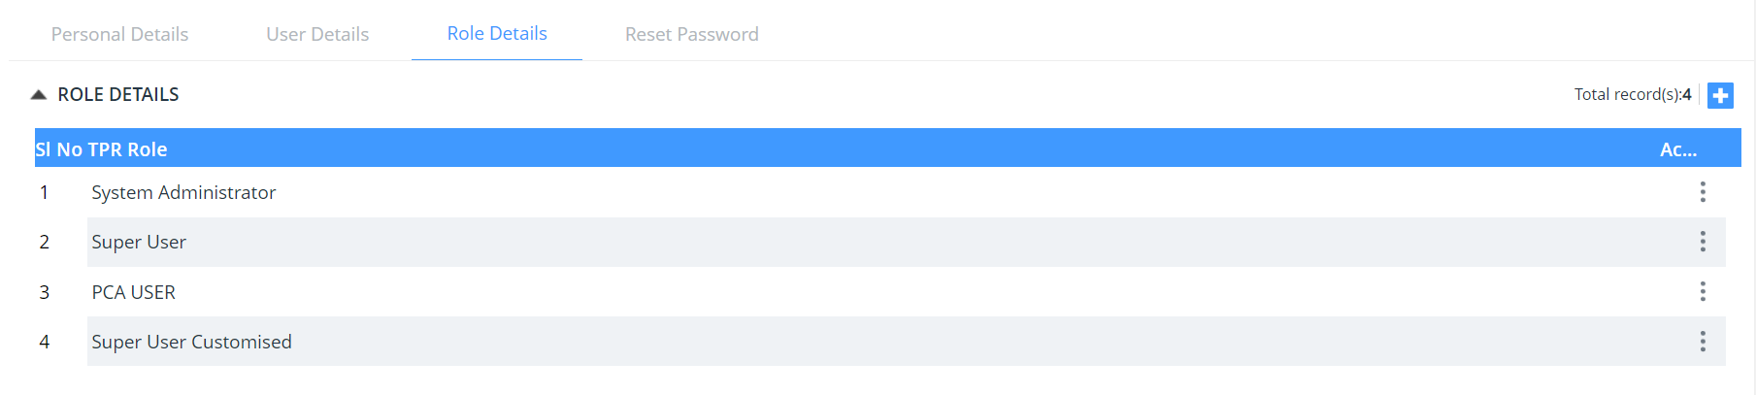
Role Details Tab

- The Company Admin can assign new roles. Click Add icon to assign new TPR role to that particular user.
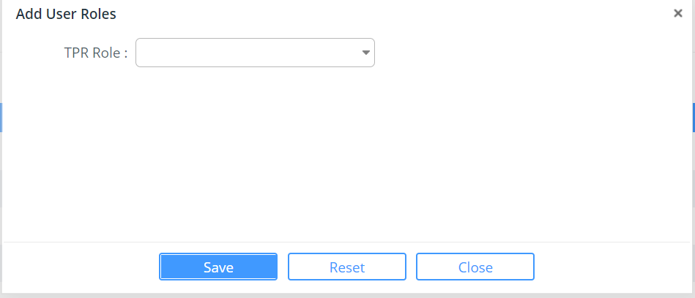
Add User Details Popup
- Select the type of role to be assigned to the user and click save button.
- Click Ok button to close the confirmation message.
- Click Reset button to clear the TPR role field.

@ | Click the Add icon to add more than one TPR Role details.  Click the Edit icon to edit the role details.  Click the View icon to view the role details.  Click the Print icon to print the role details from the available list.  Click Quick View icon to overview the role details.  Click Print icon to remove role details.

- The Company Admin can reset password for the user. Click Reset Password to reset password for a particular user.
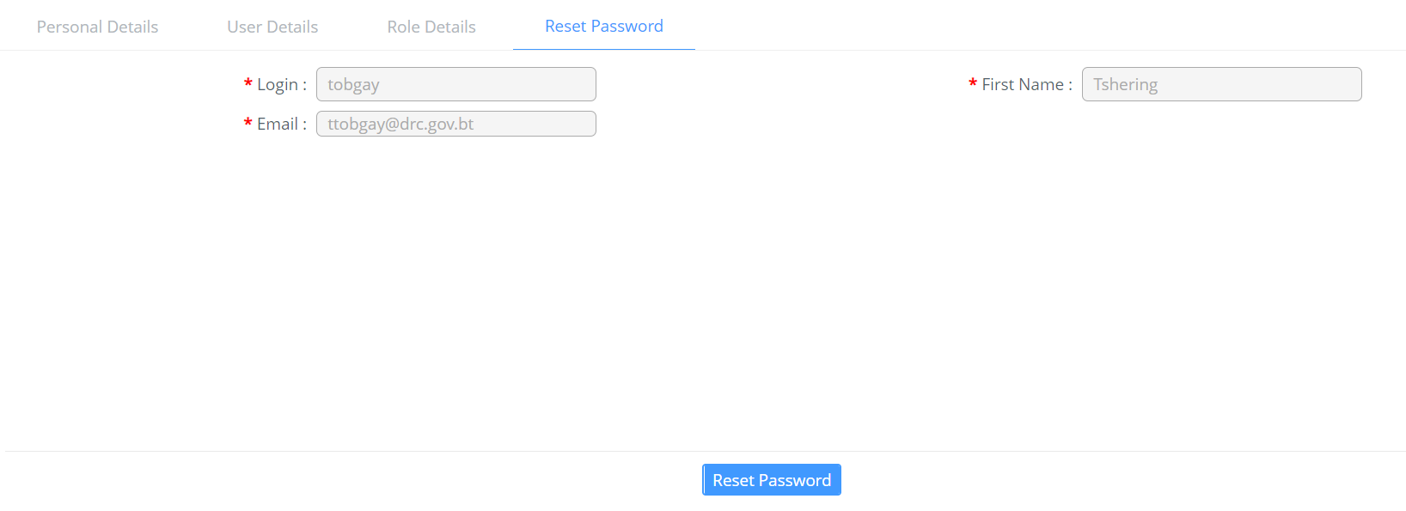

Searching CMS Users
This section allows the Company Admin to search, edit, view and print the users in the TFB system.
To search the user:
- Click Registration>> CMS User. The subsequent screen will be displayed.

CMS User List Search Page
- Enter any one of the search criteria to view the user details. Following are the field and button descriptions of the Search User Tab.
Field/Button description | Action/Input Required
Login ID | Enter the Login ID of the user.
Party Name | Enter the name of the user.
Communication Mode | Enter communication mode of the user.
First Name
Middle Name
E-mail | Enter the email ID of the user.
Telephone Number | Enter the telephone number.
Level | Enter the level of user.
Profile Pic
Created Date

@ | - If you do not know the complete search phrase (words) for any criterion, enter partial search phrase (words) and click the Search icon.  - To get an exact search result, you must enter the following search criteria:  - Login ID  - Name  - Telephone Number

- Enter the search criteria and Click icon to view the matching results in the Search Results Page.
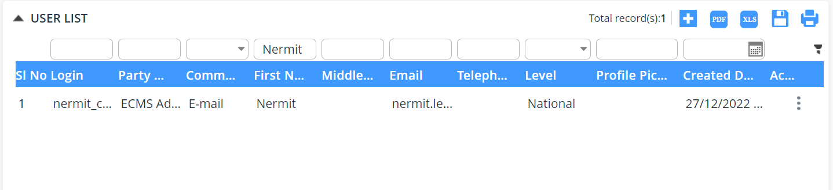
CMS User List Search Result Page

Viewing CMS User Details
This functionality allows the Company Admin to view the user details.
To view the CMS user details:
- From the search results, click the  icon to view the personal details.
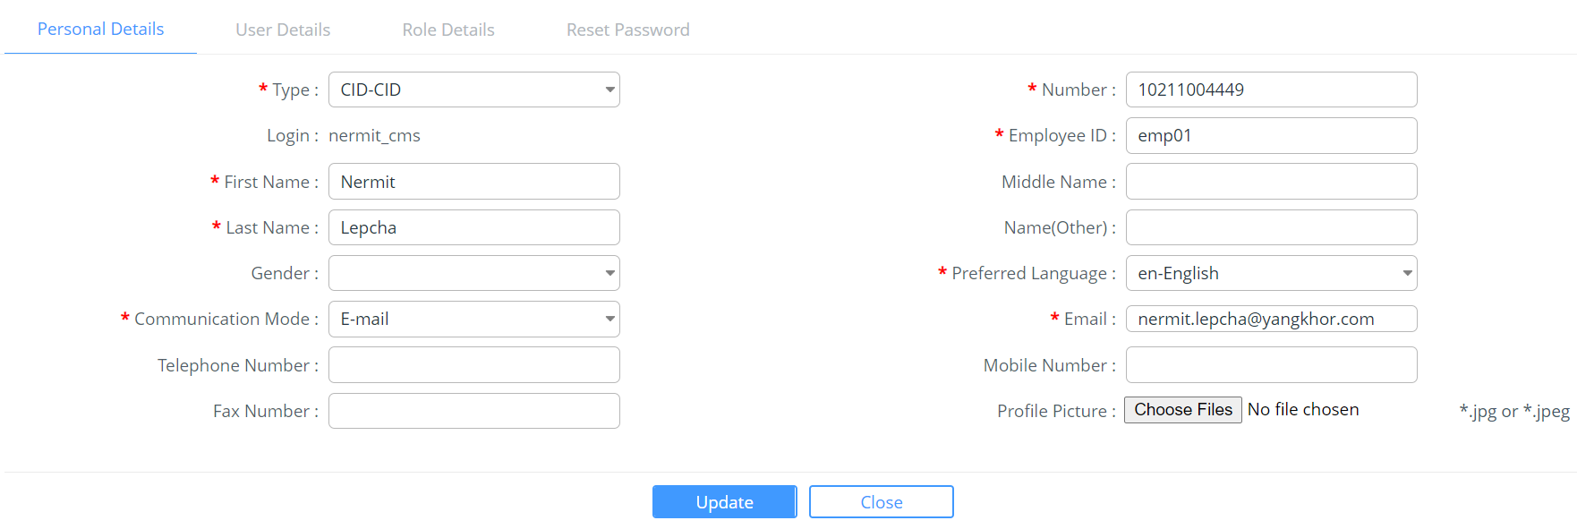
Personal Details Tab
- Click User Details tab to view the user details.
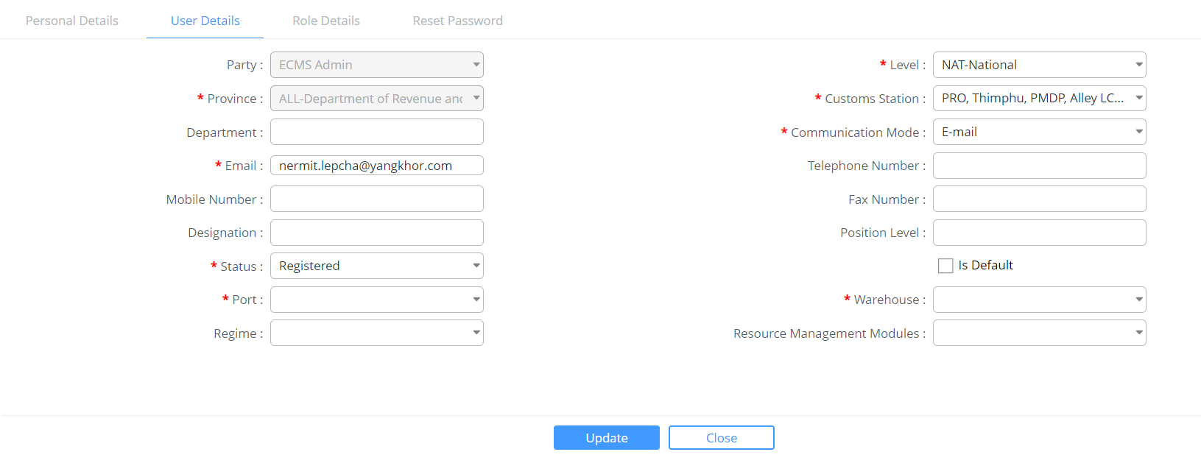
CMS User Details Tab
- Click Role tab to view and edit the roles.
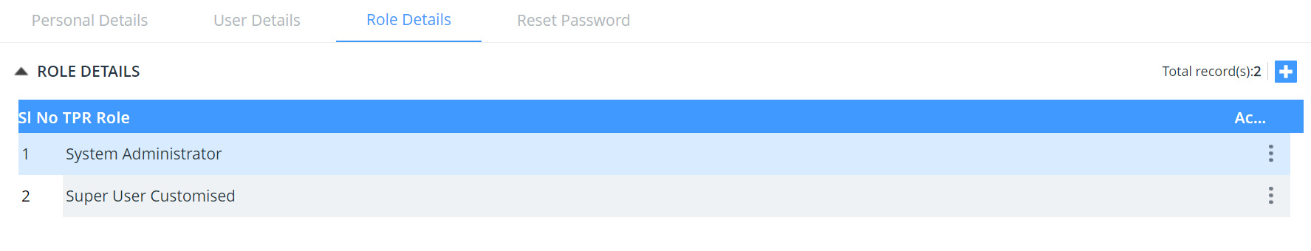
CMS User Role Details Tab
- Click the Reset password to reset password
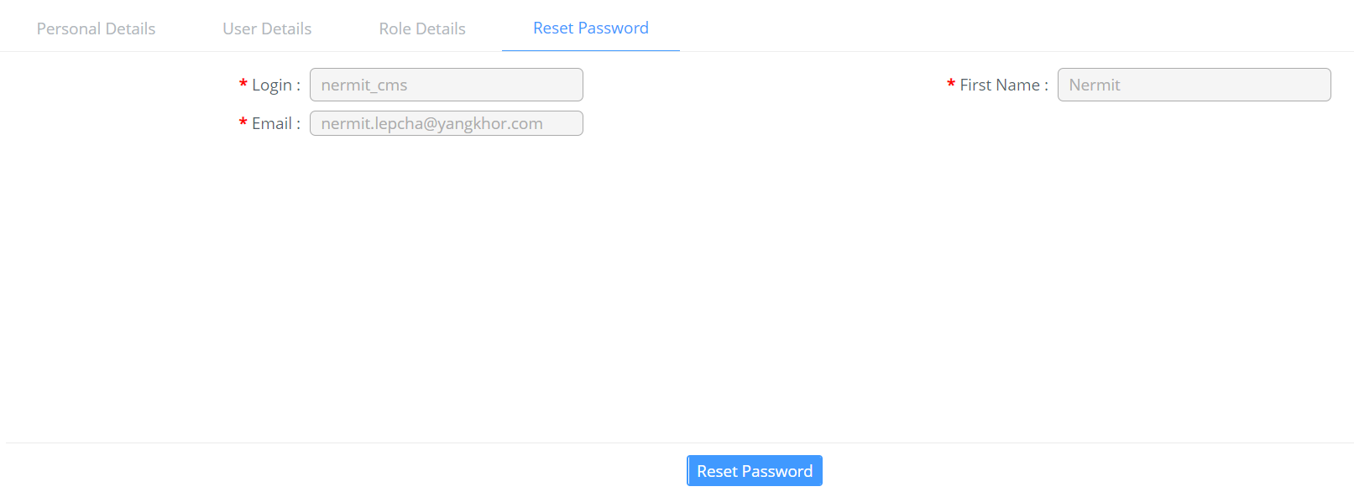
View User Role Details Popup

- Click the  icon to print preview the role details.
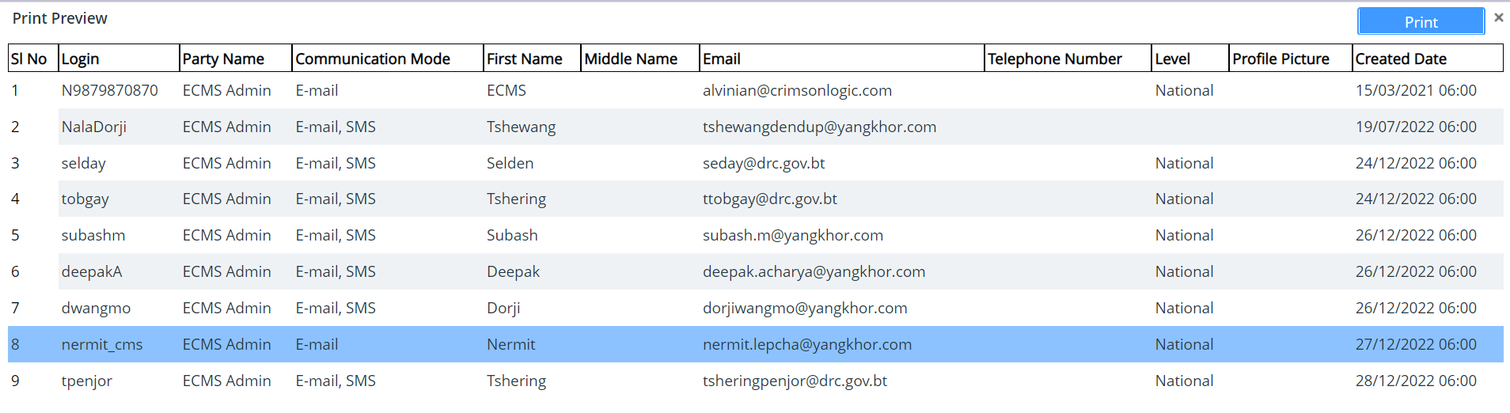
Print Preview Details Popup

Updating CMS User Details
This section allows the Company Admin to search and edit the users in the TFB system.
To search the user:
- Click Registration >> CMS User. The subsequent screen will be displayed.
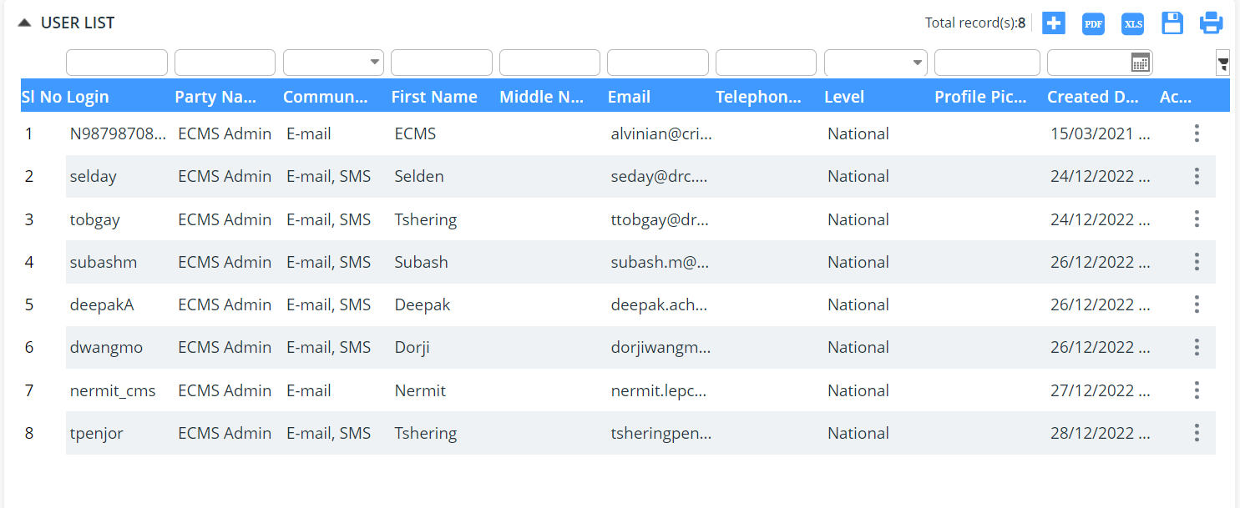
CMS User List Search Page

- Click on the user you want to update the details and then update the detail and click onto  menu the successful message will be popped up for the same
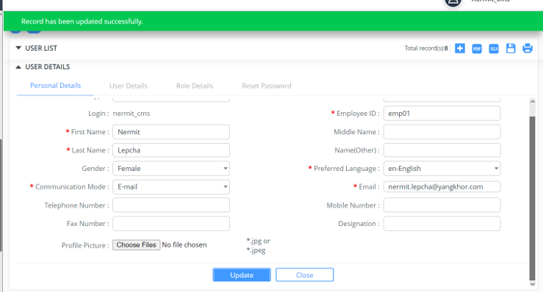
User Details Edit Tab

Creating RRCO User
The Company Administrator can create the Front End users using the eCMS Application.
To create a Front End user:
- Login to TFB application and Click Registration >> FRONT END User. The subsequent screen will be displayed.
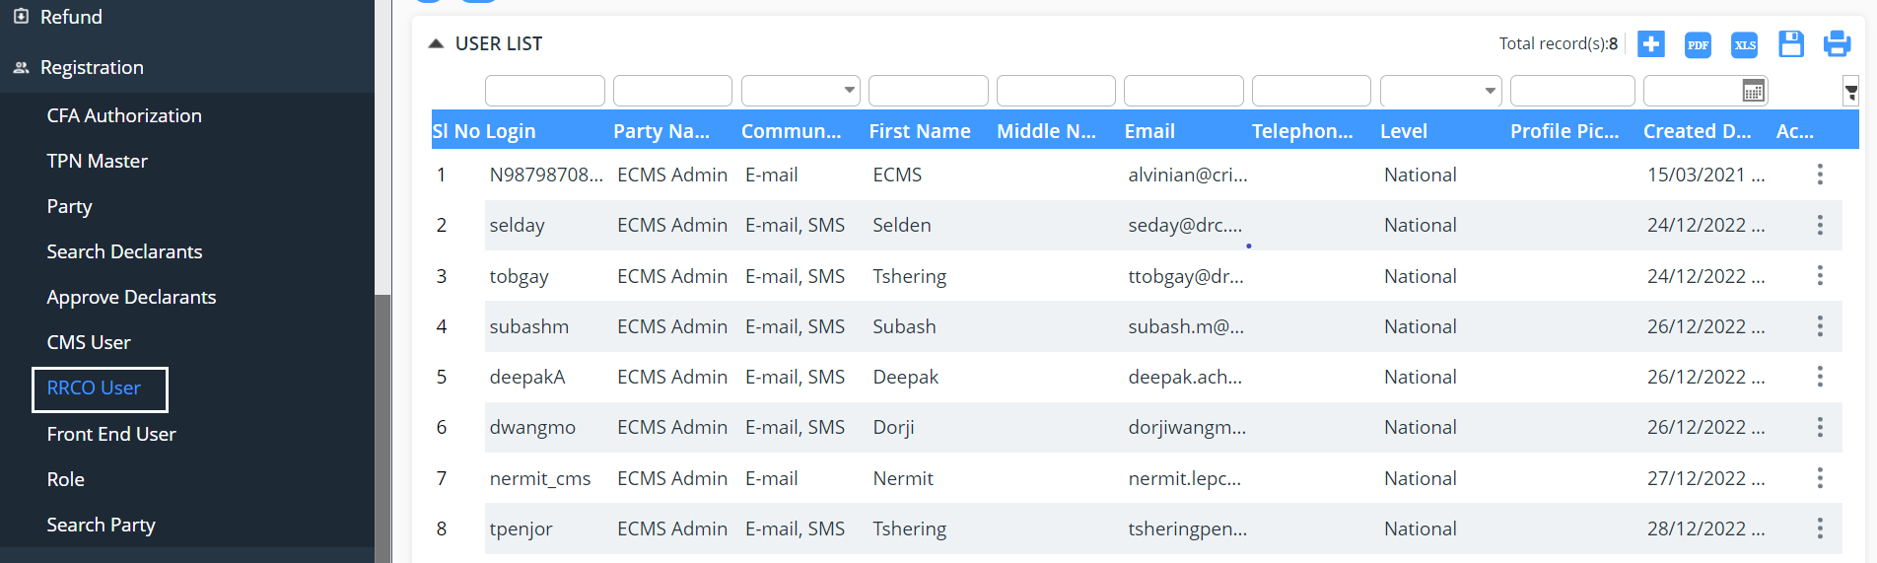
RRCO User List Page
- Click Add icon to create new RRCO user. The following screen will be displayed.
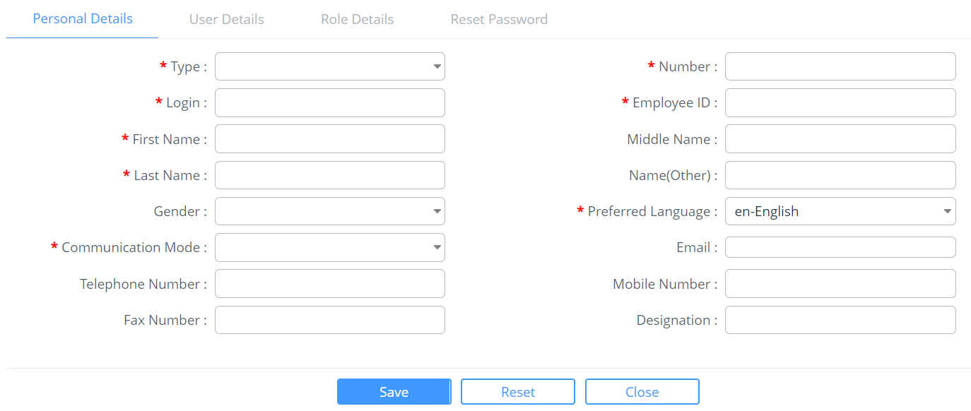
Personal Details Tab
- Enter information in the Personal Details fields.
Field/Button description | Action/Input Required
Type | Select the Identification type from the drop-down list.
Number | Enter the identification number of the user.
Login
Employee Id
First Name | Enter the first name of the user.
Middle Name | Enter the middle name of the user.
Last Name | Enter the last name of the user.
Name(Other) | Enter the other name of the user.
Gender | Select the gender from the dropdown list.
Preferred Language | Select the desired language from the drop-down list.
Communication Mode | Select the Mode of Communication as English or Other from the drop-down list.
E-mail Id | Enter the email id of the user.
Mobile Number | Enter the Ten-digit Mobile number of the user.
Fax Number | Enter the Fax number of the user.
Telephone Number | Enter the land line number of the user.
Designation | Enter the designation of the user.

- Click Save button to save the personal details.
- Click Close button to close the confirmation message.
- Click Reset button to clear the personal details fields.
- Click User Details Tab. The subsequent screen will be displayed.

User Details Tab
- Enter information in the User Details fields.
Field/Button description | Action/Input Required
Party | Select the Party to which the user belongs to from the drop-down list.
Communication Mode | Select the Mode of Communication as English or Other from the drop-down list.
E-mail Id | Enter the email id of the user.
Mobile Number | Enter the Ten-digit mobile number of the user.
Fax Number | Enter the Fax number of the user.
Telephone Number | Enter the land line number of the user.
Designation | Enter the designation of the user.
Status | Select the status as registered or de-registered from the dropdown list.
Customs Office | Select the office of the customs from the drop-down list.
Is Default | This profile will be the loaded as default during login on this ID.

- Click Close button to close the confirmation message.
- Click Role Details Tab. The subsequent screen will be displayed.

Role Details Tab

- The Company Admin can create new roles. Click icon to create new TPR role.

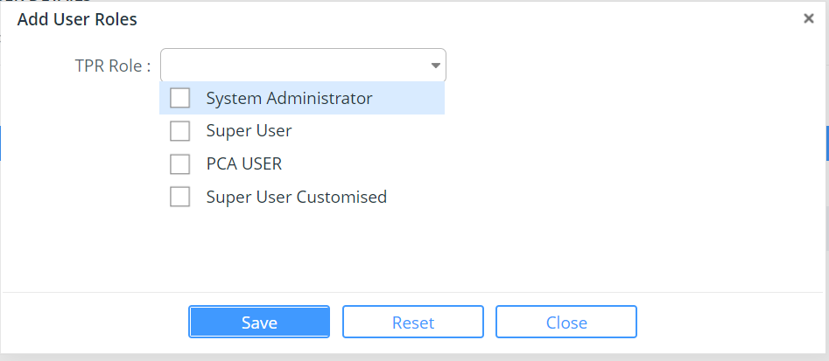
Add User Details

- Select the type of role to be assigned to the user and click Save button.
- Click Close button to close the confirmation message. The updated assigned role will be displayed in the Role Details tab.
- Click Reset button to clear the user details fields.

@ | Click the icon to add more than one TPR Role details.  Click the Edit icon to edit the role details.  Click the View icon to view the role details.  Click the Print icon to print the role details from the available list.  Click Quick View icon to overview the role details.  Click Print icon to remove roles from the list.

Searching Front End Users
This section allows the Company Admin to search, edit, view and print the users in the eCMS.
To search the Front-end user:
- Click Registration >> Front End User. The subsequent screen will be displayed.
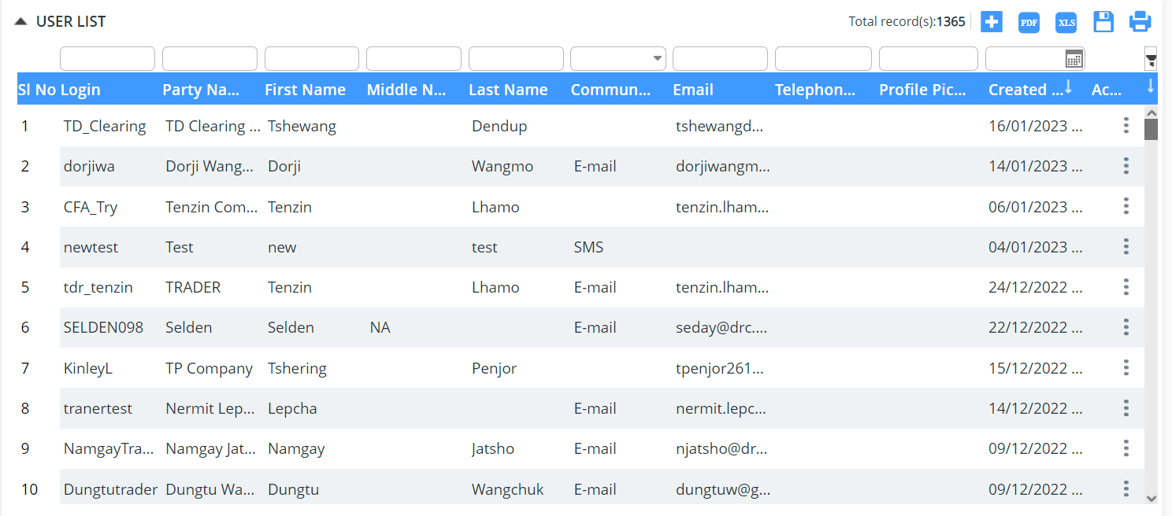
Front end User List Search Page
- Enter any one of the search criteria to view the user details. Following are the field and button descriptions of the Search User page.
Field/Button description | Action/Input Required
Login ID | Enter the Login ID of the user.
Party Name | Enter the party name of the user.
First Name
Last name
Communication Mode | Enter communication mode of the user.
E-mail | Enter the email ID of the user.
Telephone Number | Enter the telephone number.
Created date | Date of creating of the user.

@ | - If you do not know the complete search phrase (words) for any criterion, enter partial search phrase (words) and click the Search icon.  - To get an exact search result, you must enter the following search criteria:  - Login ID  - Name  - Telephone Number
- Enter the search criteria and Click icon to view the matching results in the Search Results Page.

User List Search Result Page

Viewing FRONT END User Details
This functionality allows the Company Admin to view the user details.
To view the Front-End user details:
- From the search results, click the  icon to view the personal details of front-end user. The following screen will be displayed.
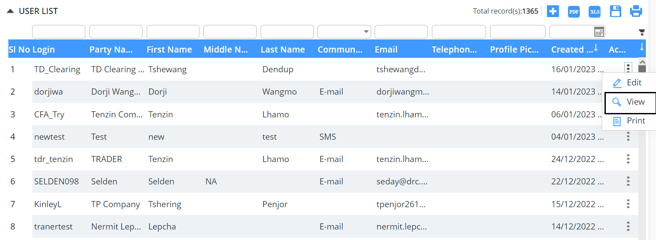
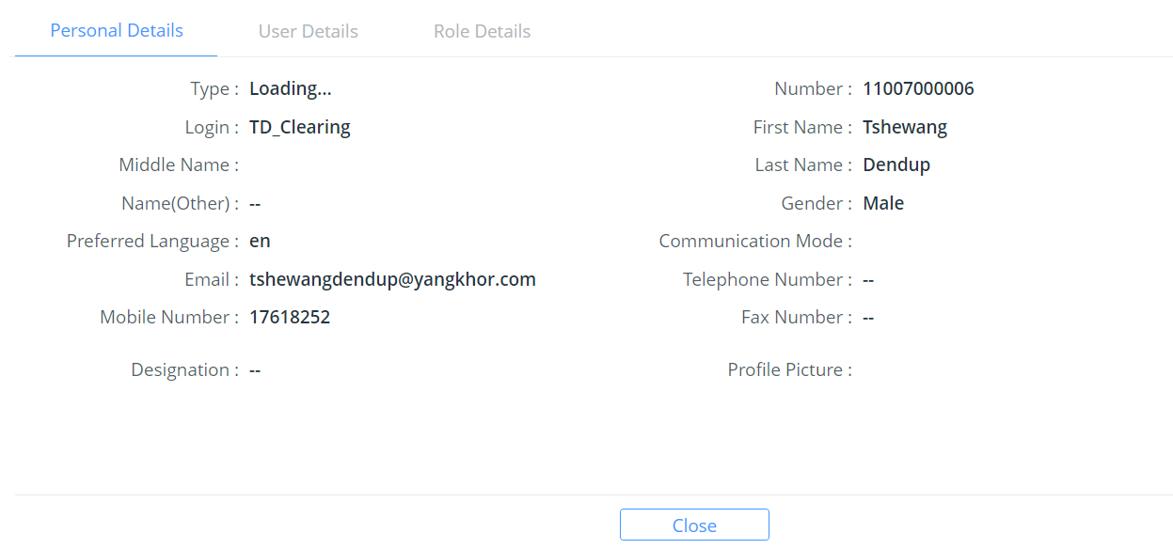
Personal Details Tab

- Click User Details tab to view the user details.
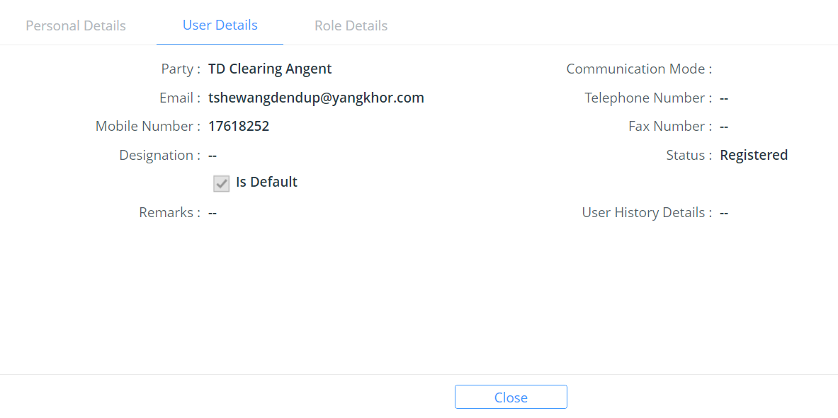
User Details Tab
- Click Role Details tab to view the user role details.
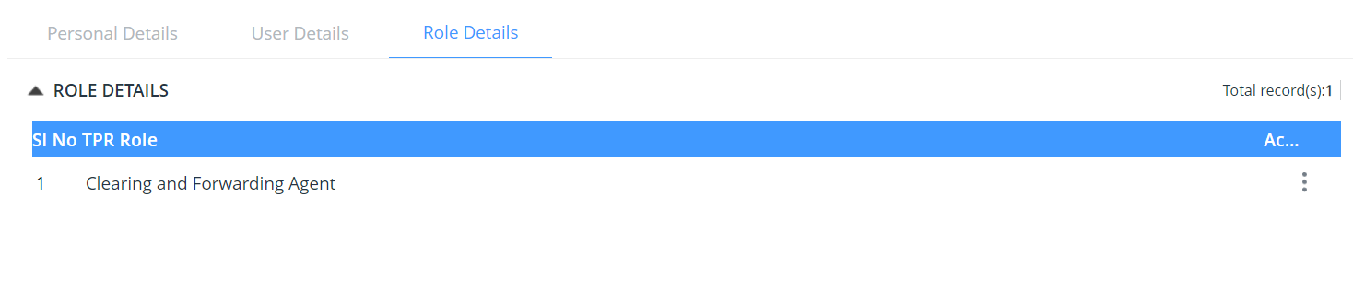
Role Details Page
- Click the  icon to view the user roles.
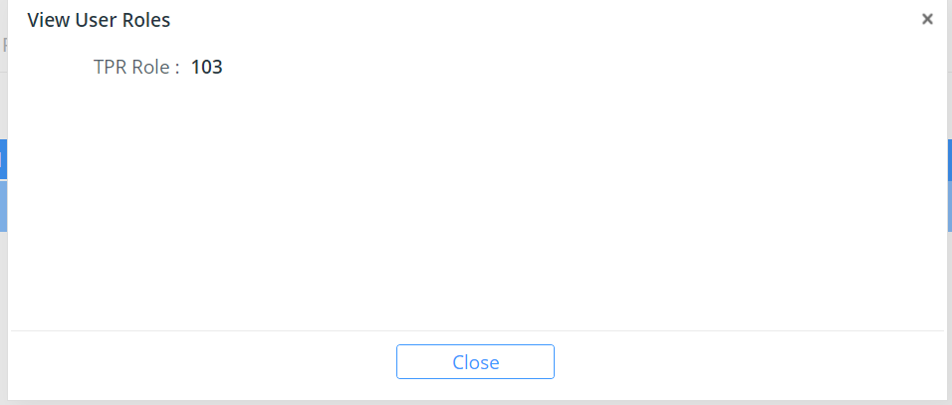
View User Role Details Page
- Click the  icon to print preview the user details.
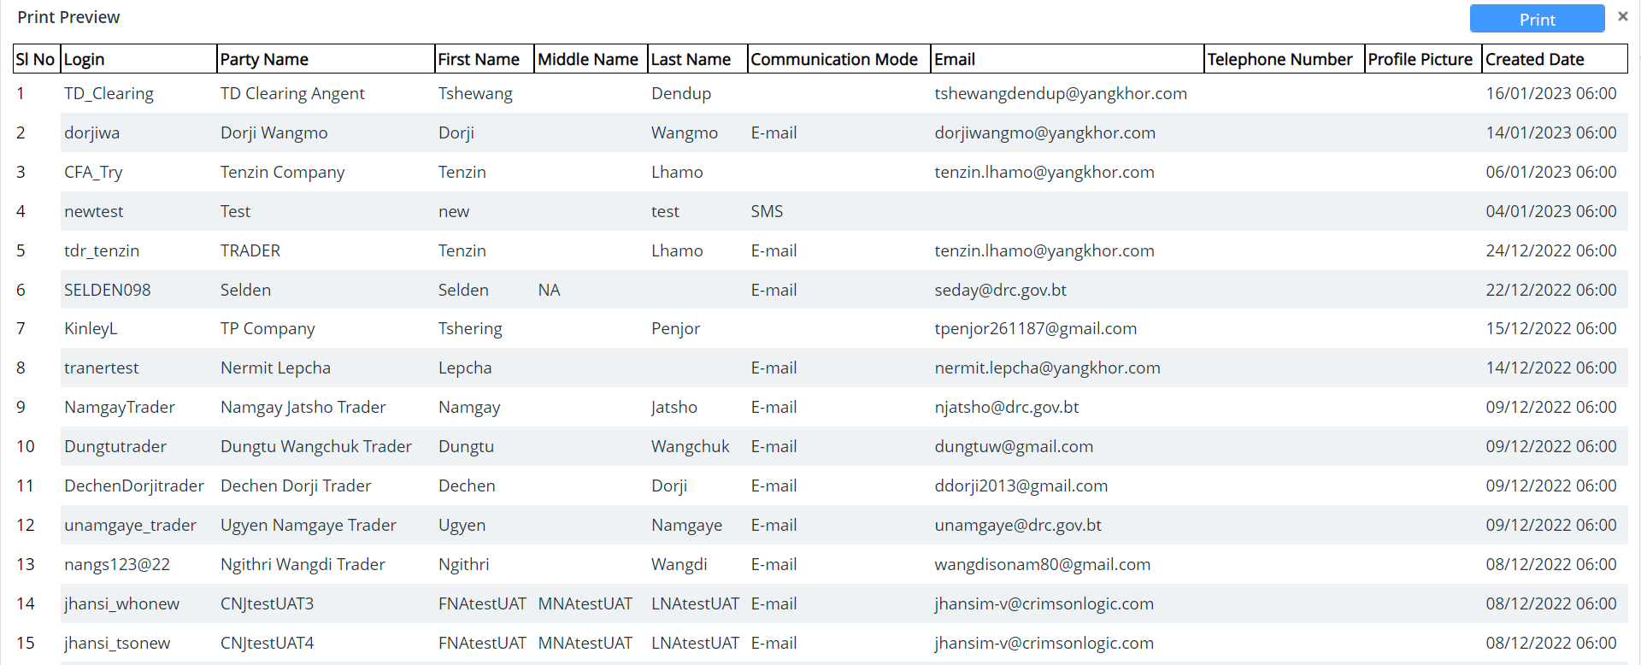
Print Preview Details Page

Updating FRONT END User Details
This section allows the Company Admin to search and edit the users in the TFB system.
To update the front-end user:
- Click Registration >> Front end users. The subsequent screen will be displayed.

Front end user List Search Page
- From search result, click the  edit icon to update the user details. The following screen will be displayed.
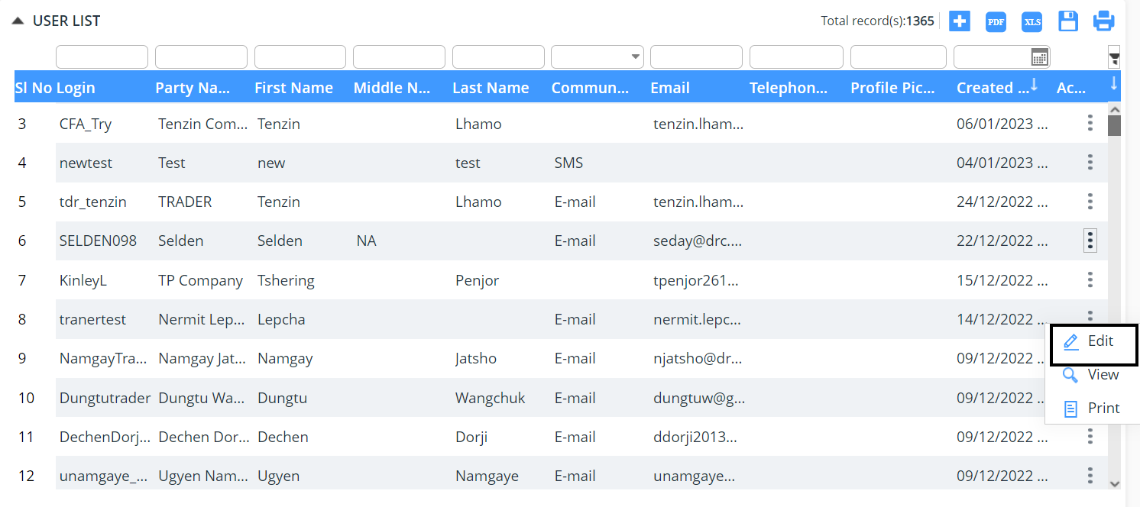
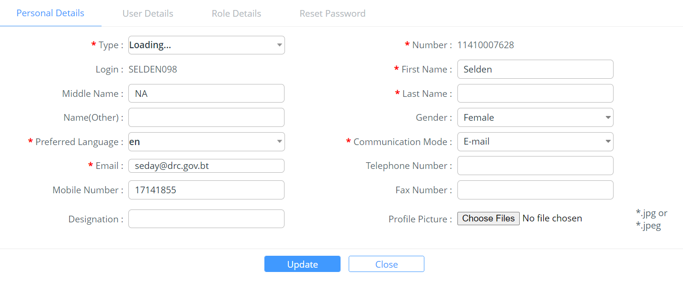
Personal Details Edit Tab
- Modify the field values and click Upodate button.
- Click Close button to close the confirmation message.

Chapter 7- Code Maintenance
This functionality allows the eCMS Admin to create and update the codes for the respective modules.

Active Type
The System Administrator creates and updates the Active type.
To create an Active type
- Click Code Maintenance >> Active Type. The subsequent screen will be displayed.
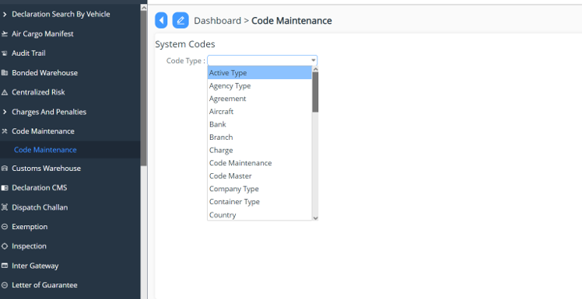
System Code Page

- Select Code Type ‘Active Type’ from the drop-down list. And click to add in the Active type and Save to save the added details:
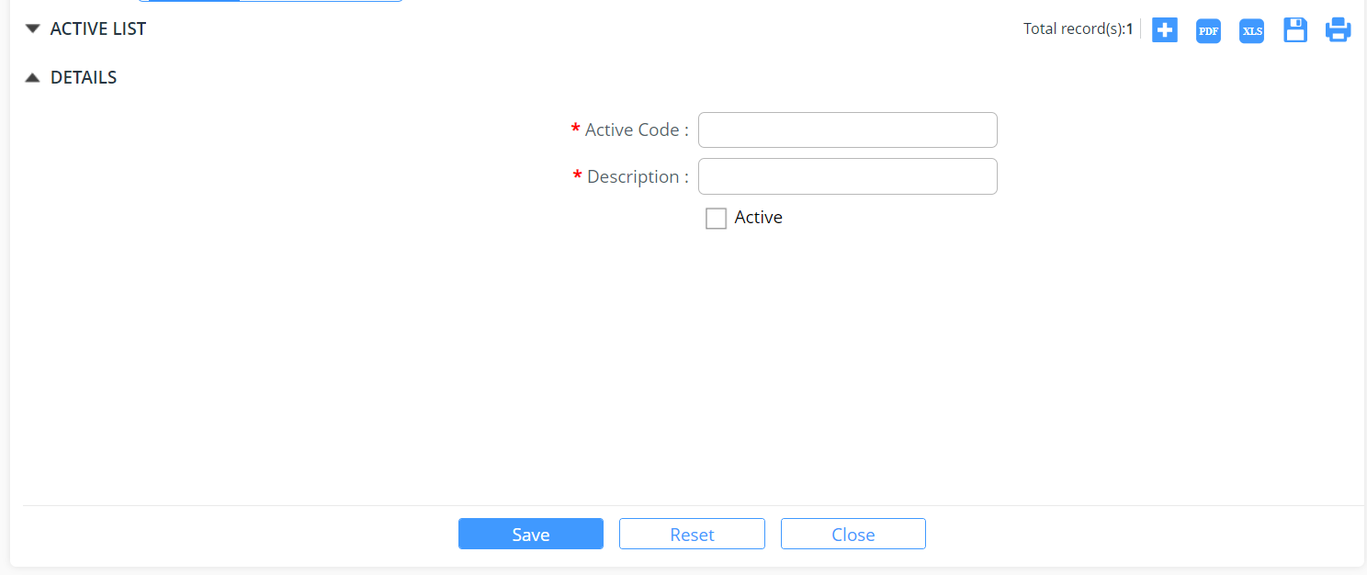

- Enter information in the Agent Details fields.
Field/Button description | Action/Input Required
Active Code | Enter the code of the agent.
Description(English) | Enter the description of the agent.
Active | Check Active to activate the agent code.

- Click Close button in success message box to continue.
- Click Reset button to clear the details.
- For Update click on the list you want to update and then add the details and Click on Update.

Agency Type
The System Administrator creates and updates the Agency Type
To create an Agency Type:
- Click Code Maintenance >> Agency Type. The subsequent screen will be displayed.
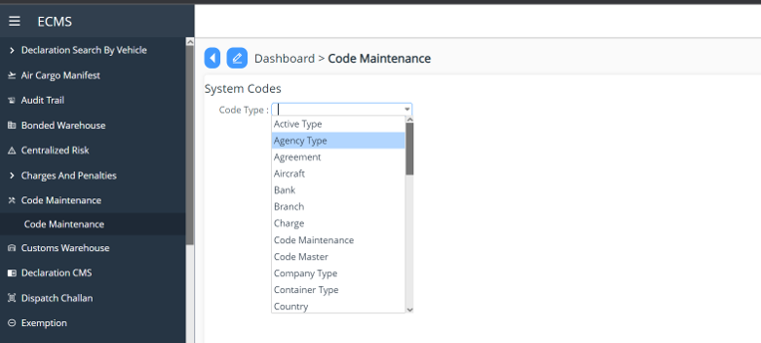
- Select Code Type ‘Active Type’ from the drop-down list. And click to add in the Active type and Save to save the added details:

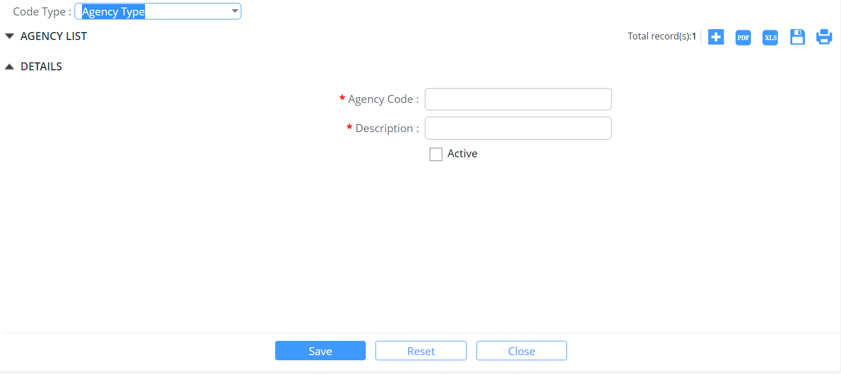
- Enter information in the Agent Details fields.
Field/Button description | Action/Input Required
Agency Code | Enter the code of the agent.
Description (English) | Enter the description of the agent.
Active | Check Active to activate the agent code.

- Click Close button in success message box to continue.
- Click Reset button to clear the details.
- For Update click on the list you want to update and then add the details and Click on Update.

Agreement Code
The System Administrator creates and updates the Agreement code.
To create an Agreement:
- Click Code Maintenance >> Agreement Code. The subsequent screen will be displayed.

System Code Page

- Select Code Type ‘Agreement’ from the drop-down list.
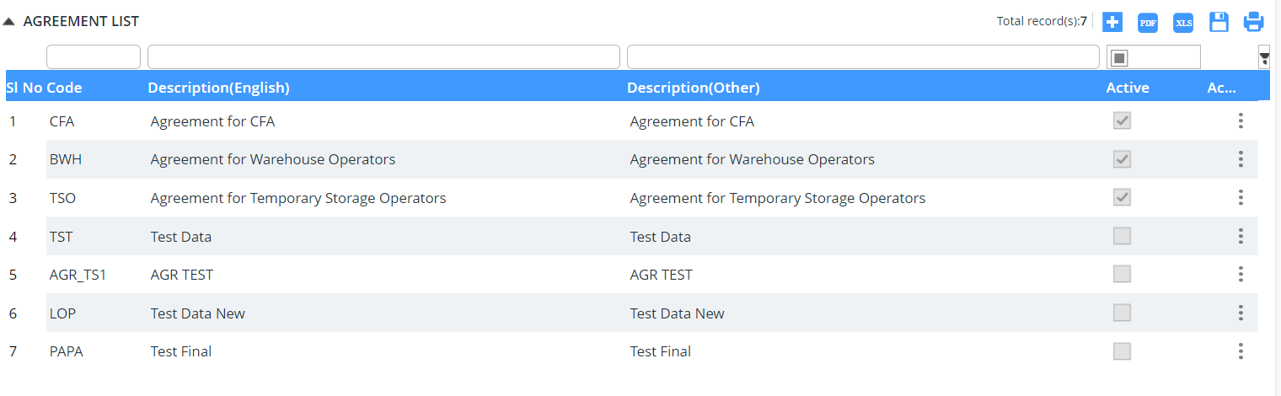
Agreement List

- Click  icon to create a new Agreement Code.
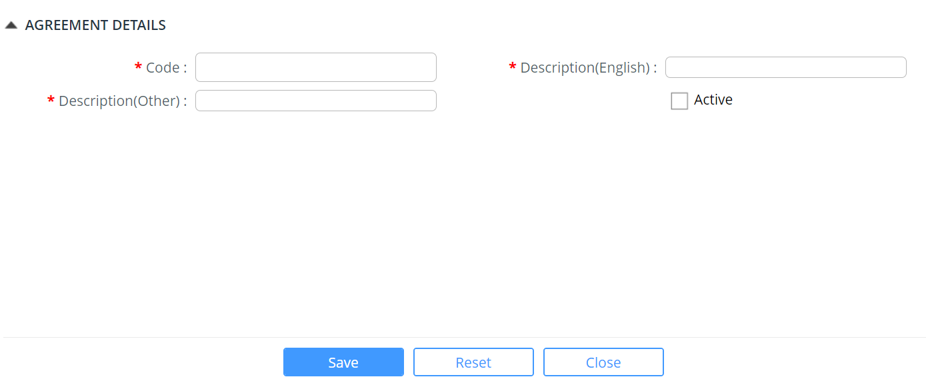
Agreement Details Page
- Enter information in the Agreement Details fields.
Field/Button description | Action/Input Required
Code | Enter the code of the agreement.
Description (English) | Enter the description of the agreement.
Description (Other) | Enter other descriptions of the agreement.
Active | Check Active to activate the agreement code.

- Click Save button to save the agreement details.
- Click Ok button in success message box to continue.
- Click Reset button to clear the agreement details.
- Click Close button to close the agreement details page.
Update Agreement
This functionality allows you to update the agreement details.
To update an Agreement:
- Click Code Maintenance >> Agreement. The subsequent screen will be displayed.

System Codes page
- Select Code Type ‘Agreement’ from the drop-down list.

Agreement List
- Click the edit icon to update the agreement details. The following screen will be displayed
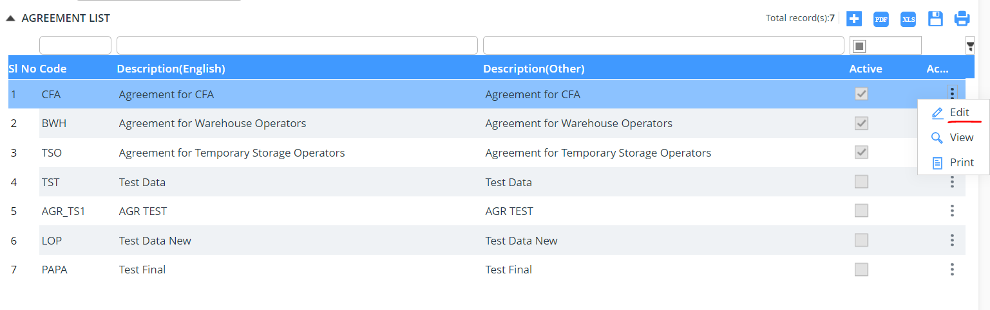
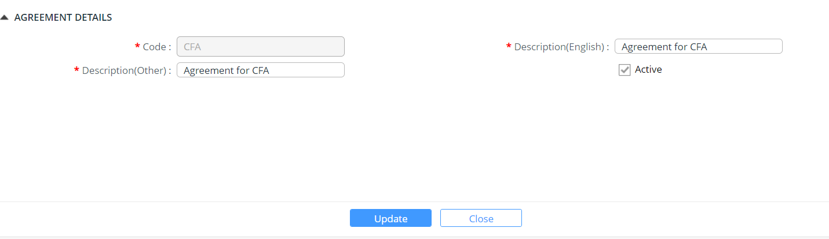
Agreement Details Edit Page

- Modify the field values and click  button.
- Click Close button to close the agreement details edit page.

Aircraft
The System Administrator creates and updates the Area code.
To create an Aircraft:
- Click Code Maintenance >> Aircraft. The subsequent screen will be displayed.
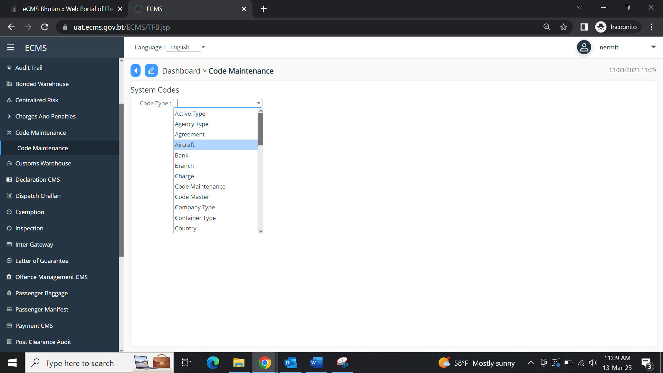
- Select Code Type ‘Aircraft from the drop-down list.

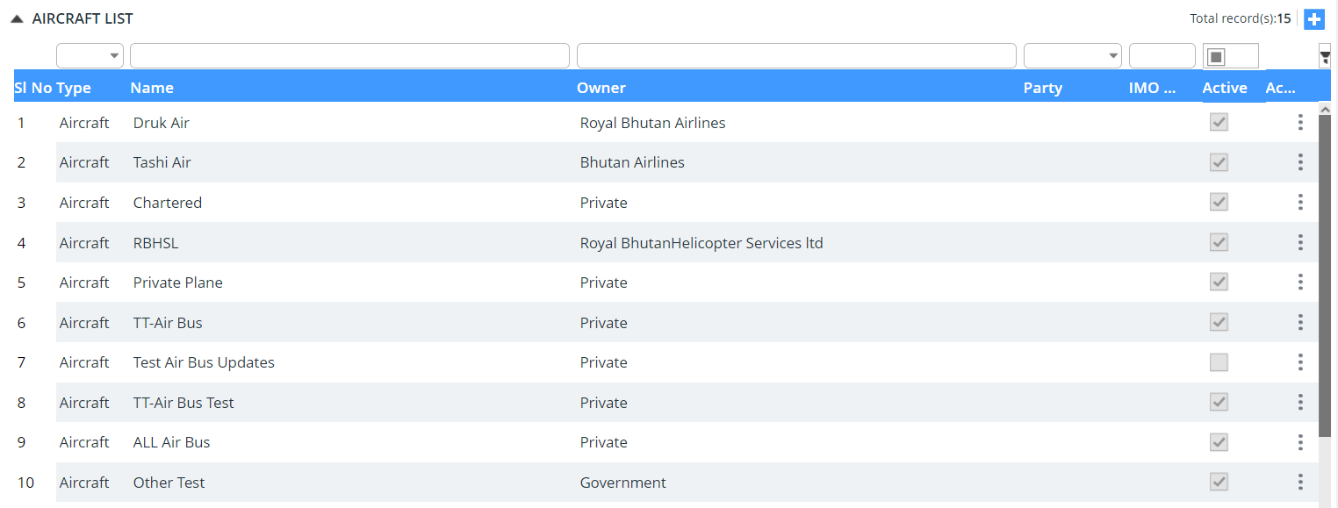
- Click  icon to create a new Aircraft.
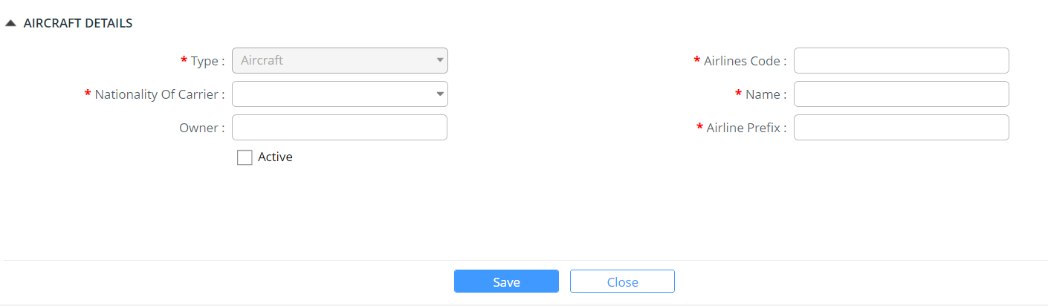

- Enter information in the Aircraft fields.
Field/Button description | Action/Input Required
Type | Aircraft gets auto populated
Airlines Code | Enter the description of the area.
Nationality of Carrier | Enter other descriptions of the area.
Name | Check Active to activate the area code.
Owner
Airline Prefix
Active status

- Click Save button to save the aircraft details.
- Click Ok button in success message box to continue.
- Click Reset button to clear the area details.
- Click Close button to close the area details page.
Update Aircraft
This functionality allows you to update the area details.
To update an Aircraft:
- Click Code Maintenance >> Aircraft.
- Select Code Type ‘Aircraft’ from the drop-down list.
- Click the edit icon to update the area details. The following screen will be displayed.
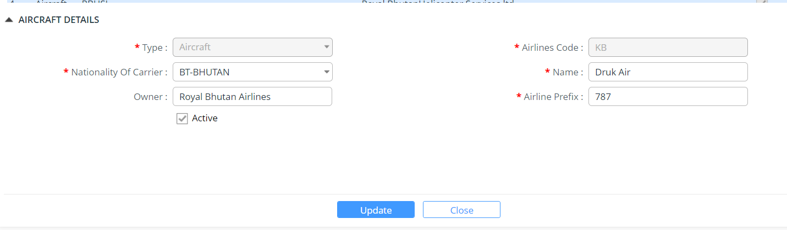
- Modify the field values and click  button.
- Success Message pops up.
- Click Close button to close the area details edit page.

Bank
The System Administrator creates and updates the Arms code.
To create a Bank:
- Click Code Maintenance >> Bank. The subsequent screen will be displayed.
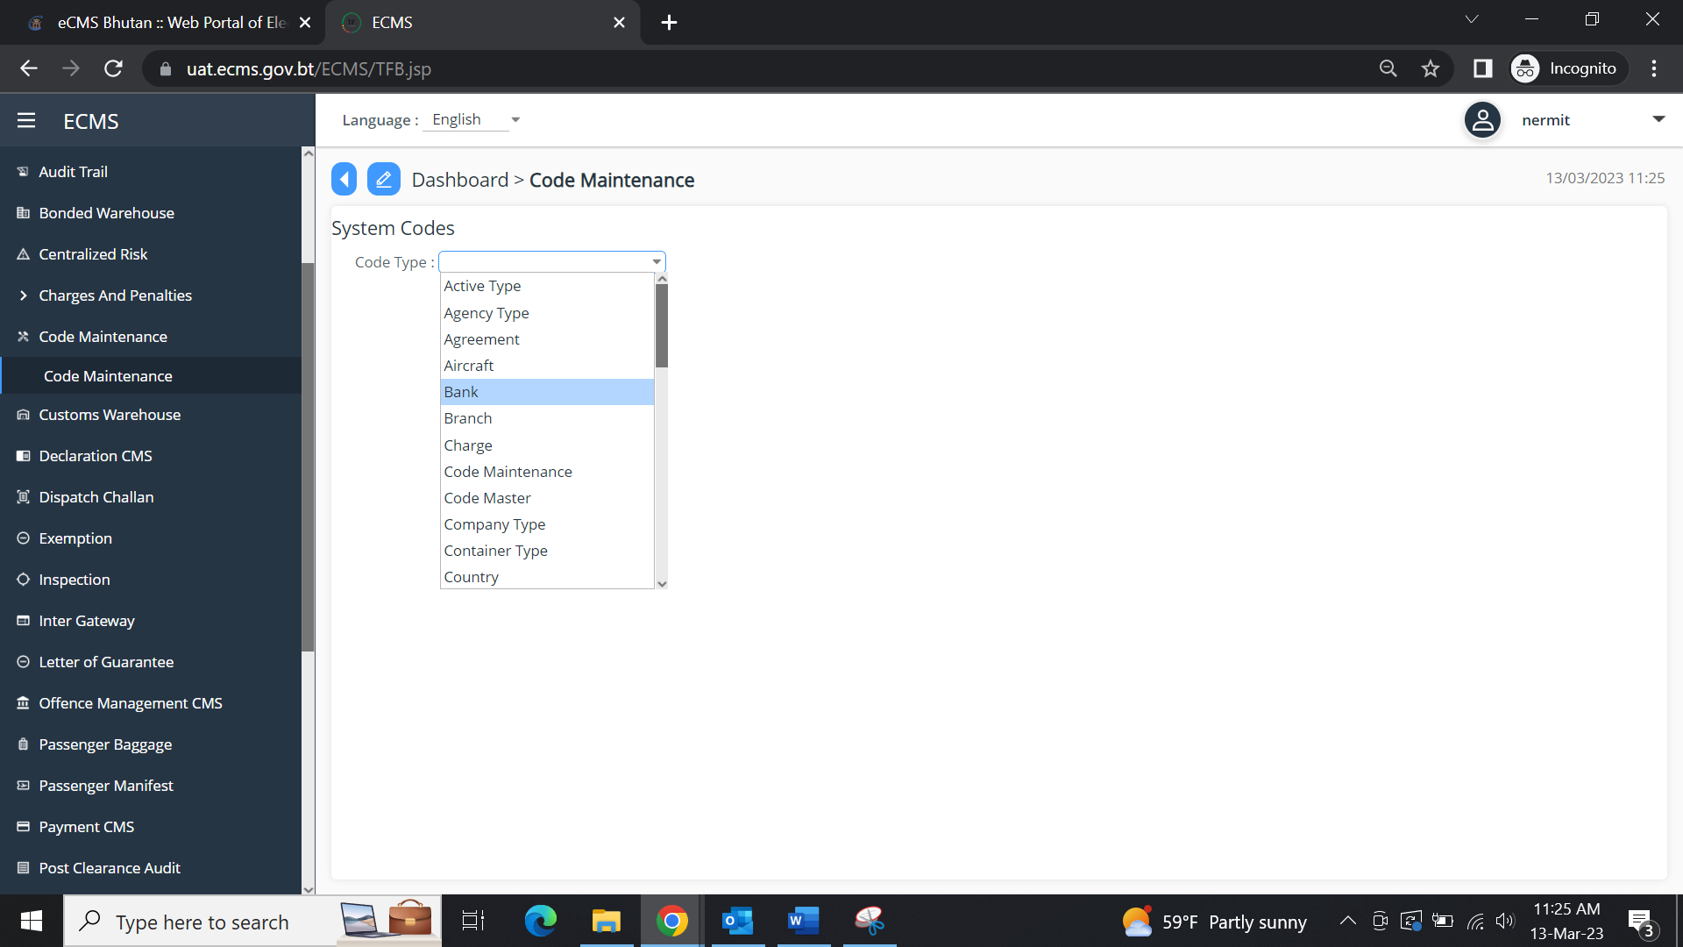
- Select Code Type ‘Bank’ from the drop-down list.
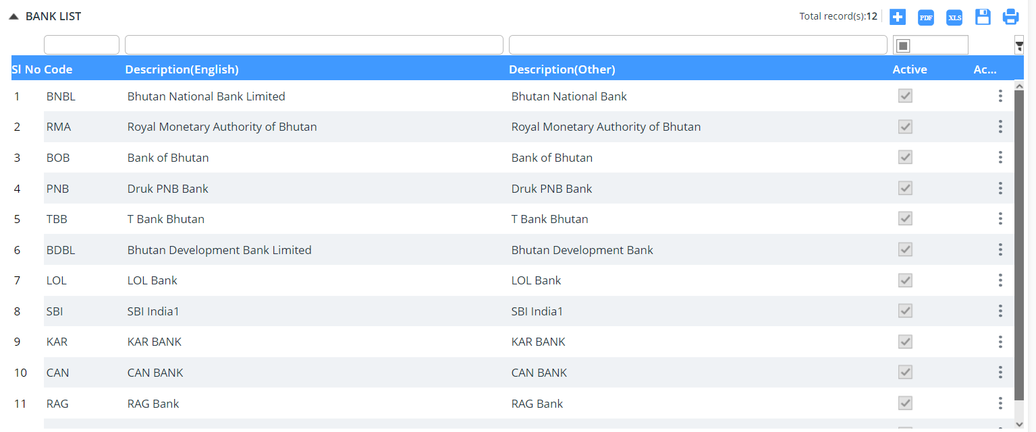
- Click  icon to create a new Bank.
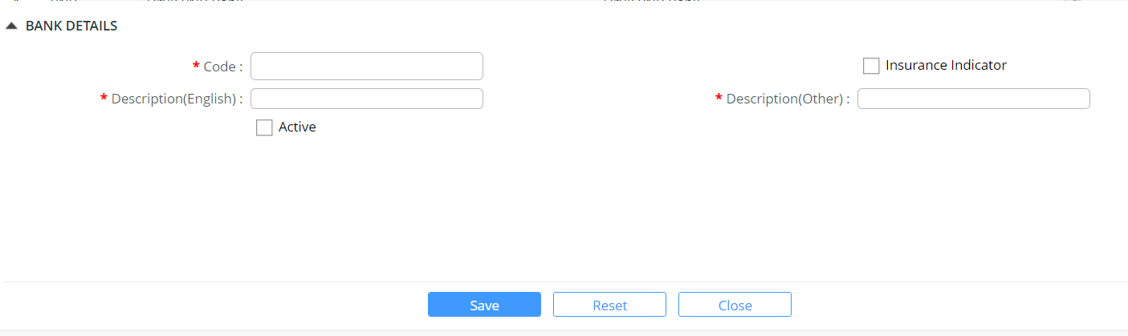
- Enter information in the Bank Details fields.
Field/Button description | Action/Input Required
Code | Enter the code of the arms.
Insurance Indicator
Description(English) | Enter the description of the arms.
Description(Other) | Enter other descriptions of the arms.
Active | Check Active to activate the arms code.

- Click Save button to save the bank details.
- Click Ok button in success message box to continue.
- Click Reset button to clear the arms details.
- Click Close button to close the arms details page.
Update Bank
This functionality allows you to update the arms details.
To update a bank:
- Click Code Maintenance >> Bank
- Select Code Type ‘Arms’ from the drop-down list.
- Click the edit icon to update the arms details. The following screen will be displayed:
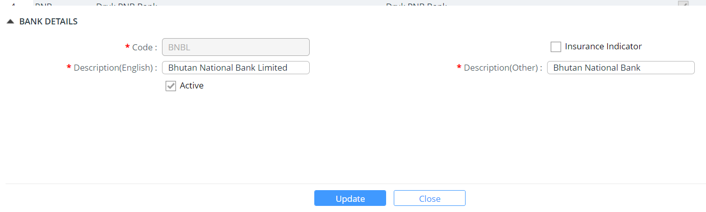
- Modify the field values and click  button. The data gets updated.
- Click Close button to close the bank details edit page.

Branch
The System Administrator creates and updates the Branch.
To create a Bank:
- Click Code Maintenance >> Branch. The subsequent screen will be displayed:
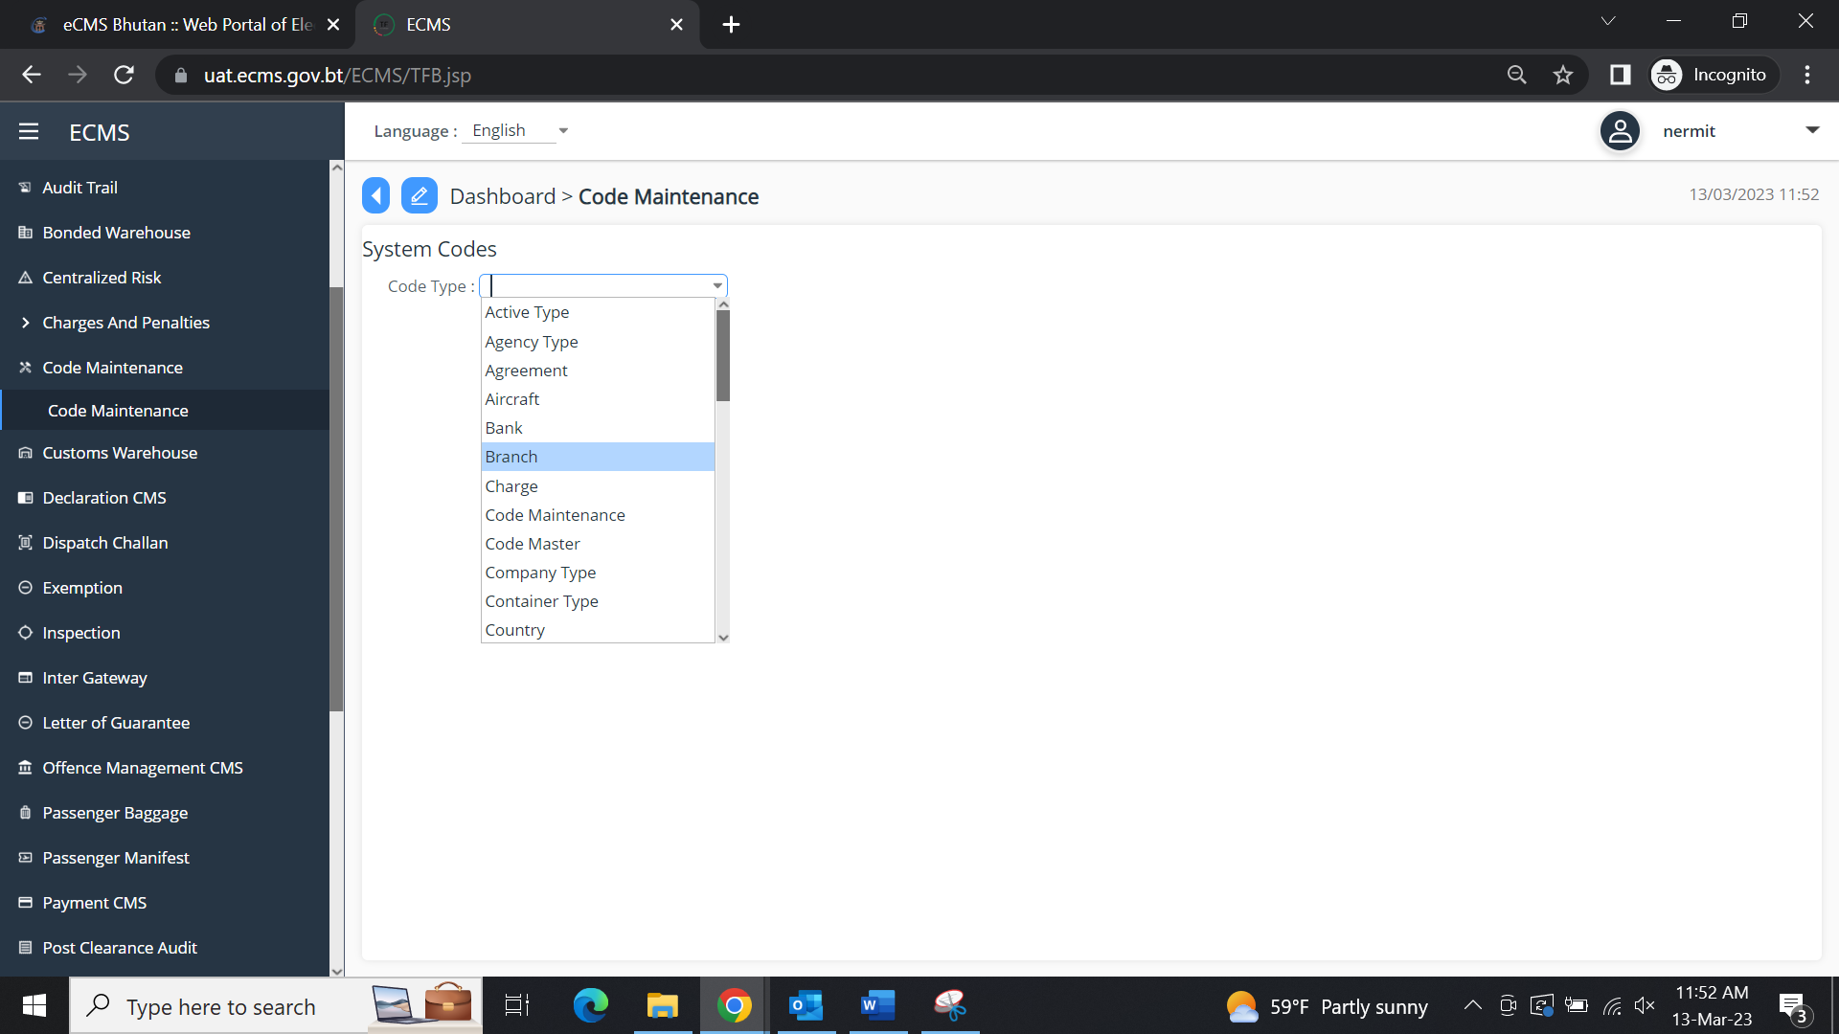

- Select Code Type ‘Branch’ from the drop-down list:
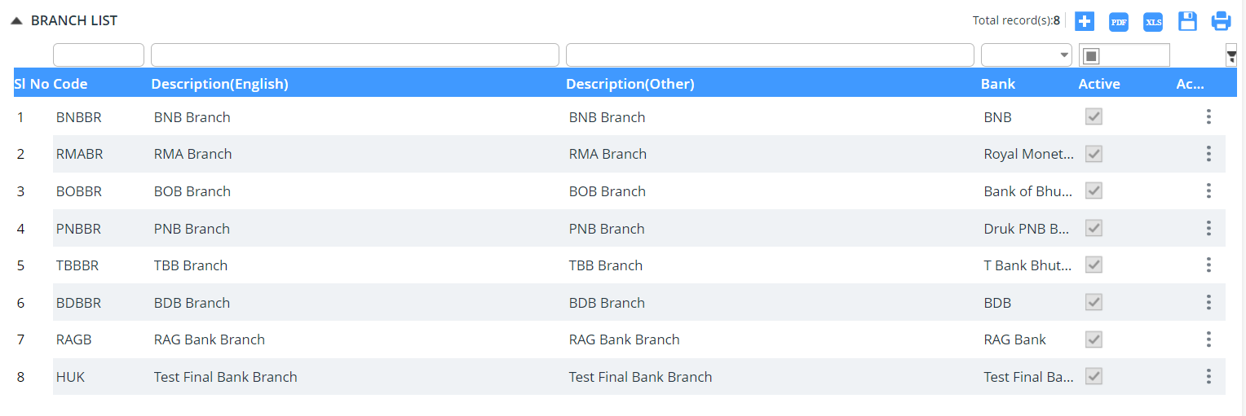
- Click  icon to create a new Branch Code.
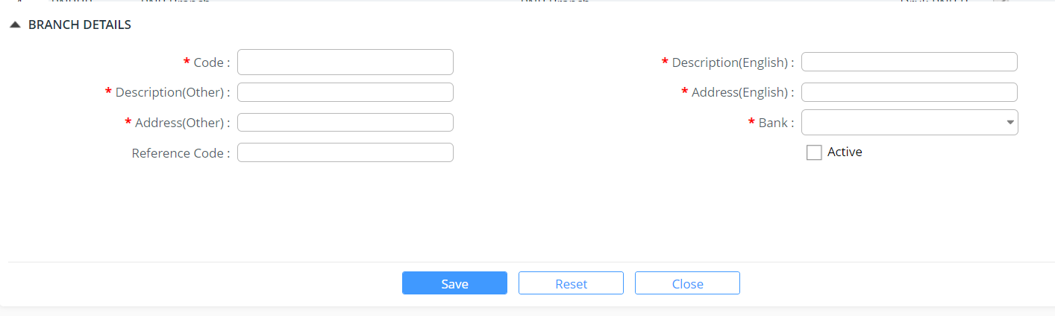
- Enter information in the Branch Details fields.
Field/Button description | Action/Input Required
Code | Enter the code of the bank.
Description (English) | Enter the description of the bank.
Description (Other) | Enter other descriptions of the bank.
Address (English)
Address (Other)
Bank
Reference Code
Active | Check Active to activate the bank code.

- Click Save button to save the bank details.
- Click Ok button in success message box to continue.
- Click Reset button to clear the bank details.
- Click Close button to close the bank details page.
Update Branch
This functionality allows you to update the bank details.
To update a Branch:
- Click Code Maintenance >> Branch Code. The subsequent screen will be displayed.
- Select Code Type ‘Branch’ from the drop-down list.
- Click the item to update the branch details. The following screen will be displayed:
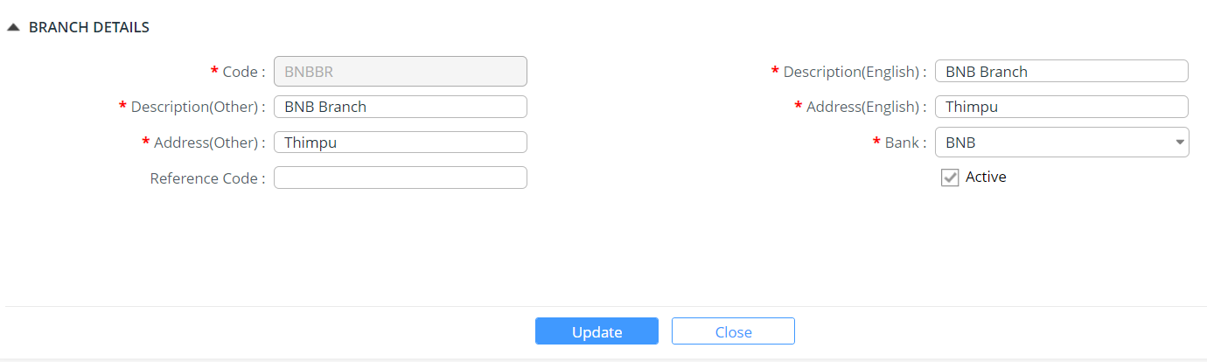
- Modify the field values and click  button and the success message pops in.
- Click Close button to close the bank details edit page.

Charge
The System Administrator creates and updates the Berth code.
To create a charge:
- Click Code Maintenance >> Charge. The subsequent screen will be displayed:
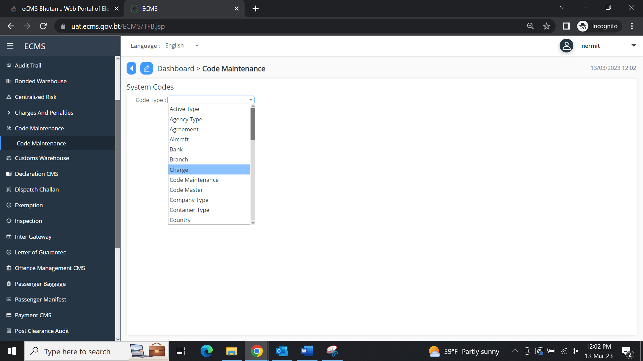
- Select Code Type ‘Charge’ from the drop-down list:
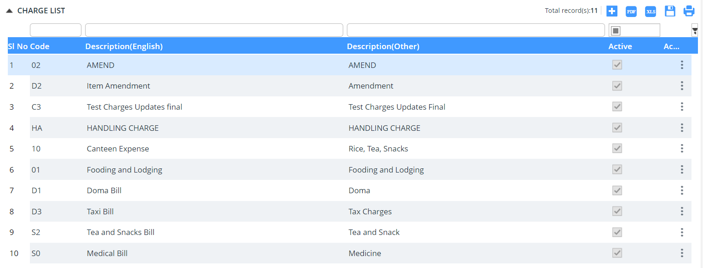
- Click  icon to create a new Charge Code.
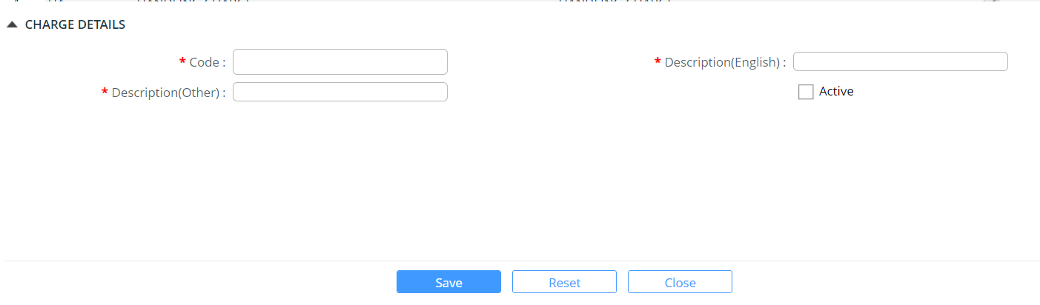
- Enter information in the Berth Details fields.
Field/Button description | Action/Input Required
Code | Enter the code of the berth.
Description (English) | Enter the description of the berth.
Description (Other) | Enter other descriptions of the berth.
Active | Check Active to activate the berth code.

- Click Save button to save the berth details. Success Message pops up.
- Click Ok button in success message box to continue.
- Click Reset button to clear the berth details.
- Click Close button to close the berth details page.

Update Charge
This functionality allows you to update the berth details.
To update a Charge:
- Click Code Maintenance >> Charge.
- Select Code Type ‘Berth’ from the drop-down list.
- Click the item to edit and update the charge details. The following screen will be displayed:
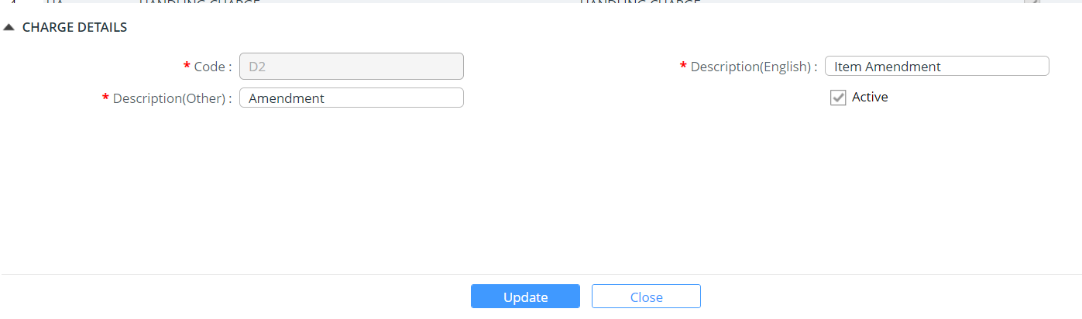
- Modify the field values and click  button.
- Click Close button to close the berth details edit page.

Code maintenance
The System Administrator creates and updates the code maintenance.
To create a code maintenance data:
- Click Code Maintenance >> Code Maintenance. The subsequent screen will be displayed:
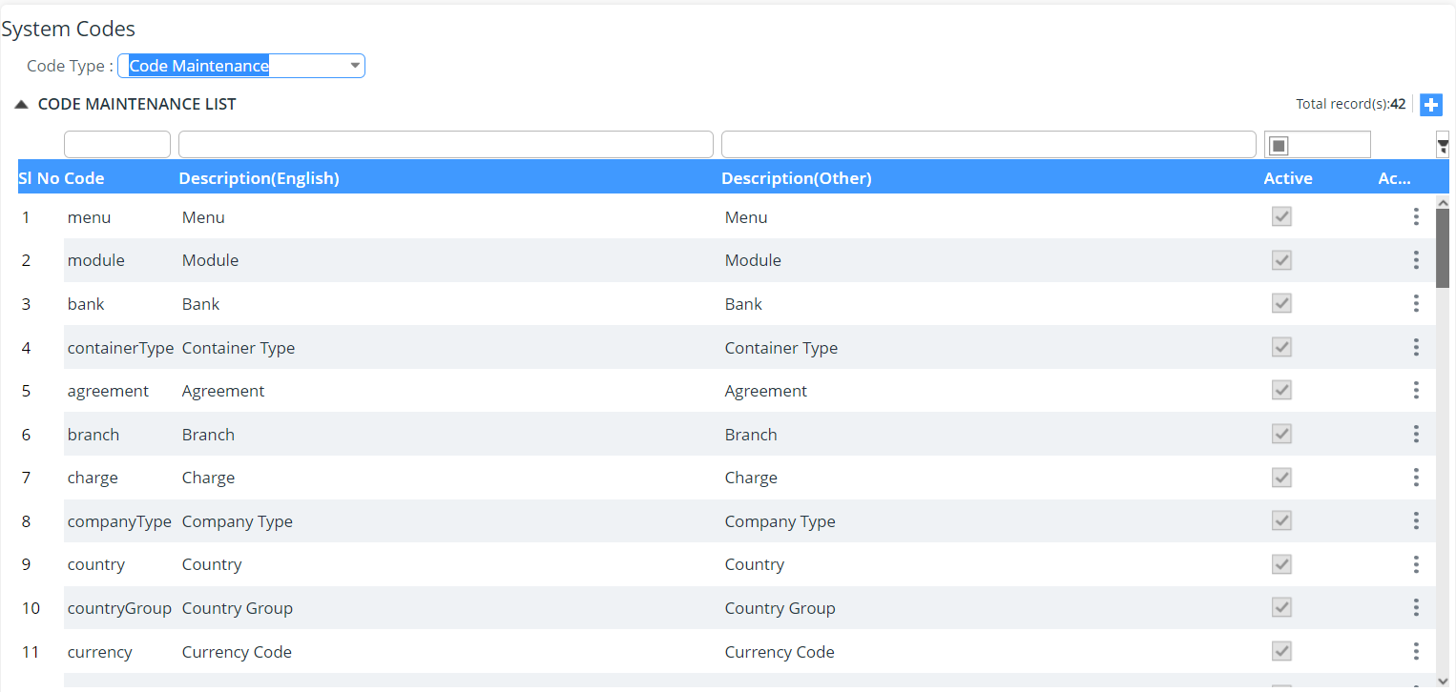
- Select Code Type ‘Code Maintenance’ from the drop-down list as shown above.
- Click  icon to create a new Code maintenance:
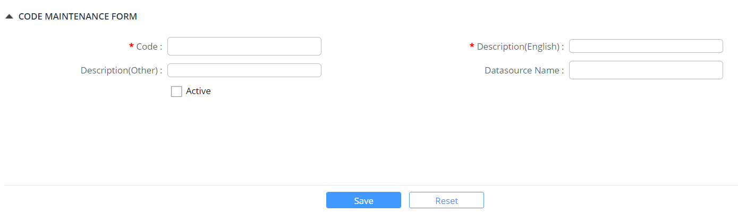
- Enter information in the Berth Details fields.
Field/Button description | Action/Input Required
Code | Enter the code of the code maintenance.
Description (English) | Enter the description of the code maintenance.
Description (Other) | Enter other descriptions of the code maintenance.
Data source name
Active | Check Active to activate the code maintenance code.

- Click Save button to save the code maintenance details. Success Message pops up.
- Click Ok button in success message box to continue.
- Click Reset button to clear the code maintenance details.
- Click Close button to close the code maintenance details page.

Update Charge
This functionality allows you to update the code maintenance details.
To update a Charge:
- Click Code Maintenance >> Code Maintenance.
- Select Code Type ‘code maintenance’ from the drop-down list.
- Click the item to edit and update the charge details. The following screen will be displayed:
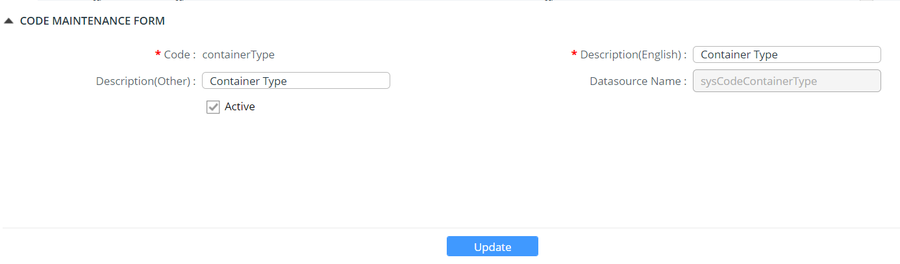
- Modify the field values and click  button.
- Click Close button to close the code maintenance details edit page.

Code Master
The System Administrator creates and updates the code master.
To create a code master data:
- Click Code Maintenance >> Code Master. The subsequent screen will be displayed:
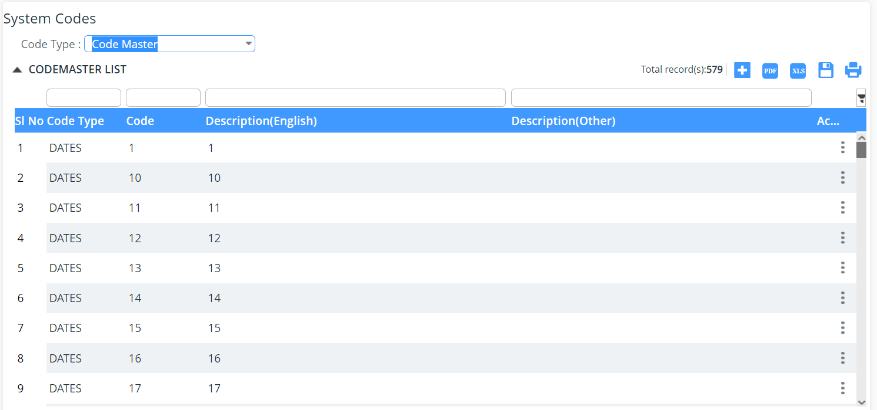

- Select Code Type ‘Code master from the drop-down list as shown above.
- Click  icon to create a new Code Master:
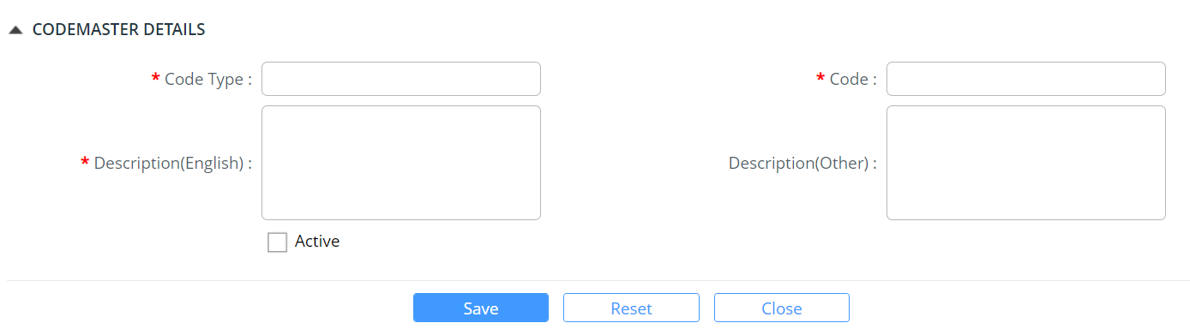
- Enter information in the code master Details fields.
Field/Button description | Action/Input Required
Code | Enter the code of the code maintenance.
Description (English) | Enter the description of the code maintenance.
Description (Other) | Enter other descriptions of the code maintenance.
Active | Check Active to activate the code maintenance code.

- Click Save button to save the code maintenance details. Success Message pops up.
- Click Ok button in success message box to continue.
- Click Reset button to clear the code maintenance details.
- Click Close button to close the code maintenance details page.

Update Code Master
This functionality allows you to update the code maintenance details.
To update a Code Master:
- Click Code Maintenance >> Code Master.
- Select Code Type ‘code master from the drop-down list.
- Click the item to edit and update the charge details. The following screen will be displayed:
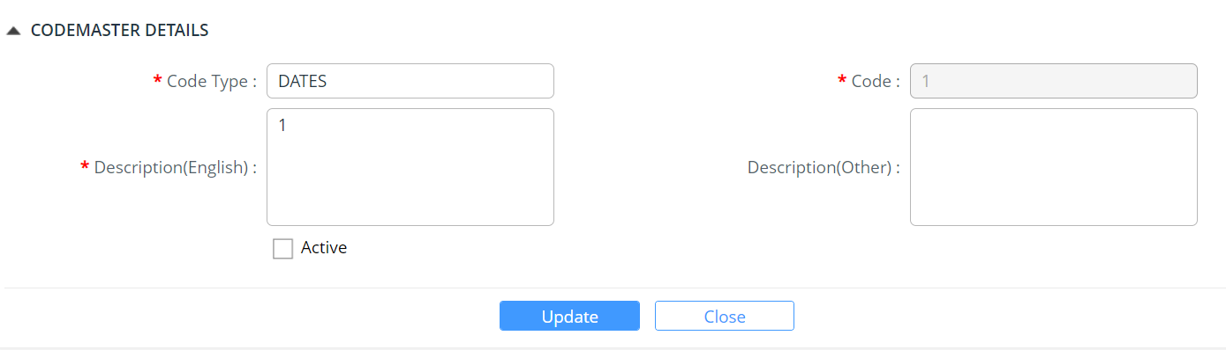
- Modify the field values and click  button.
- Click Close button to close the code master details edit page.

Company Type
The System Administrator creates and updates the company type.
To create a company type data:
- Click Code Maintenance >> Company Type. The subsequent screen will be displayed:
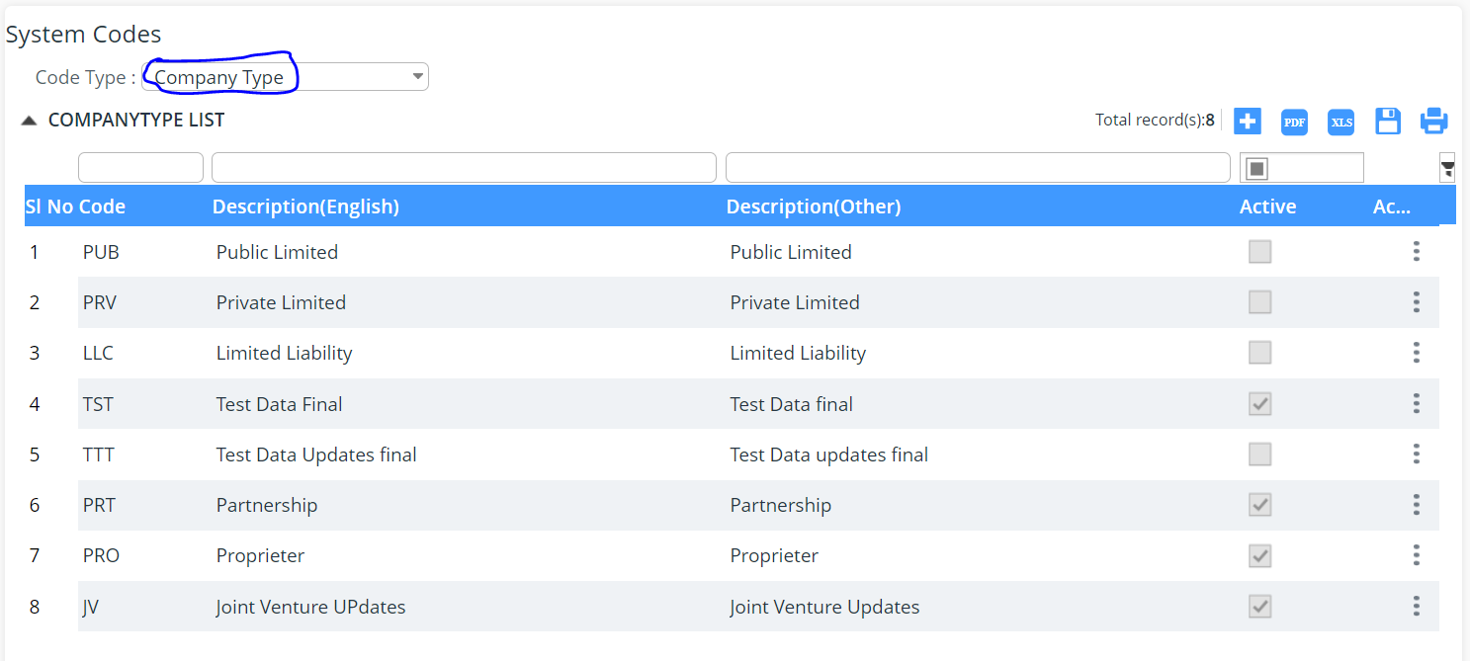
- Select Code Type ‘Company Type’ from the drop-down list as shown above.
- Click  icon to create a new Company Type:
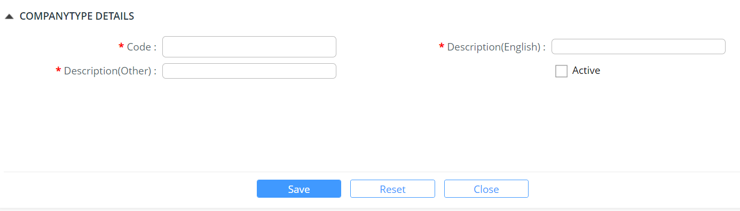
- Enter information in the company type Details fields.
Field/Button description | Action/Input Required
Code
Description (English)
Description (Other)
Active

- Click Save button to save the company type details. Success Message pops up.
- Click Ok button in success message box to continue.
- Click Reset button to clear the company type details.
- Click Close button to close the country type details page.

Update Company Type
This functionality allows you to update the company type details.
To update a Company Type:
- Click Code Maintenance >> company type.
- Select Code Type ‘company type from the drop-down list.
- Click the item to edit and update the charge details. The following screen will be displayed:
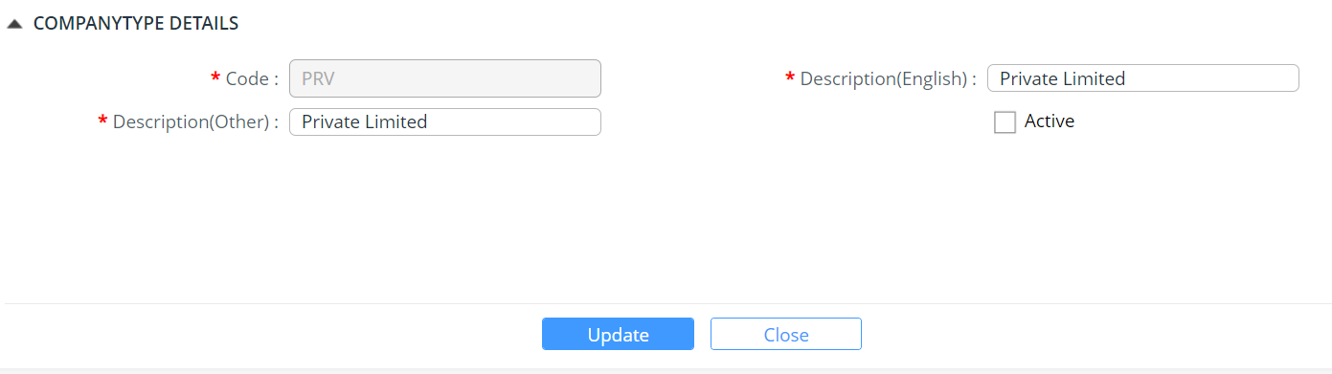

- Modify the field values and click  button.
- Click Close button to close the company type details edit page.

Container Type
The System Administrator creates and updates the company type.
To create a container type data:
- Click Code Maintenance >> Container Type. The subsequent screen will be displayed:
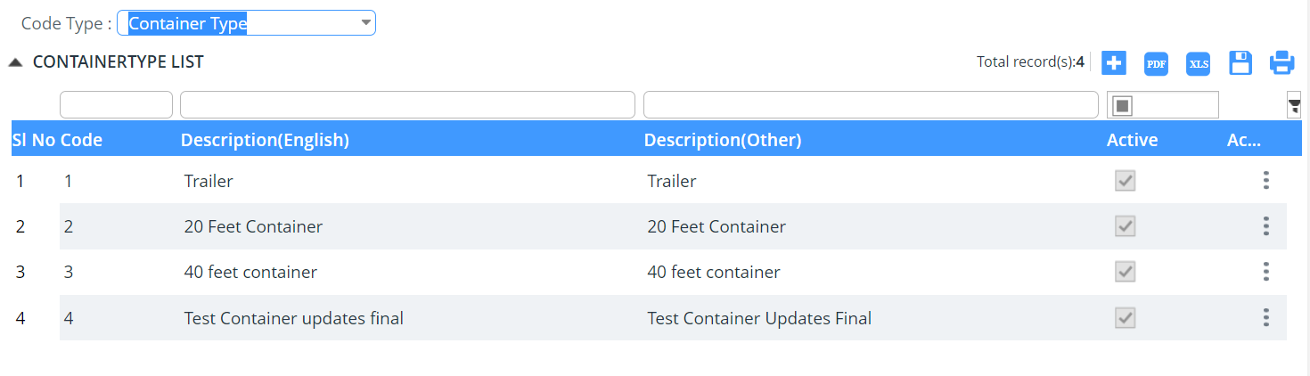
- Select Code Type ‘Container Type’ from the drop-down list as shown above.
- Click  icon to create a new Container Type:
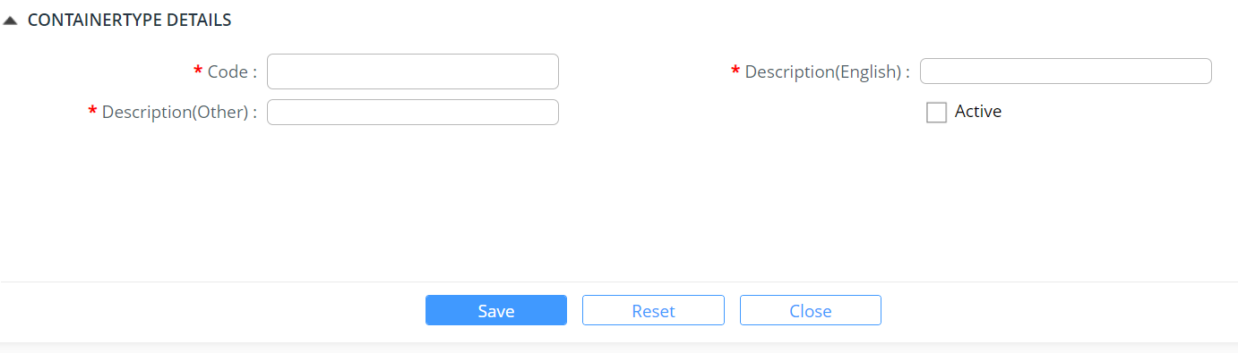
- Enter information in the container type Details fields.
Field/Button description | Action/Input Required
Code
Description (English)
Description (Other)
Active

- Click Save button to save the company type details. Success Message pops up.
- Click Ok button in success message box to continue.
- Click Reset button to clear the container type details.
- Click Close button to close the container type details page.

Update Container Type
This functionality allows you to update the container type details.
To update a Container Type:
- Click Code Maintenance >> container type.
- Select Code Type ‘container type from the drop-down list.
- Click the item to edit and update the charge details. The following screen will be displayed:
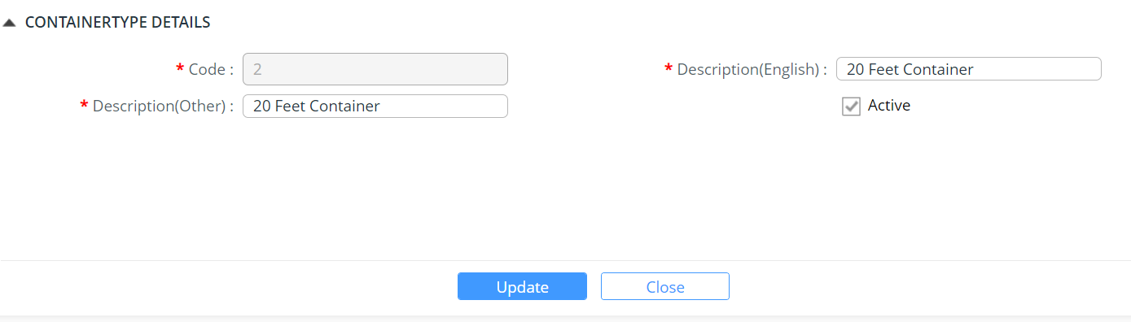

- Modify the field values and click  button.
- Click Close button to close the container type details edit page.

Country
The System Administrator creates and updates the company type.
To create a country data:
- Click Code Maintenance >> Country. The subsequent screen will be displayed:
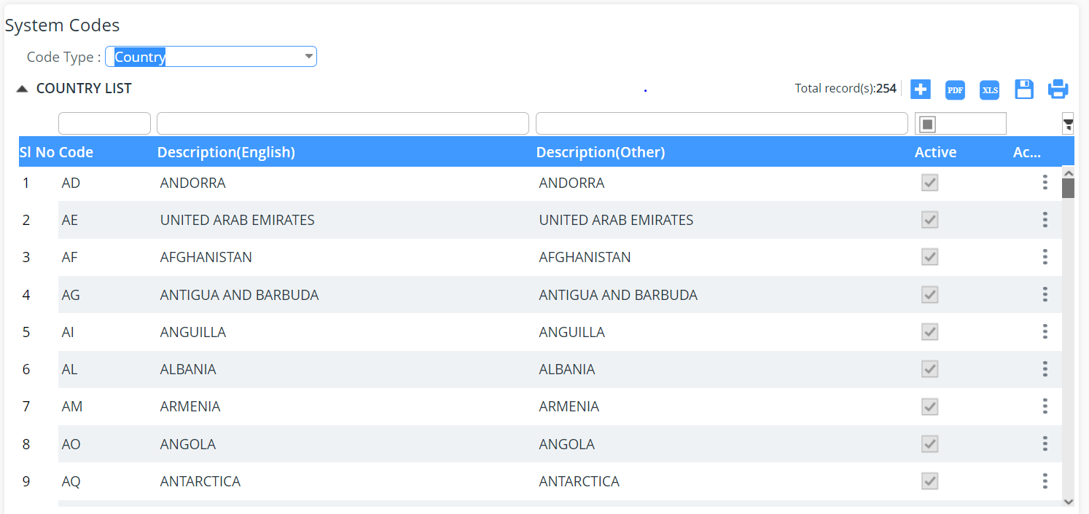
- Select Code Type ‘Container Type’ from the drop-down list as shown above.
- Click  icon to create a new Container Type:
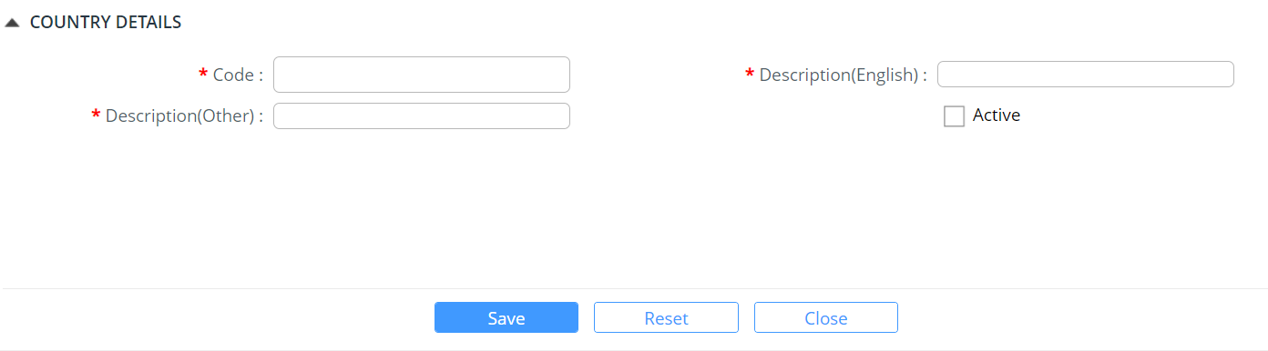
- Enter information in the country details fields.
Field/Button description | Action/Input Required
Code
Description (English)
Description (Other)
Active

- Click Save button to save the country details. Success Message pops up.
- Click Ok button in success message box to continue.
- Click Reset button to clear the country type details.
- Click Close button to close the country type details page.

Update Country
This functionality allows you to update the country type details.
To update a Country:
- Click Code Maintenance >> country.
- Select Code Type ‘country’ from the drop-down list.
- Click the item to edit and update the charge details. The following screen will be displayed:
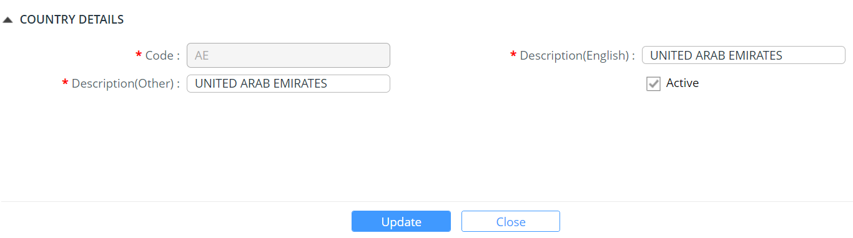
- Modify the field values and click  button.
- Click Close button to close the container type details edit page.

Currency Code
The System Administrator creates and updates the Currency code.
To create a Currency:
- Click Code Maintenance >> Code Maintenance. The subsequent screen will be displayed.
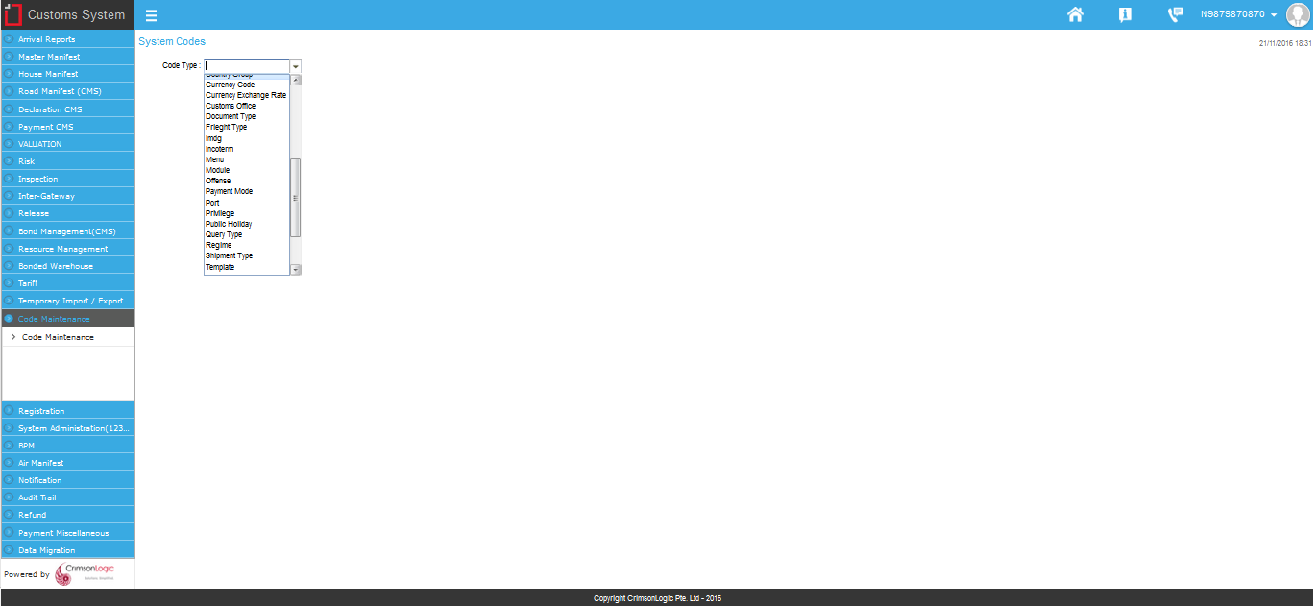
System Codes page
- Select Code Type ‘Currency’ from the drop-down list.
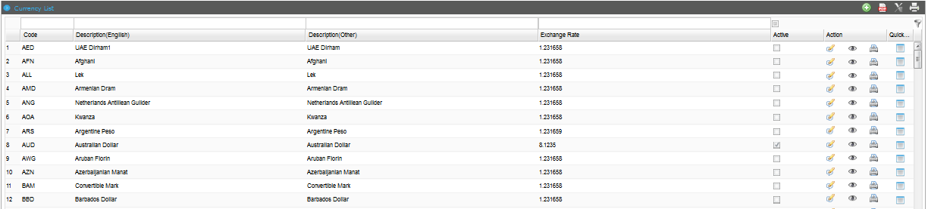
Currency List
- Click icon to create a new Currency Code.
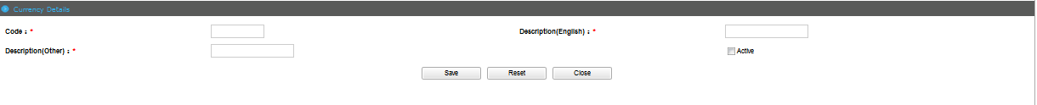
Currency Details Page
- Enter information in the Currency Details fields.
Field/Button description | Action/Input Required
Code | Enter the code of the Currency.
Description(English) | Enter the description of the Currency.
Description(Other) | Enter other descriptions of the Currency.
Active | Check Active to activate the Currency code.

- Click Save button to save the Currency details.
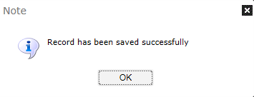
Success Message
- Click Ok button in success message box to continue.
- Click Reset button to clear the Currency details.
- Click Close button to close the Currency details page.

Update Currency
This functionality allows you to update the currency details.
To update a Currency:
- Click Code Maintenance >> Code Maintenance. The subsequent screen will be displayed.

System Codes page
- Select Code Type ‘Currency’ from the drop-down list.

Currency List
- Click the edit icon to update the Currency details. The following screen will be displayed
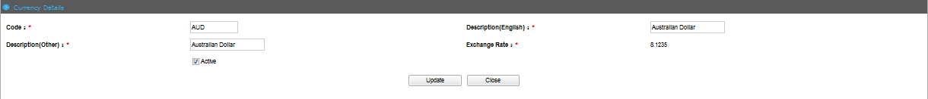
Currency Details Edit Page
- Modify the field values and click button.
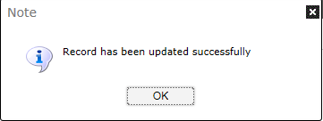
Success Message
- Click Close button to close the Currency details edit page.

Customs Office Code
The System Administrator creates and updates the Customs Office code.
To create a Customs Office:
- Click Code Maintenance >> Code Maintenance. The subsequent screen will be displayed.

System Codes page
- Select Code Type ‘Customs Office’ from the drop-down list.
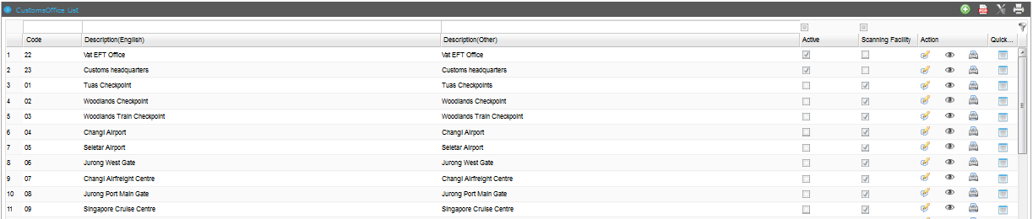
Customs Office List
- Click icon to create a new Customs Office Code.
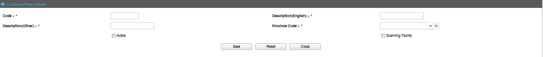
Customs Office Details Page
- Enter information in the Customs Office Details fields.
Field/Button description | Action/Input Required
Code | Enter the code of the Customs Office.
Description(English) | Enter the description of the Customs Office.
Description(Other) | Enter other descriptions of the Customs Office.
Province Code | Select the Province Code of the Customs Office.
Active | Check Active to activate the Customs Office code.
Scanning Facility | Check Scanning Facility if the Customs Office has a scanning facility.

- Click Save button to save the Customs Office details.

Success Message
- Click Ok button in success message box to continue.
- Click Reset button to clear the Customs Office details.
- Click Close button to close the Customs Office details page.

Update Customs Office
This functionality allows you to update the customs office details.
To update a Customs Office:
- Click Code Maintenance >> Code Maintenance. The subsequent screen will be displayed.

System Codes page
- Select Code Type ‘Customs Office’ from the drop-down list.

Customs Office List
- Click the edit icon to update the Customs Office details. The following screen will be displayed
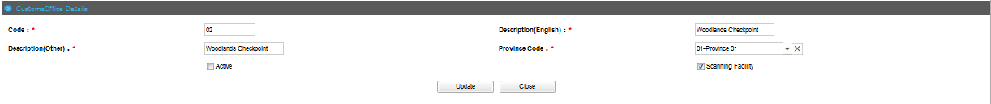
Customs Office Details Edit Page
- Modify the field values and click button.

Success Message
- Click Close button to close the Customs Office details edit page.

Document Type Code
The System Administrator creates and updates the Document Type code.
To create a Document Type:
- Click Code Maintenance >> Code Maintenance. The subsequent screen will be displayed.

System Codes page
- Select Code Type ‘Document Type’ from the drop-down list.
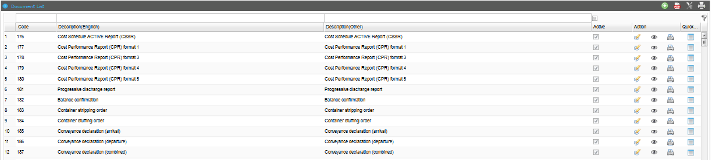
Document Type List

- Click icon to create a new Document Type Code.
Document Type Details Page
- Enter information in the Document Type Details fields.
Field/Button description | Action/Input Required
Code | Enter the code of the Document Type.
Description(English) | Enter the description of the Document Type.
Description(Other) | Enter other descriptions of the Document Type.
Active | Check Active to activate the Document Type code.

- Click Save button to save the Document Type details.

Success Message
- Click Ok button in success message box to continue.
- Click Reset button to clear the Document Type details.
- Click Close button to close the Document Type details page.

Update Document Type
This functionality allows you to update the document type details.
To update a Document Type:
- Click Code Maintenance >> Code Maintenance. The subsequent screen will be displayed.

System Codes page
- Select Code Type ‘Document Type’ from the drop-down list.

Document Type List
- Click the edit icon to update the Document Type details. The following screen will be displayed
Document Type Details Edit Page
- Modify the field values and click button.

Success Message
- Click Close button to close the Document Type details edit page.

Freight Type Code
The System Administrator creates and updates the Freight Type code.
To create a Freight Type:
- Click Code Maintenance >> Code Maintenance. The subsequent screen will be displayed.

System Codes page
- Select Code Type ‘Freight Type’ from the drop-down list.
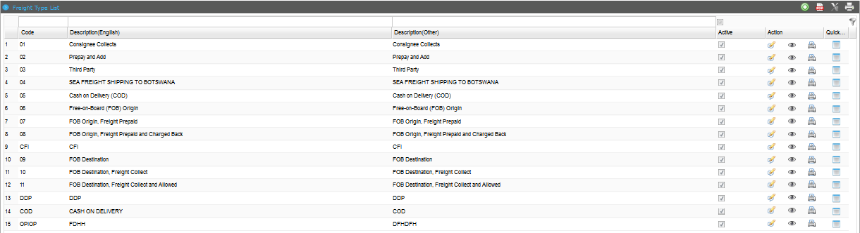
Freight Type List
- Click icon to create a new Freight Type Code.
Freight Type Details Page
- Enter information in the Freight Type Details fields.
Field/Button description | Action/Input Required
Code | Enter the code of the Freight Type.
Description(English) | Enter the description of the Freight Type.
Description(Other) | Enter other descriptions of the Freight Type.
Active | Check Active to activate the Freight Type code.

- Click Save button to save the Freight Type details.

Success Message
- Click Ok button in success message box to continue.
- Click Reset button to clear the Freight Type details.
- Click Close button to close the Freight Type details page.

Update Freight Type
This functionality allows you to update the freight type details.
To update a Freight Type:
- Click Code Maintenance >> Code Maintenance. The subsequent screen will be displayed.

System Codes page
- Select Code Type ‘Freight Type’ from the drop-down list.

Freight Type List
- Click the edit icon to update the Freight Type details. The following screen will be displayed
Freight Type Details Edit Page
- Modify the field values and click button.

Success Message
- Click Close button to close the Freight Type details edit page.

IMDG Code
The System Administrator creates and updates the IMDG code.
To create an IMDG:
- Click Code Maintenance >> Code Maintenance. The subsequent screen will be displayed.

System Codes page
- Select Code Type ‘IMDG’ from the drop-down list.
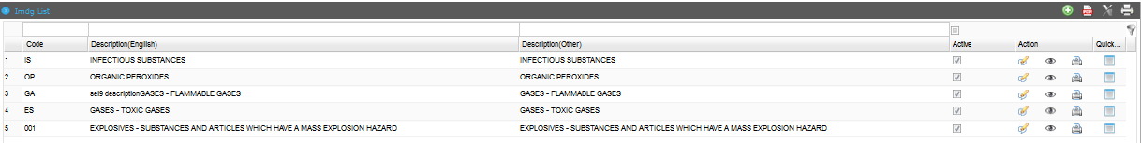
IMDG List
- Click icon to create a new IMDG Code.
IMDG Details Page
- Enter information in the IMDG Details fields.
Field/Button description | Action/Input Required
Code | Enter the code of the IMDG.
Description(English) | Enter the description of the IMDG.
Description(Other) | Enter other descriptions of the IMDG.
Active | Check Active to activate the IMDG code.

- Click Save button to save the IMDG details.

Success Message
- Click Ok button in success message box to continue.
- Click Reset button to clear the IMDG details.
- Click Close button to close the IMDG details page.

Update IMDG
This functionality allows you to update the IMDG details.
To update an IMDG:
- Click Code Maintenance >> Code Maintenance. The subsequent screen will be displayed.

System Codes page
- Select Code Type ‘IMDG from the drop-down list.

IMDG List
- Click the edit icon to update the IMDG details. The following screen will be displayed
IMDG Details Edit Page
- Modify the field values and click button.

Success Message
- Click Close button to close the IMDG details edit page.

Incoterm Code
The System Administrator creates and updates the Incoterm code.
To create an Incoterm:
- Click Code Maintenance >> Code Maintenance. The subsequent screen will be displayed.

System Codes page
- Select Code Type ‘Incoterm’ from the drop-down list.
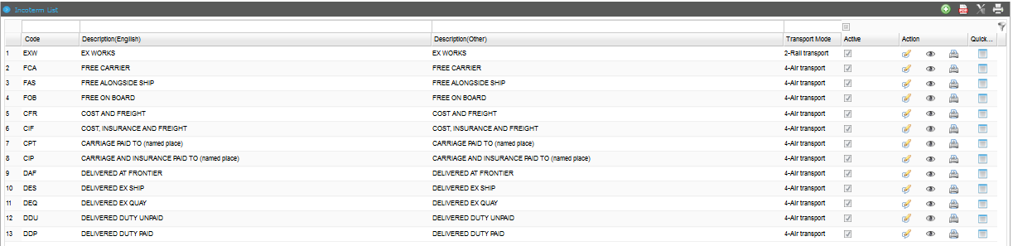
Incoterm List
- Click icon to create a new Incoterm Code.
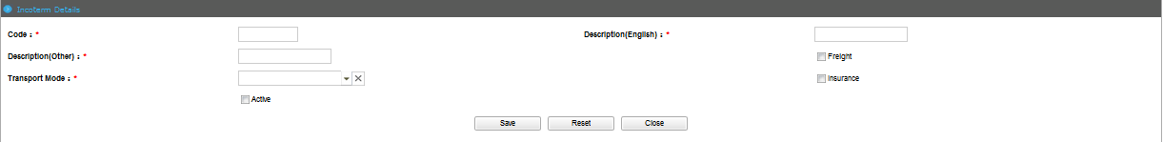
Incoterm Details Page

@ | The Transport Mode Codes should already be created.
- Enter information in the Incoterm Details fields.
Field/Button description | Action/Input Required
Code | Enter the code of the Incoterm.
Description(English) | Enter the description of the Incoterm.
Description(Other) | Enter other descriptions of the Incoterm.
Freight | Check Freight if the Incoterm allows Freight.
Transport Mode | Select the Transport Mode of the Incoterm.
Insurance | Check Insurance if the Incoterm allows Insurance.
Active | Check Active to activate the Incoterm code.

- Click Save button to save the Incoterm details.

Success Message
- Click Ok button in success message box to continue.
- Click Reset button to clear the Incoterm details.
- Click Close button to close the Incoterm details page.

Update Incoterm
This functionality allows you to update the Incoterm details.
To update an Incoterm:
- Click Code Maintenance >> Code Maintenance. The subsequent screen will be displayed.

System Codes page
- Select Code Type ‘Incoterm’ from the drop-down list.

Incoterm List
- Click the edit icon to update the Incoterm details. The following screen will be displayed
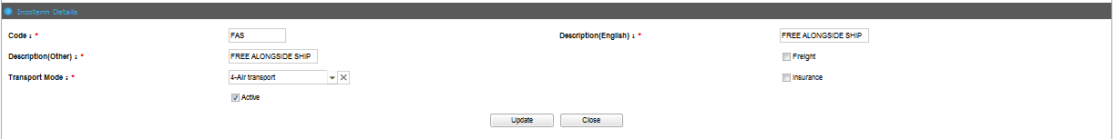
Incoterm Details Edit Page
- Modify the field values and click button.

Success Message
- Click Close button to close the Incoterm details edit page.

Offense Code
The System Administrator creates and updates the Offense code.
To create an Offense:
- Click Code Maintenance >> Code Maintenance. The subsequent screen will be displayed.

System Codes page
- Select Code Type ‘Offense’ from the drop-down list.
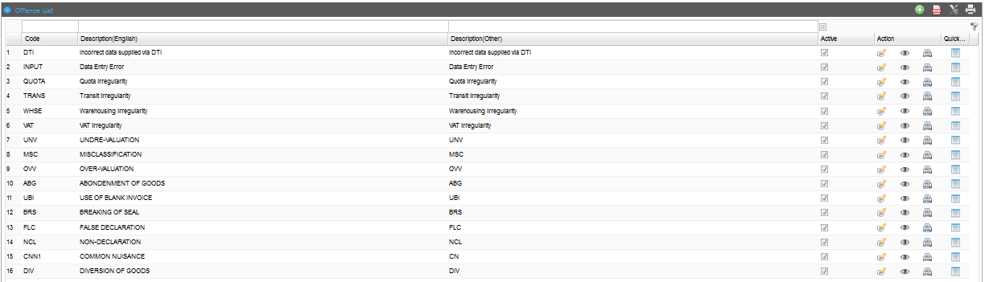
Offense List
- Click icon to create a new Offense Code.
Offense Details Page
- Enter information in the Offense Details fields.
Field/Button description | Action/Input Required
Code | Enter the code of the Offense.
Description(English) | Enter the description of the Offense.
Description(Other) | Enter other descriptions of the Offense.
Active | Check Active to activate the Offense code.

- Click Save button to save the Offense details.

Success Message
- Click Ok button in success message box to continue.
- Click Reset button to clear the Offense details.
- Click Close button to close the Offense details page.

Update Offense
This functionality allows you to update the offense details.
To update an Offense:
- Click Code Maintenance >> Code Maintenance. The subsequent screen will be displayed.

System Codes page
- Select Code Type ‘Offense’ from the drop-down list.

Offense List
- Click the edit icon to update the Offense details. The following screen will be displayed
Offense Details Edit Page
- Modify the field values and click button.

Success Message
- Click Close button to close the Offense details edit page.

Payment Mode Code
The System Administrator creates and updates the Payment Mode code.
To create a Payment Mode:
- Click Code Maintenance >> Code Maintenance. The subsequent screen will be displayed.

System Codes page
- Select Code Type ‘Payment Mode’ from the drop-down list.
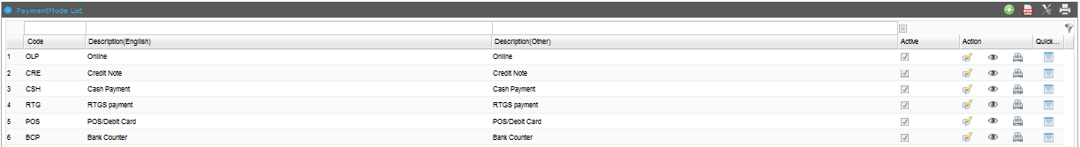
Payment Mode List
- Click icon to create a new Payment Mode Code.
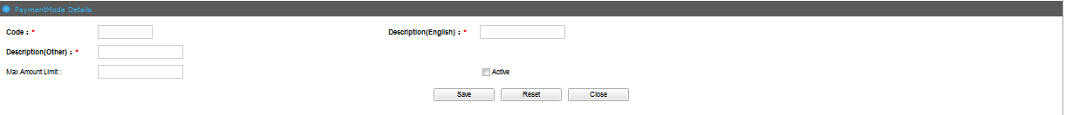
Payment Mode Details Page
- Enter information in the Payment Mode Details fields.
Field/Button description | Action/Input Required
Code | Enter the code of the Payment Mode.
Description(English) | Enter the description of the Payment Mode.
Description(Other) | Enter other descriptions of the Payment Mode.
Max Amount Limit | Enter Maximum Amount Limit for the Payment Mode.
Active | Check Active to activate the Payment Mode code.

- Click Save button to save the Payment Mode details.

Success Message
- Click Ok button in success message box to continue.
- Click Reset button to clear the Payment Mode details.
- Click Close button to close the Payment Mode details page.

Update Payment Mode
This functionality allows you to update the payment mode details.
To update a Payment Mode:
- Click Code Maintenance >> Code Maintenance. The subsequent screen will be displayed.

System Codes page
- Select Code Type ‘Payment Mode’ from the drop-down list.

Payment Mode List
- Click the edit icon to update the Payment Mode details. The following screen will be displayed
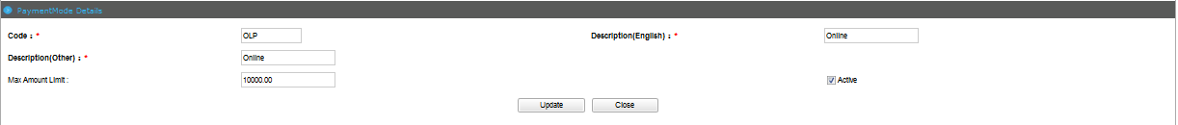
Payment Mode Details Edit Page
- Modify the field values and click button.

Success Message
- Click Close button to close the Payment Mode details edit page.

Port Code
The System Administrator creates and updates the Port code.
To create a Port:
- Click Code Maintenance >> Code Maintenance. The subsequent screen will be displayed.

System Codes page
- Select Code Type ‘Port’ from the drop-down list.
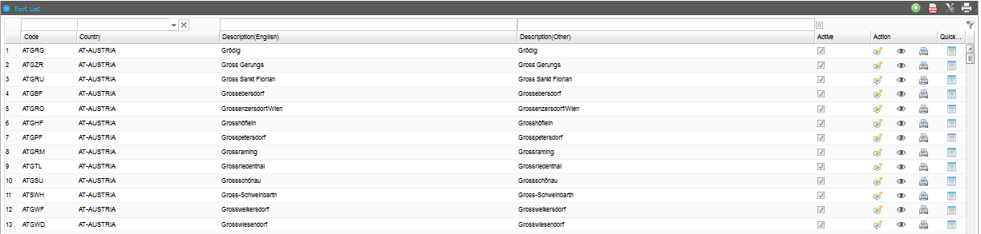
Port List
- Click icon to create a new Port Code.
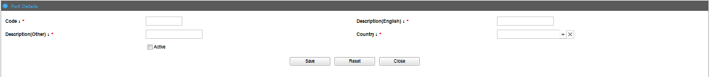
Port Details Page

@ | The Country Codes should already be created.
- Enter information in the Port Details fields.
Field/Button description | Action/Input Required
Code | Enter the code of the Port.
Description(English) | Enter the description of the Port.
Description(Other) | Enter other descriptions of the Port.
Country | Select the Country that the Port belongs to.
Active | Check Active to activate the Port code.

- Click Save button to save the Port details.

Success Message
- Click Ok button in success message box to continue.
- Click Reset button to clear the Port details.
- Click Close button to close the Port details page.

Update Port Code
This functionality allows you to update the port code details.
To update a Port:
- Click Code Maintenance >> Code Maintenance. The subsequent screen will be displayed.

System Codes page
- Select Code Type ‘Port’ from the drop-down list.

Port List
- Click the edit icon to update the Port details. The following screen will be displayed.
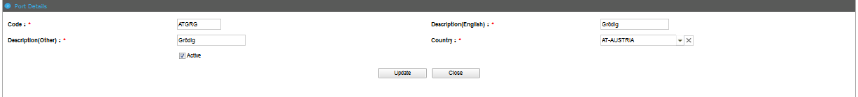
Port Details Edit Page
- Modify the field values and click button.

Success Message
- Click Close button to close the Port details edit page.

Public Holiday Code
The System Administrator creates and updates the Public Holiday code.
To create a Public Holiday:
- Click Code Maintenance >> Code Maintenance. The subsequent screen will be displayed.

System Codes page
- Select Code Type ‘Public Holiday’ from the drop-down list.
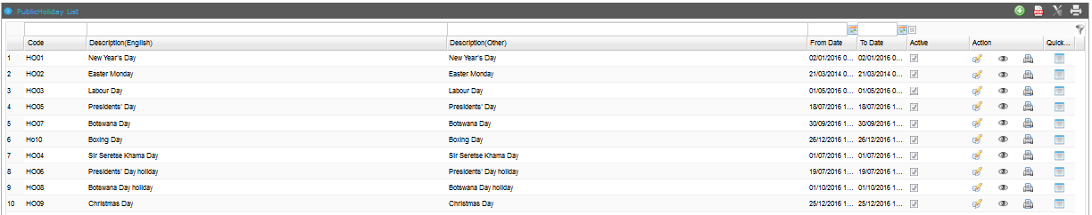
Public Holiday List
- Click icon to create a new Public Holiday Code.
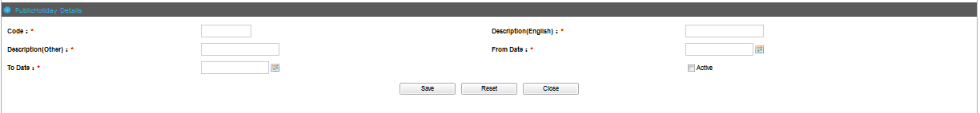
Public Holiday Details Page
- Enter information in the Public Holiday Details fields.
Field/Button description | Action/Input Required
Code | Enter the code of the Public Holiday.
Description(English) | Enter the description of the Public Holiday.
Description(Other) | Enter other descriptions of the Public Holiday.
From Date | Select the Date the Public Holiday starts.
To Date | Select the Date the Public Holiday ends.
Active | Check Active to activate the Public Holiday code.

- Click Save button to save the Public Holiday details.

Success Message
- Click Ok button in success message box to continue.
- Click Reset button to clear the Public Holiday details.
- Click Close button to close the Public Holiday details page.

Update Public Holiday
This functionality allows you to update the public holiday details.
To update a Public Holiday:
- Click Code Maintenance >> Code Maintenance. The subsequent screen will be displayed.

System Codes page
- Select Code Type ‘Public Holiday’ from the drop-down list.

Public Holiday List
- Click the edit icon to update the Public Holiday details. The following screen will be displayed
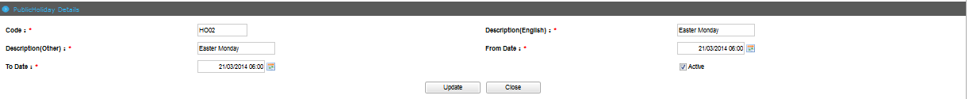
Public Holiday Details Edit Page
- Modify the field values and click button.

Success Message
- Click Close button to close the Public Holiday details edit page.

Regime Code
The System Administrator creates and updates the Regime code.
To create a Regime:
- Click Code Maintenance >> Code Maintenance. The subsequent screen will be displayed.

System Codes page
- Select Code Type ‘Regime’ from the drop-down list.
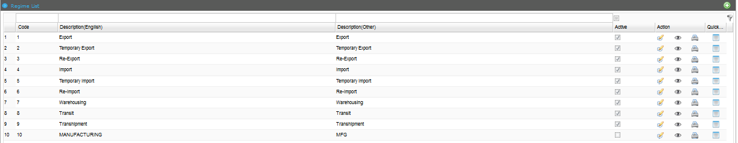
Regime List
- Click icon to create a new Regime Code.
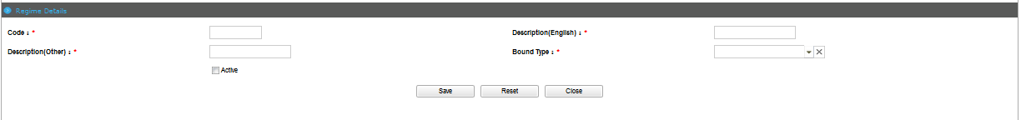
Regime Details Page
- Enter information in the Regime Details fields.
Field/Button description | Action/Input Required
Code | Enter the code of the Regime.
Description(English) | Enter the description of the Regime.
Description(Other) | Enter other descriptions of the Regime.
Bound Type | Select the Bound Type of the Regime.
Active | Check Active to activate the Regime code.

- Click Save button to save the Regime details.

Success Message
- Click Ok button in success message box to continue.
- Click Reset button to clear the Regime details.
- Click Close button to close the Regime details page.

Update Regime
This functionality allows you to update the regime details.
To update a Regime:
- Click Code Maintenance >> Code Maintenance. The subsequent screen will be displayed.

System Codes page
- Select Code Type ‘Regime’ from the drop-down list.

Regime List
- Click the edit icon to update the Regime details. The following screen will be displayed
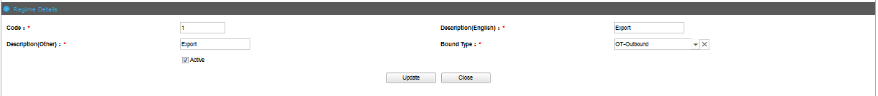
Regime Details Edit Page
- Modify the field values and click button.

Success Message
- Click Close button to close the Regime details edit page.

Shipment Type Code
The System Administrator creates and updates the Shipment Type code.
To create a Shipment Type:
- Click Code Maintenance >> Code Maintenance. The subsequent screen will be displayed.

System Codes page
- Select Code Type ‘Shipment Type’ from the drop-down list.
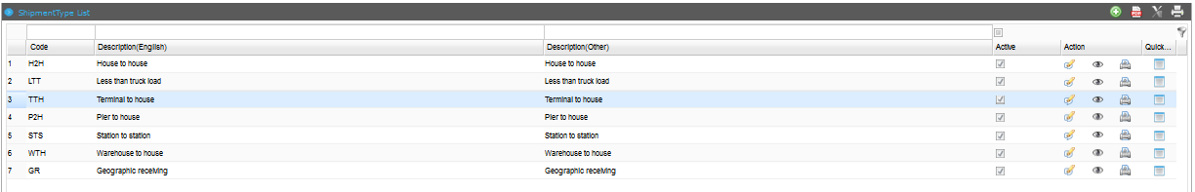
Shipment Type List
- Click icon to create a new Shipment Type Code.
Shipment Type Details Page
- Enter information in the Shipment Type Details fields.
Field/Button description | Action/Input Required
Code | Enter the code of the Shipment Type.
Description(English) | Enter the description of the Shipment Type.
Description(Other) | Enter other descriptions of the Shipment Type.
Active | Check Active to activate the Shipment Type code.

- Click Save button to save the Shipment Type details.

Success Message
- Click Ok button in success message box to continue.
- Click Reset button to clear the Shipment Type details.
- Click Close button to close the Shipment Type details page.

Update Shipment Type
This functionality allows you to update the shipment type details.
To update a Shipment Type:
- Click Code Maintenance >> Code Maintenance. The subsequent screen will be displayed.

System Codes page
- Select Code Type ‘Shipment Type’ from the drop-down list.

Shipment Type List
- Click the edit icon to update the Shipment Type details. The following screen will be displayed
Shipment Type Details Edit Page
- Modify the field values and click button.

Success Message
- Click Close button to close the Shipment Type details edit page.

Transit Route Code
The System Administrator creates and updates the Transit Route code.
To create a Transit Route:
- Click Code Maintenance >> Code Maintenance. The subsequent screen will be displayed.
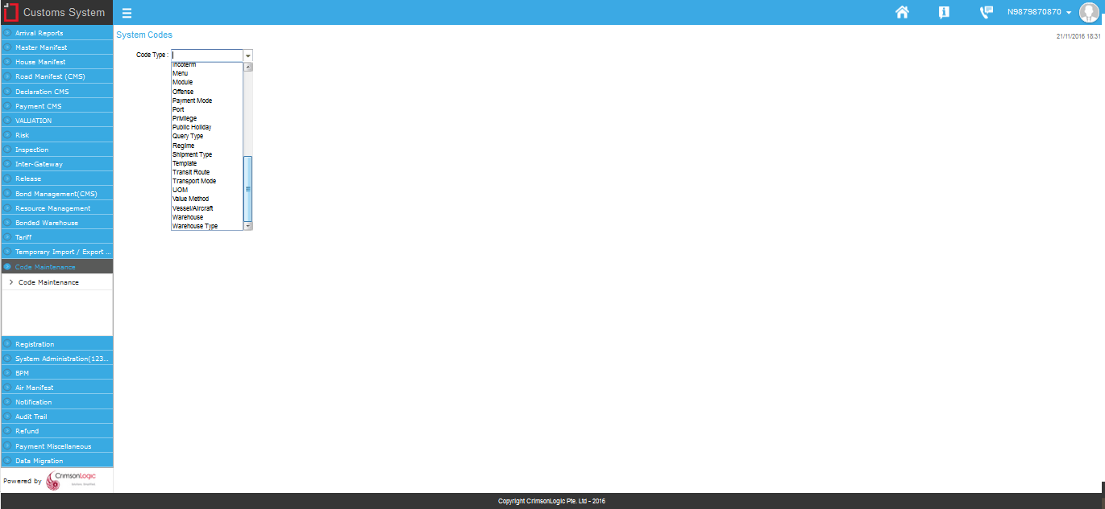
System Codes page
- Select Code Type ‘Transit Route’ from the drop-down list.
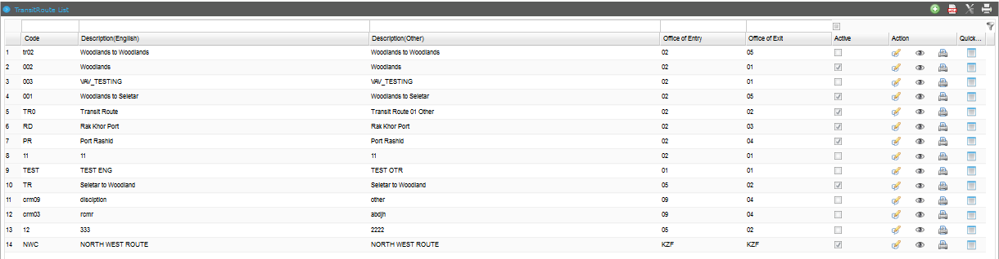
Transit Route List
- Click icon to create a new Transit Route Code.
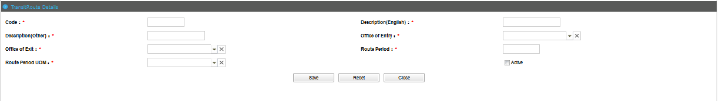
Transit Route Details Page
- Enter information in the Transit Route Details fields.
Field/Button description | Action/Input Required
Code | Enter the code of the Transit Route.
Description(English) | Enter the description of the Transit Route.
Description(Other) | Enter other descriptions of the Transit Route.
Office of Entry | Select the Office of Entry of the Transit Route.
Office of Exit | Select the Office of Exit of the Transit Route.
Route Period | Enter the route period of the Transit Route.
Route Period UOM | Select the UOM of the route period.
Active | Check Active to activate the Transit Route code.

- Click Save button to save the Transit Route details.

Success Message
- Click Ok button in success message box to continue.
- Click Reset button to clear the Transit Route details.
- Click Close button to close the Transit Route details page.

Update Transit Route
This functionality allows you to update the transit route details.
To update a Transit Route:
- Click Code Maintenance >> Code Maintenance. The subsequent screen will be displayed.

System Codes page
- Select Code Type ‘Transit Route’ from the drop-down list.

Transit Route List
- Click the edit icon to update the Transit Route details. The following screen will be displayed
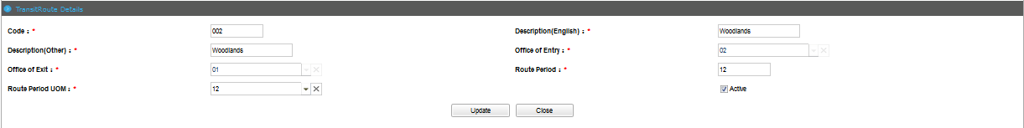
Transit Route Details Edit Page
- Modify the field values and click button.

Success Message
- Click Close button to close the Transit Route details edit page.

Transport Mode Code
The System Administrator creates and updates the Transport Mode code.
To create a Transport Mode:
- Click Code Maintenance >> Code Maintenance. The subsequent screen will be displayed.

System Codes page
- Select Code Type ‘Transport Mode’ from the drop-down list.
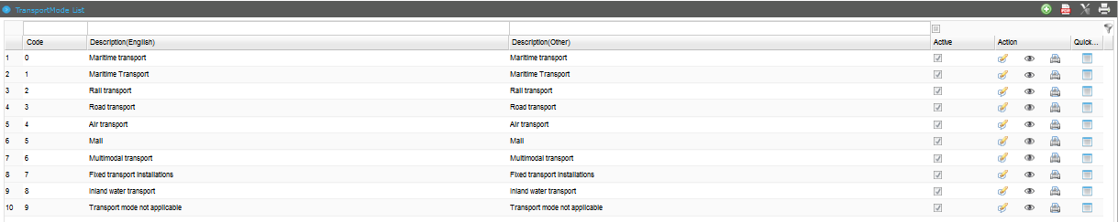
Transport Mode List

- Click icon to create a new Transport Mode Code.
Transport Mode Details Page
- Enter information in the Transport Mode Details fields.
Field/Button description | Action/Input Required
Code | Enter the code of the Transport Mode.
Description(English) | Enter the description of the Transport Mode.
Description(Other) | Enter other descriptions of the Transport Mode.
Active | Check Active to activate the Transport Mode code.

- Click Save button to save the Transport Mode details.

Success Message
- Click Ok button in success message box to continue.
- Click Reset button to clear the Transport Mode details.
- Click Close button to close the Transport Mode details page.

Update Transit Mode
This functionality allows you to update the transit mode details.
To update a Transport Mode:
- Click Code Maintenance >> Code Maintenance. The subsequent screen will be displayed.

System Codes page
- Select Code Type ‘Transport Mode’ from the drop-down list.

Transport Mode List
- Click the edit icon to update the Transport Mode details. The following screen will be displayed
Transport Mode Details Edit Page
- Modify the field values and click button.

Success Message
- Click Close button to close the Transport Mode details edit page.

UOM Code
The System Administrator creates and updates the UOM code.
To create an UOM:
- Click Code Maintenance >> Code Maintenance. The subsequent screen will be displayed.

System Codes page
- Select Code Type ‘UOM’ from the drop-down list.
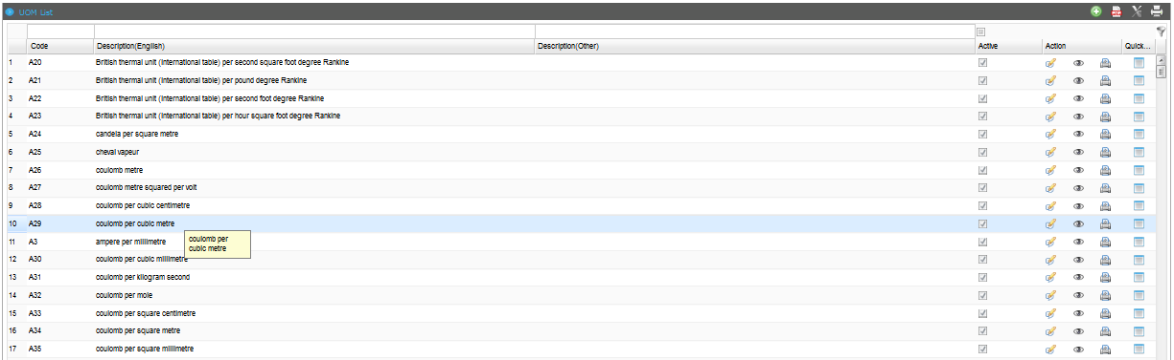
UOM List
- Click icon to create a new UOM Code.
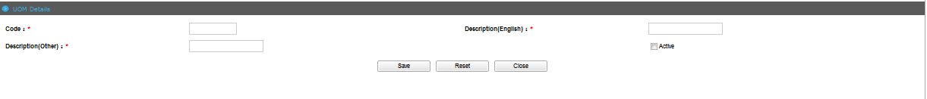
UOM Details Page
- Enter information in the UOM Details fields.
Field/Button description | Action/Input Required
Code | Enter the code of the UOM.
Description(English) | Enter the description of the UOM.
Description(Other) | Enter other descriptions of the UOM.
Active | Check Active to activate the UOM code.

- Click Save button to save the UOM details.

Success Message
- Click Ok button in success message box to continue.
- Click Reset button to clear the UOM details.
- Click Close button to close the UOM details page.

Update UOM
This functionality allows you to update the UOM details.
To update an UOM:
- Click Code Maintenance >> Code Maintenance. The subsequent screen will be displayed.

System Codes page
- Select Code Type ‘UOM’ from the drop-down list.

UOM List
- Click the edit icon to update the UOM details. The following screen will be displayed
UOM Details Edit Page
- Modify the field values and click button.

Success Message
- Click Close button to close the UOM details edit page.

Vessel/Aircraft Code
The System Administrator creates and updates the Vessel/Aircraft code.
To create a Vessel/Aircraft:
- Click Code Maintenance >> Code Maintenance. The subsequent screen will be displayed.

System Codes page
- Select Code Type ‘Vessel/Aircraft’ from the drop-down list.
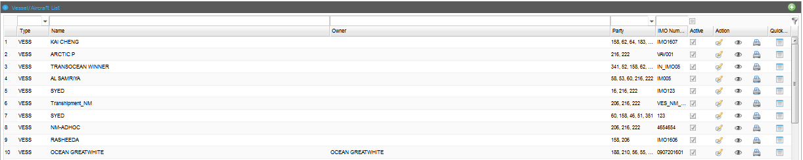
Vessel/Aircraft List

- Click icon to create a new Vessel Code.
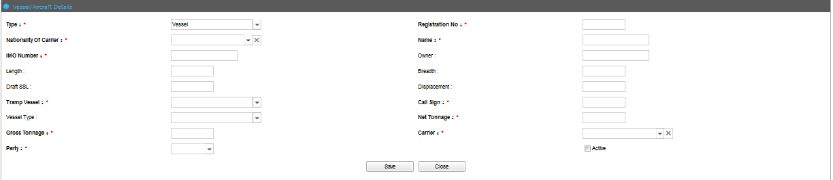
Vessel/Aircraft Details Page

@ | The Carrier Codes should already be created.
- Enter information in the Vessel Details fields.
Field/Button description | Action/Input Required
Type | Select Type ‘Vessel’
Registration No | Enter the registration number of the Vessel.
Nationality of Carrier | Select the Nationality of the Carrier of the Vessel.
Name | Enter the name of the Vessel.
IMO Number | Enter the IMO Number of the Vessel.
Owner | Enter the Owner of the Vessel.
Length | Enter the Length of the Vessel.
Breadth | Enter the Breadth of the Vessel.
Draft SSL | Enter the Draft SSL of the Vessel.
Displacement | Enter the Displacement of the Vessel.
Tramp Vessel | Select the Tramp Vessel of the Vessel.
Call Sign | Enter the Call Sign of the Vessel.
Vessel Type | Select the Vessel Type of the Vessel.
Net-Tonnage | Enter the Net-Tonnage of the Vessel.
Gross Tonnage | Enter the Gross Tonnage of the Vessel.
Carrier | Select the Carrier of the Vessel.
Party | Select the Party that the Vessel belongs to.
Active | Check Active to activate the Vessel code.
- Click icon to create a new Aircraft Code.
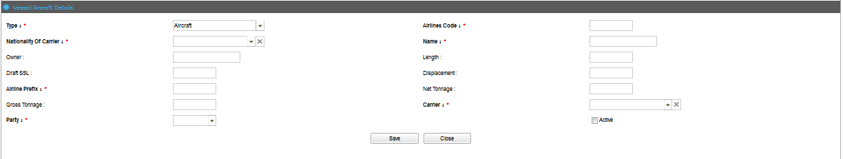
Vessel/Aircraft Details Page
- Enter information in the Aircraft Details fields.
Field/Button description | Action/Input Required
Type | Select type Aircraft
Airline Code | Enter the Airline code of the Aircraft.
Nationality of Carrier | Select the Nationality of the Carrier of the Aircraft.
Name | Enter the name of the Aircraft.
Owner | Enter the Owner of the Aircraft.
Length | Enter the Length of the Aircraft.
Draft SSL | Enter the Draft SSL of the Aircraft.
Displacement | Enter the Displacement of the Aircraft.
Airline Prefix | Enter the Airline Prefix of the Aircraft.
Net-Tonnage | Enter the Net-Tonnage of the Aircraft.
Gross Tonnage | Enter the Gross Tonnage of the Aircraft.
Carrier | Select the Carrier of the Aircraft.
Party | Select the Party that the Aircraft belongs to.
Active | Check Active to activate the Aircraft code.
- Click Save button to save the Vessel/Aircraft details.

Success Message
- Click Ok button in success message box to continue.
- Click Close button to close the Vessel/Aircraft details page.

Update Vessel or Aircraft
This functionality allows you to update the Vessel or Aircraft details.
To update a Vessel/Aircraft:
- Click Code Maintenance >> Code Maintenance. The subsequent screen will be displayed.

System Codes page
- Select Code Type ‘Vessel/Aircraft’ from the drop-down list.

Vessel/Aircraft List
- Click the edit icon to update the Vessel/Aircraft details. The following screen will be displayed
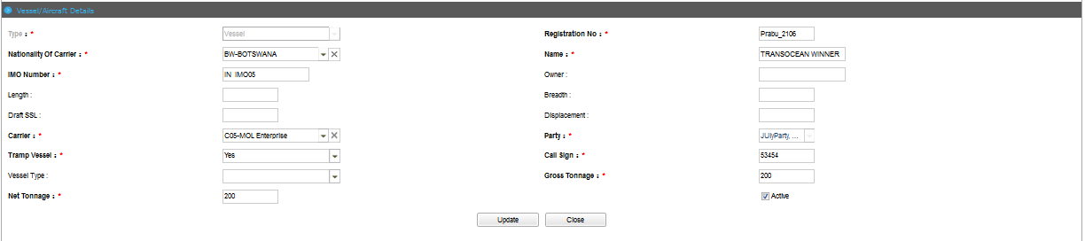
Vessel/Aircraft Details Edit Page
- Modify the field values and click button.

Success Message
- Click Close button to close the Vessel/Aircraft details edit page.

Warehouse Code
The System Administrator creates and updates the Warehouse code.
To create a Warehouse:
- Click Code Maintenance >> Code Maintenance. The subsequent screen will be displayed.

System Codes page
- Select Code Type ‘Warehouse’ from the drop-down list.
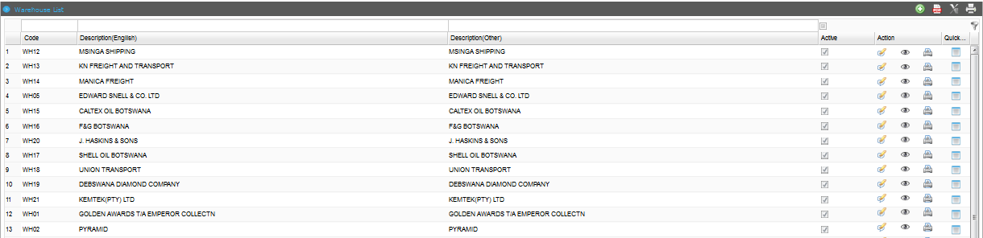
Warehouse List
- Click icon to create a new Warehouse Code.
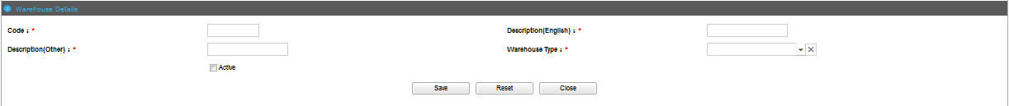
Warehouse Details Page

@ | The Warehouse Type Codes should already be created.

- Enter information in the Warehouse Details fields.
Field/Button description | Action/Input Required
Code | Enter the code of the Warehouse.
Description(English) | Enter the description of the Warehouse.
Description(Other) | Enter other descriptions of the Warehouse.
Warehouse Type | Select the Warehouse type that the Warehouse belongs to.
Active | Check Active to activate the Warehouse code.

- Click Save button to save the Warehouse details.

Success Message
- Click Ok button in success message box to continue.
- Click Reset button to clear the Warehouse details.
- Click Close button to close the Warehouse details page.

Update Warehouse
This functionality allows you to update the warehouse details.
To update a Warehouse:
- Click Code Maintenance >> Code Maintenance. The subsequent screen will be displayed.

System Codes page
- Select Code Type ‘Warehouse’ from the drop-down list.

Warehouse List
- Click the edit icon to update the Warehouse details. The following screen will be displayed
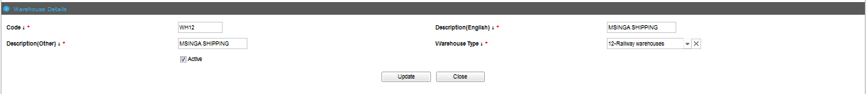
Warehouse Details Edit Page
- Modify the field values and click button.

Success Message
- Click Close button to close the Warehouse details edit page.

Warehouse Type Code
The System Administrator creates and updates the Warehouse Type code.
To create a Warehouse Type:
- Click Code Maintenance >> Code Maintenance. The subsequent screen will be displayed.

System Codes page
- Select Code Type ‘Warehouse Type’ from the drop-down list.
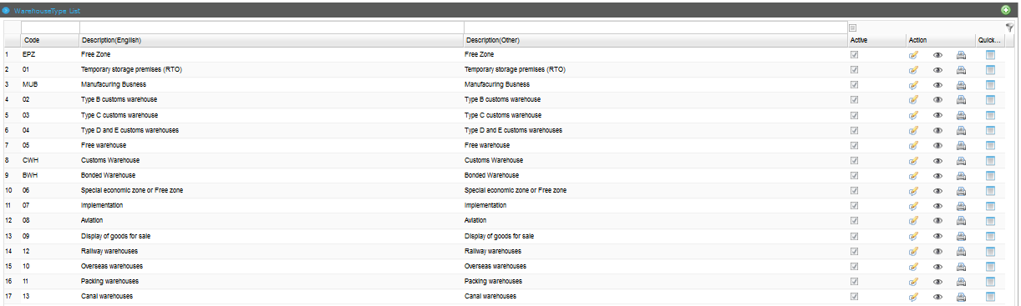
Warehouse Type List
- Click icon to create a new Warehouse Type Code.
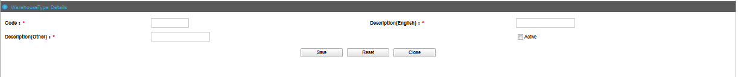
Warehouse Type Details Page
- Enter information in the Warehouse Type Details fields.
Field/Button description | Action/Input Required
Code | Enter the code of the Warehouse Type.
Description(English) | Enter the description of the Warehouse Type.
Description(Other) | Enter other descriptions of the Warehouse Type.
Active | Check Active to activate the Warehouse Type code.

- Click Save button to save the Warehouse Type details.

Success Message
- Click Ok button in success message box to continue.
- Click Reset button to clear the Warehouse Type details.
- Click Close button to close the Warehouse Type details page.

Update Warehouse Type
This functionality allows you to update the warehouse type details.
To update a Warehouse Type:
- Click Code Maintenance >> Code Maintenance. The subsequent screen will be displayed.

System Codes page
- Select Code Type ‘Warehouse Type’ from the drop-down list.

Warehouse Type List
- Click the edit icon to update the Warehouse Type details. The following screen will be displayed
Warehouse Type Details Edit Page
- Modify the field values and click button.

Success Message
- Click Close button to close the Warehouse Type details edit page.

Chapter8

Notification
Notification module is used to send out notifications to relevant parties involved in trade, such as the Trader, Shipping Line, Shipping Agents, and Customs Officer. These notifications contain instructions that the involved parties are to perform and/or conduct.
Notifications to parties like the Shipping or Air Carrier Agents, Customs Clearing Agents and Traders can be sent through SMS or Email depending on the communication preference selected by the user during registration.
This chapter covers the following topics:
- Creating Notification Template Details
- Searching Notification Template Details
- Searching Transaction Details
- Creating Email Settings
- Searching Email Settings

Creating Notification Template Details
The functionality allows you to create a template for notification in the TFB system.
To create a template for notification:
- Click Notification>> Create/Search Template. The Search Template Page will be displayed.
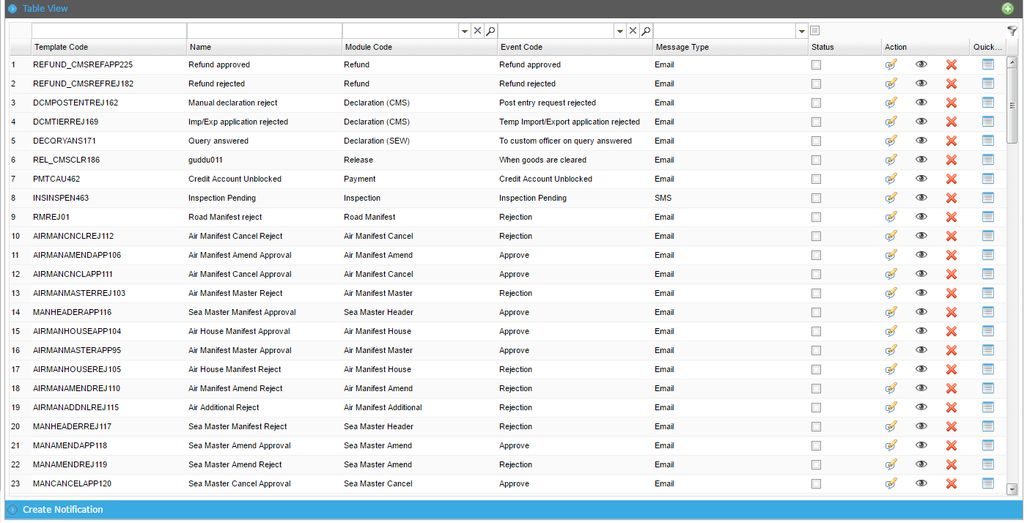
Search Template Page
- Click the add button to create a new notification.
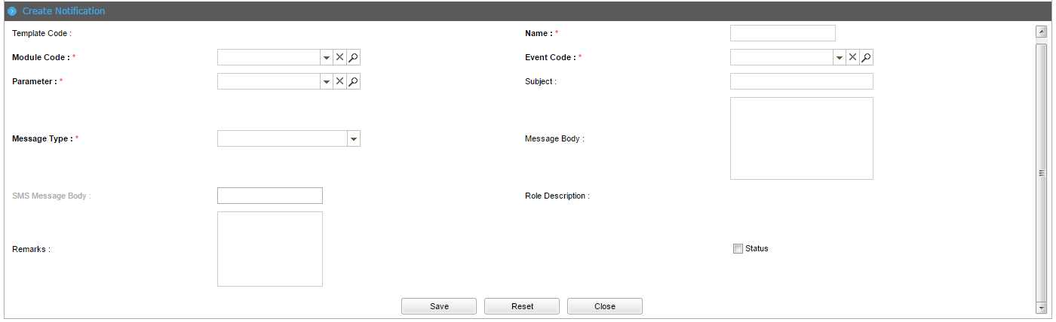
Create Template Page

Following are the field and button descriptions of the Create Notification Template page.
Field/Button description | Action/Input Required
Template Code | The system generates the template code once the details has been saved.
Name | Enter the name of the notification.
Module Code | Select the module code from the dropdown list.
Event Code | Select the event code from the dropdown list.
Parameter | Select the parameter from the dropdown list. This will be added to the message body.
Subject | Enter the subject of the notification.
Message Type | Select the message type from the dropdown list. If the message type is selected as SMS, the SMS Message Body field is displayed.
Message Body | Enter the message body of the notification.
Remarks | Enter the remarks of the notification if any.
Status | Select the status checkbox if Checked, it is ON, if unchecked it is OFF.

- Click Save button to save the notification details. The Record saved successfully message will be displayed.
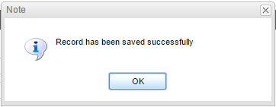
Record Saved Successfully Message

Search Notification Template Details
The functionality allows you to search for, view, edit and overview the notification details in the TFB system.
To search for a notification template:
- Click Notification>> Create/Search Template. The Search Template Page will be displayed.

Search Template Page
Following are the field and button descriptions of the Search Template page.
Field/Button description | Action/Input Required
Template Code | The system generates the template code once the details have been saved.
Name | Enter the name of the notification.
Module Code | Select the module code from the dropdown list.
Event Code | Select the event code from the dropdown list.
Message Type | Select the message type from the dropdown list.
Status | Select the status checkbox of the notification.

@ | - If you do not know the complete search phrase (words) for any criterion, enter partial search phrase (words) and click the Search icon.  - To get an exact search result, you must enter the following search criteria:  - Template Code  - Name  - Module Code  - Event Code  - Message Type  - Status

- Enter the search criteria and Click icon to view the matching results in the Search Results Page.
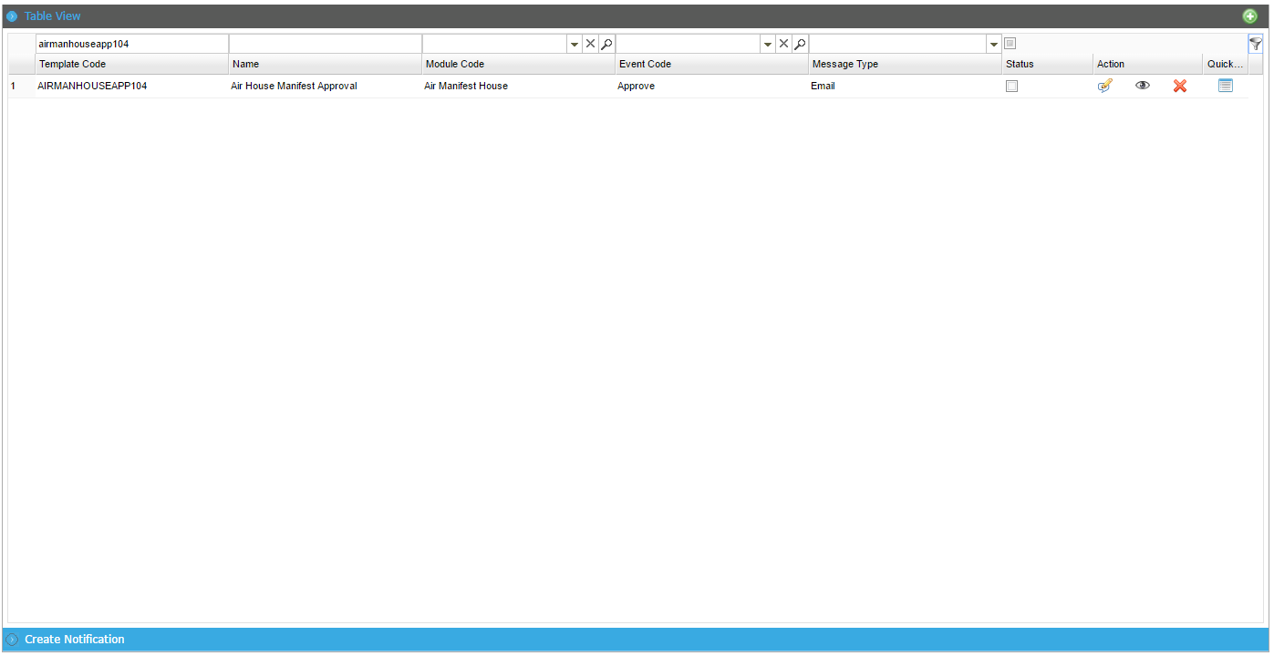
Search Results Page

View Notification Details
This functionality allows you to view the Notification details.
To view the notification details:
- From the search results, click the icon. The Notification Details Page will be displayed.
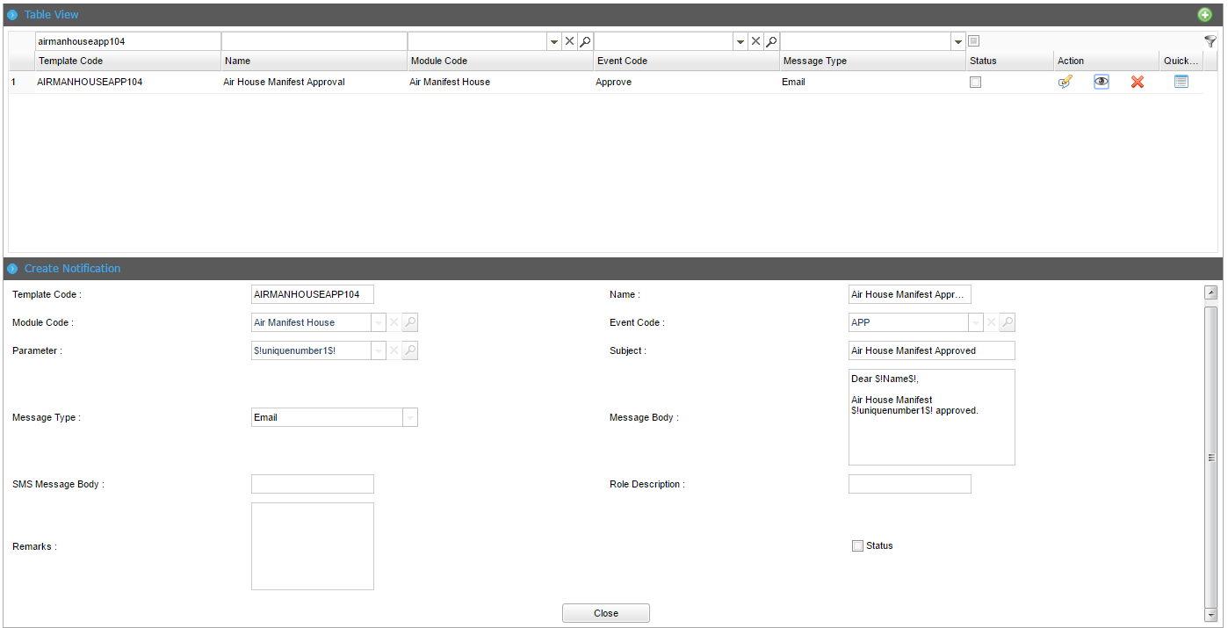
Notification Details Page
- Click Close button to close the Notification details.

@ | Click the Delete icon to delete the notification details.

Quick View Notification Details
This functionality allows you to overview view the Notification details such as Name, Module Code, Event Code and Message Type.
To quick view the notification details:
- From the search results, click the icon. The Notification Details Quick View Page will be displayed.
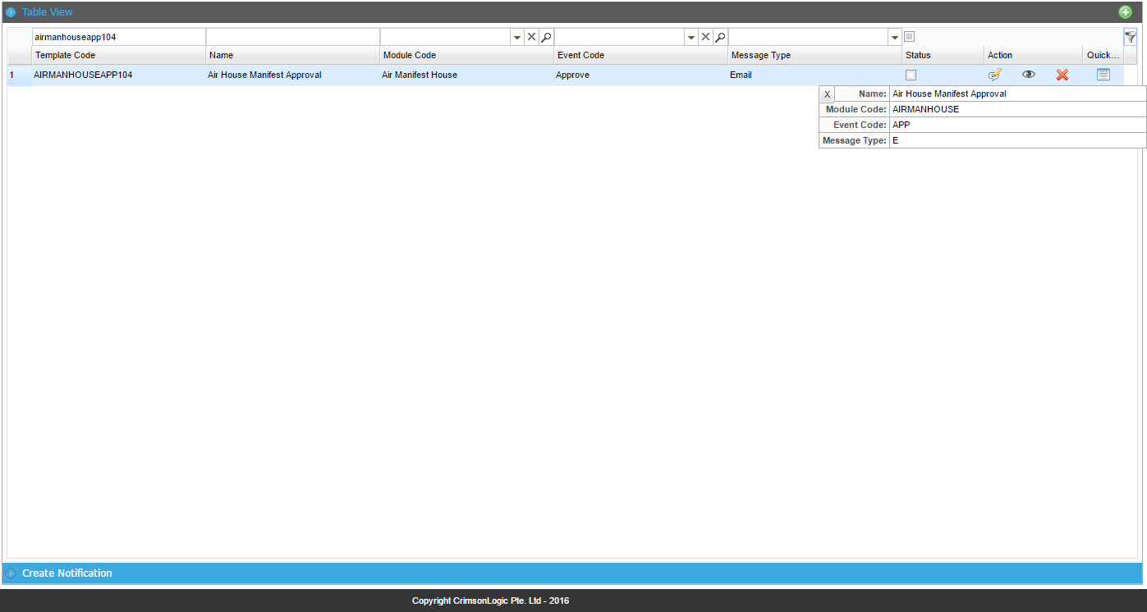
Notification Quick View Details Page

Edit Notification Details
This functionality allows you to edit the Notification details in the TFB system.
To edit the notification details:
- From the search results, click the icon. The Notification Search Results page will be displayed.
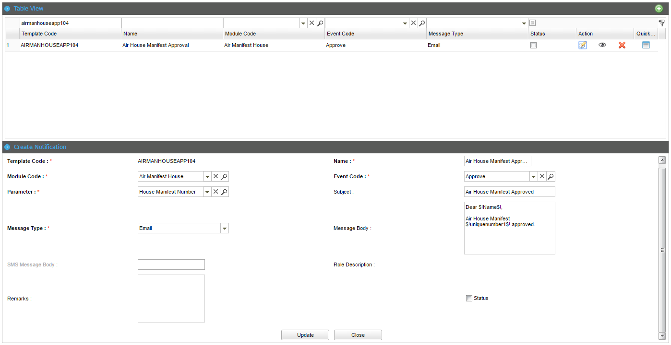
Notification Details Page

- Click Close button to close the Notification details.
- Modify the necessary information in the Notification details and click Update. The Records updated successfully message will be displayed.
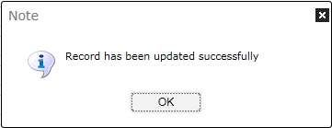
Records Updated Successfully Message
- Click Ok button to close the confirmation message.

Search Transaction Details
The functionality allows you to search for, view, edit and overview the Transaction details in the TFB system.
To search for a transaction:
- Click Notification>> Search Transaction. The Search Transaction Page will be displayed.
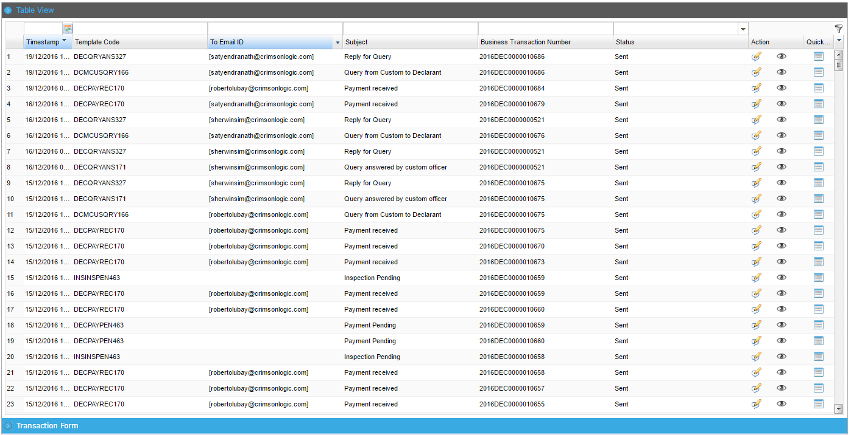
Search Transaction Page
Following are the field and button descriptions of the Search Transaction page.
Field/Button description | Action/Input Required
Timestamp | Enter the time using the calendar icon.
Template Code | Enter the template code.
To Email Id | Enter the name of the notification.
Subject | Enter the subject of the notification.
Business Transaction Number | Enter the Business Transaction Number of the notification.
Status | Select the status checkbox of the notification.

@ | - If you do not know the complete search phrase (words) for any criterion, enter partial search phrase (words) and click the Search icon.  - To get an exact search result, you must enter the following search criteria:  - Timestamp  - Template Code  - To Email Id  - Subject  - Business Transaction Number  - Status

- Enter the search criteria and Click icon to view the matching results in the Search Results Page.
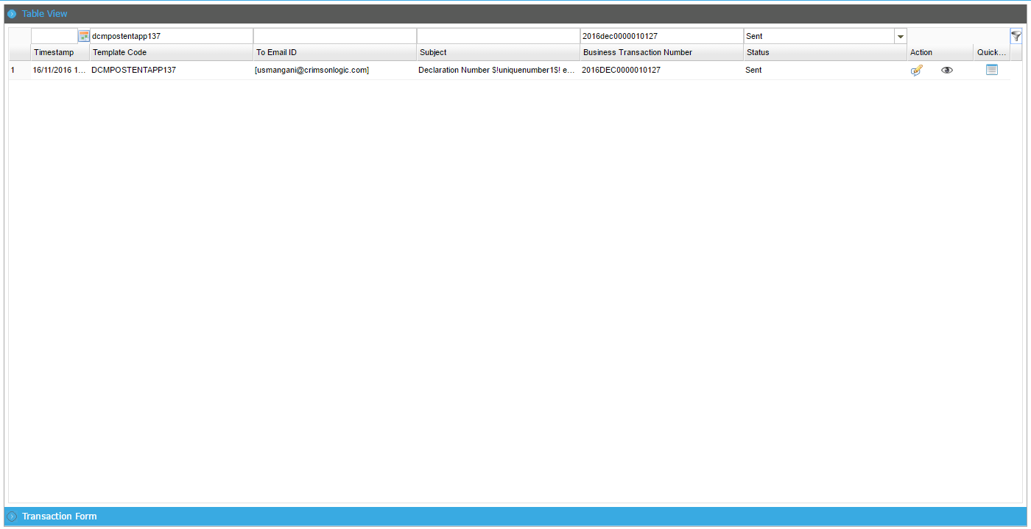
Search Results Page

View Transaction Details
This functionality allows you to view the Transaction details.
To view the transaction details:
- From the search results, click the icon. The Transaction Details Page will be displayed.
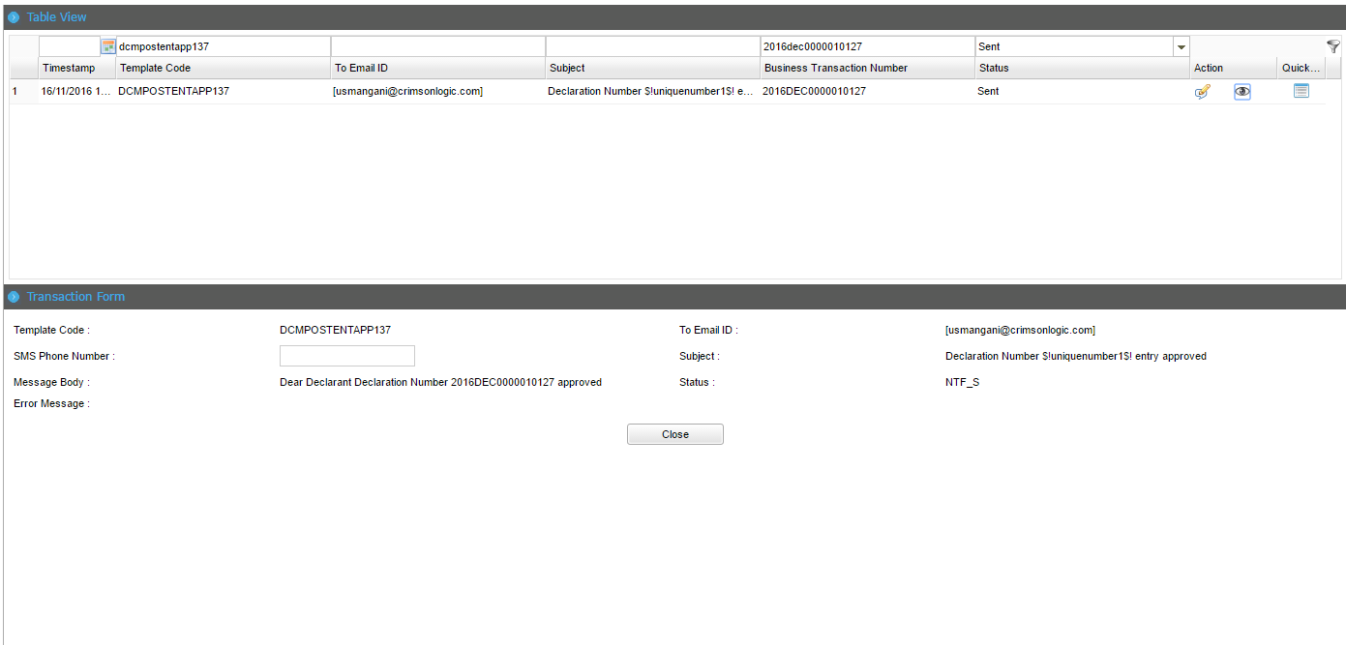
Transaction Details Page
- Click Close button to close the Transaction details.

Quick View Transaction Details
This functionality allows you to overview view the Transaction details such as To Email ID, Subject, Business Transaction Number and Status.
To quick view the transaction details:
- From the search results, click the icon. The Transaction Details Quick View Page will be displayed.
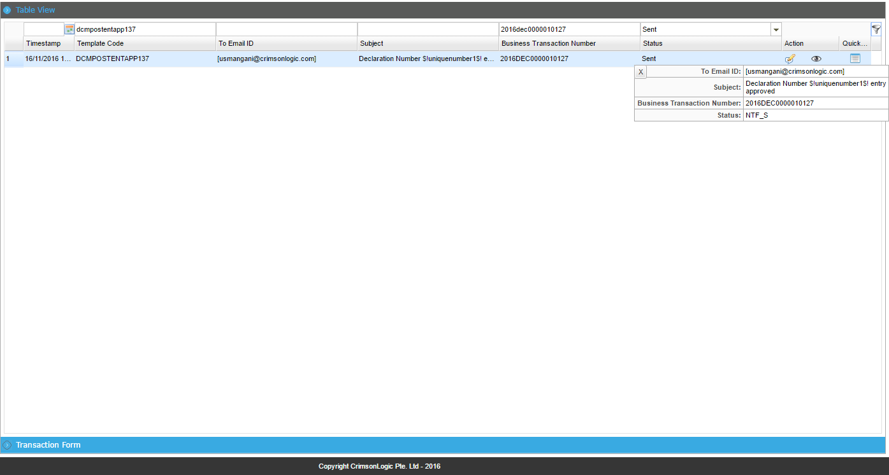
Transaction Quick View Details Page

Edit Transaction Details
This functionality allows you to resend the email in the TFB system.
To edit the Transaction details:
- From the search results, click the icon. The Transaction Search Results page will be displayed.
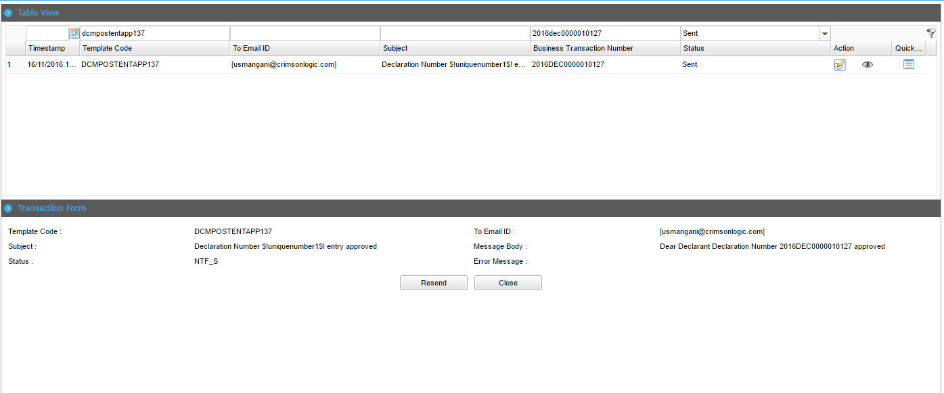
Transaction Details Page

- Click Close button to close the Transaction details.
- Click Resend button to resend the Transaction details. The Records updated successfully message will be displayed.

Records Updated Successfully Message
- Click Ok button to close the confirmation message.

Creating Email Setting Form
The functionality allows you to create an email setting form to configure the email server in the TFB system.
To create an email setting form:
- Click Notification>> Email Setting. The Search Email Setting Page will be displayed.
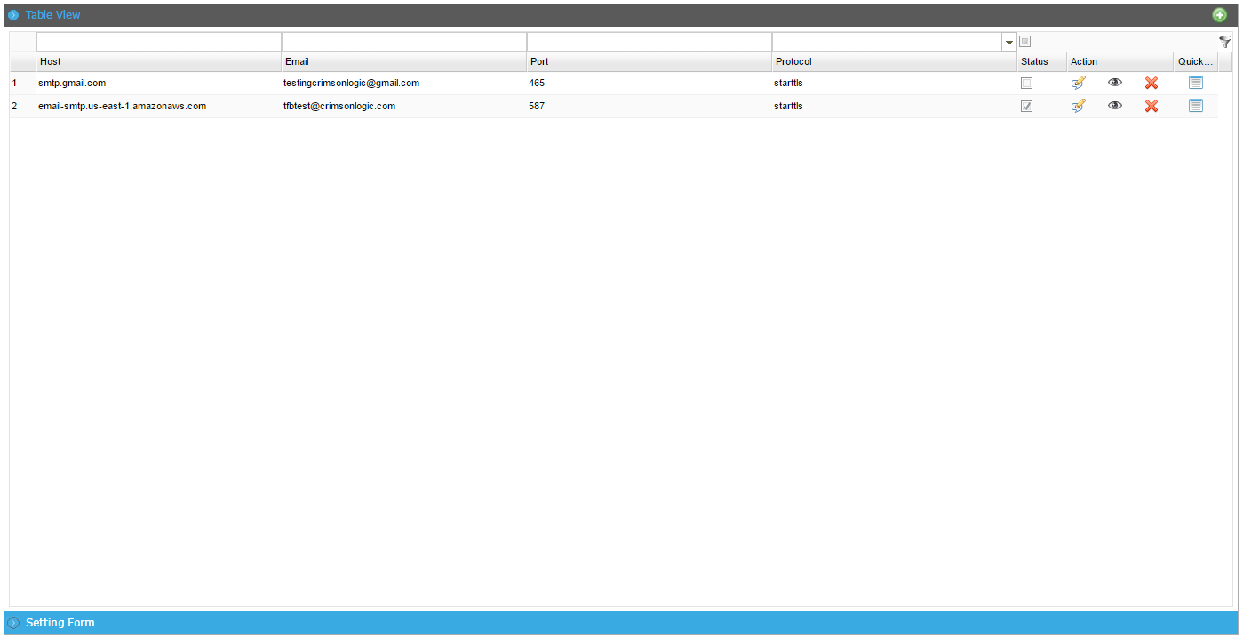
Search Email Setting Page
- Click the add button to create a new notification.
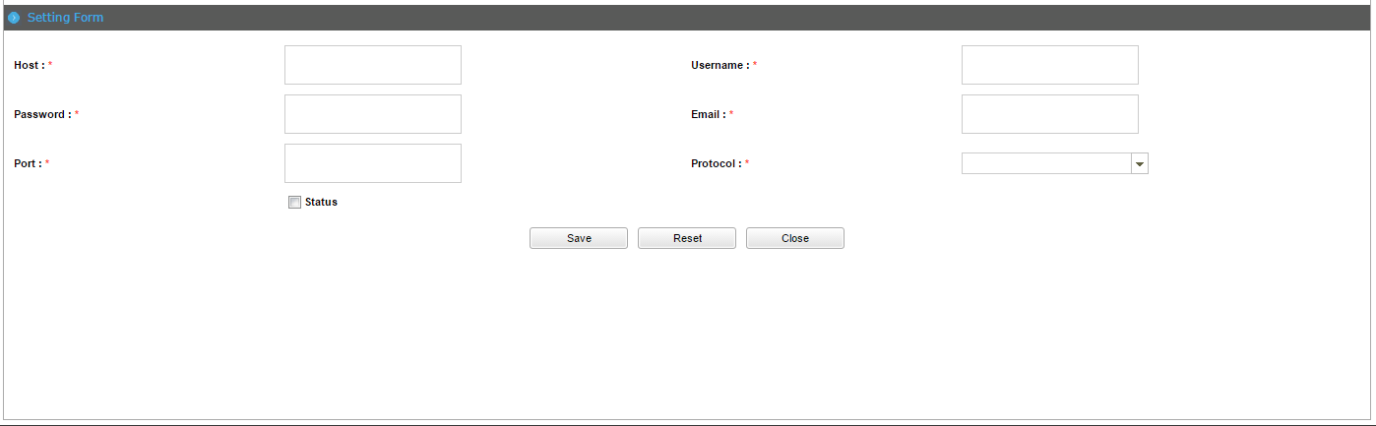
Create Template Page

Following are the field and button descriptions of the Create Setting Form page.
Field/Button description | Action/Input Required
Host | Enter the host name.
Username | Enter the user name.
Password | Enter the password.
Email | Enter the email address.
Port | Enter the port.
Protocol | Select the protocol from the dropdown list.
Status | Select the status checkbox.

- Click Save button to save the setting form details. The Record saved successfully message will be displayed.

Record Saved Successfully Message

Search Email Setting Form Details
The functionality allows you to search for, view, edit, delete and overview the Email Setting Form details in the TFB system.
To search for an Email Setting Form:
- Click Notification>> Email Setting. The Search Email Setting Page will be displayed.
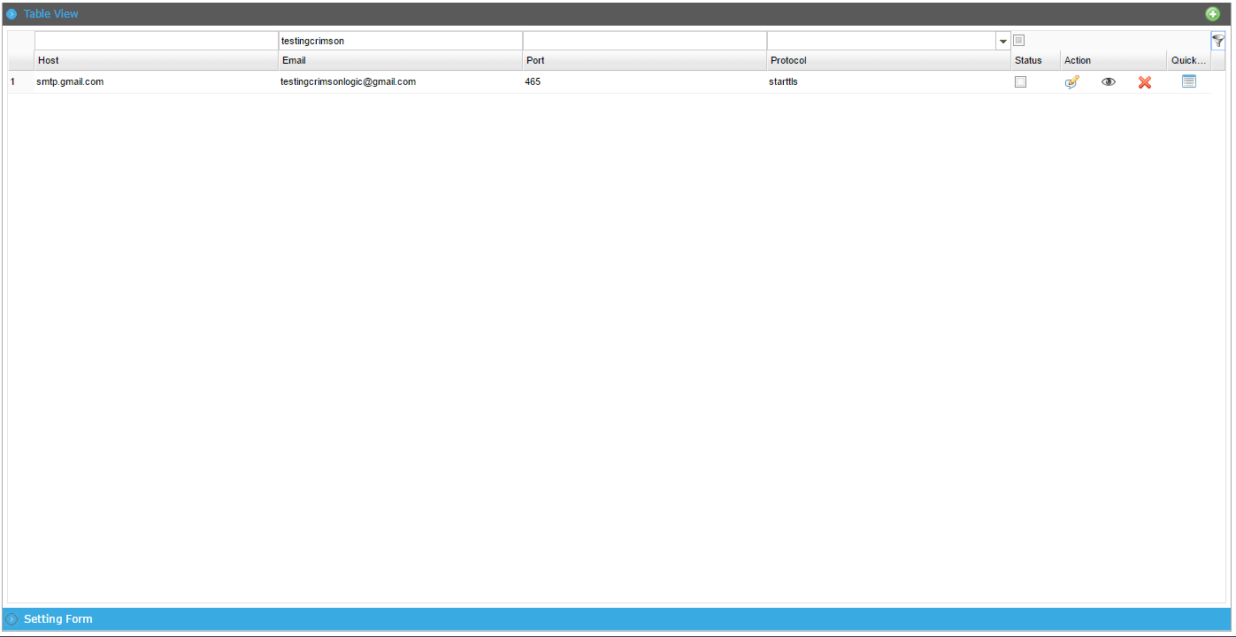
Search Email Setting Page
Following are the field and button descriptions of the Search Email Setting page.
Field/Button description | Action/Input Required
Host | Enter the host name.
Email | Enter the email address.
Port | Enter the port.
Protocol | Select the protocol from the dropdown list.

@ | - If you do not know the complete search phrase (words) for any criterion, enter partial search phrase (words) and click the Search icon.  - To get an exact search result, you must enter the following search criteria:  - Host  - Email  - Port  - Protocol

- Enter the search criteria and Click icon to view the matching results in the Search Results Page.

Search Results Page

View Email Setting Details
This functionality allows you to view the Email Setting details.
To view the Email Setting details:
- From the search results, click the icon. The Email Setting Details Page will be displayed.
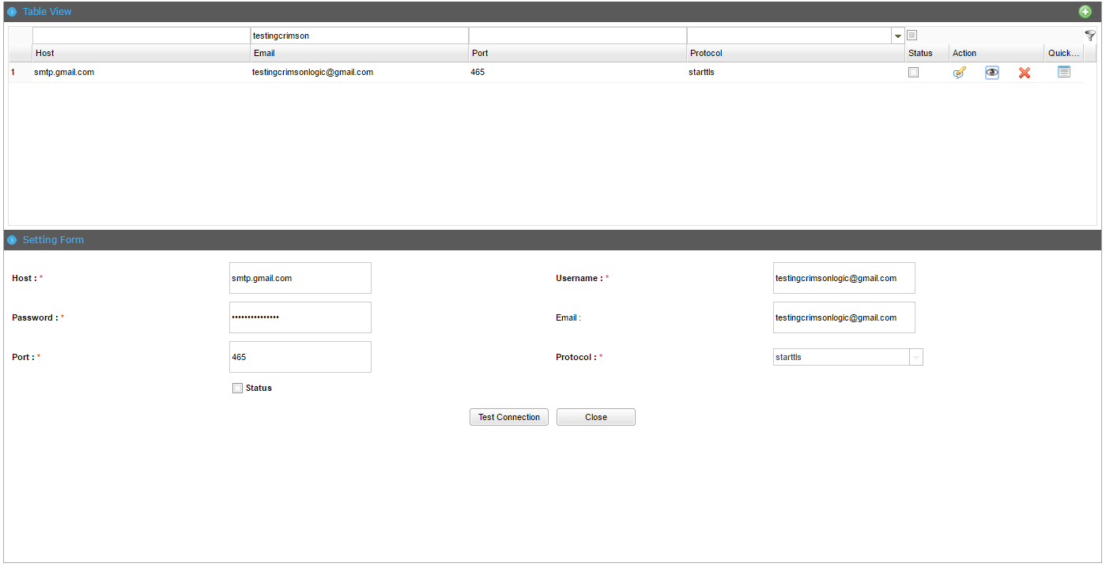
Email Setting Details Page
- Click Close button to close the Email Setting details.

@ | Click the Delete icon to delete the Email Setting details.

Quick View Email Setting Details
This functionality allows you to overview view the Email Setting details such as Email, Port and Protocol.
To quick view the Email Setting details:
- From the search results, click the icon. The Email Setting Details Quick View Page will be displayed.
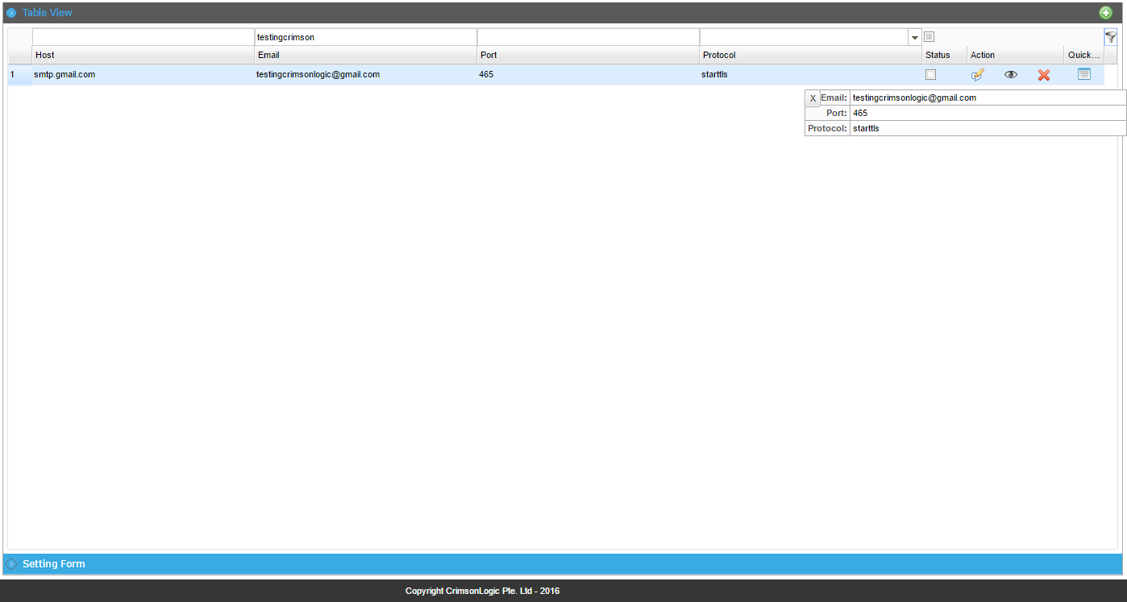
Email Setting Quick View Details Page

Edit Email Setting Details
This functionality allows you to edit and test the connection to the email server in the TFB system.
To edit the Email Setting details:
- From the search results, click the icon. The Email Setting Search Results page will be displayed.
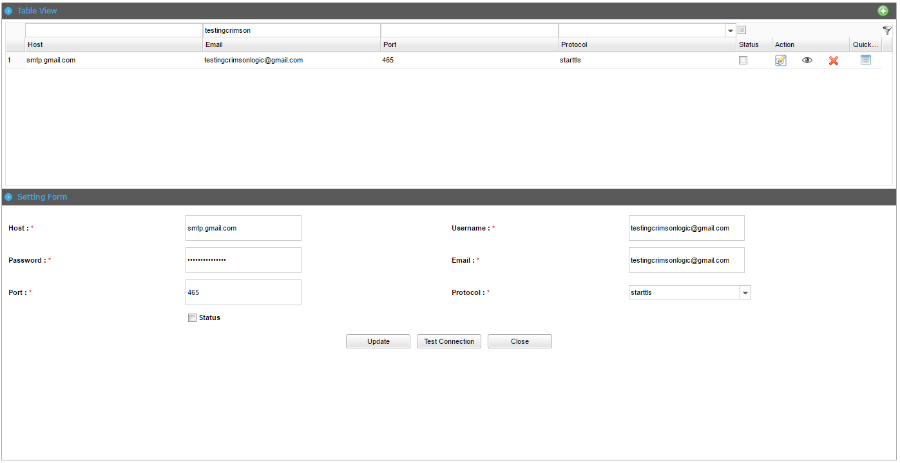
Email Setting Details Page

- Modify the necessary information in the Email Setting details and click Update. The Records updated successfully message will be displayed.

Records Updated Successfully Message
- Click Ok button to close the confirmation message.
- Click Test Connection button to test the connection to the email server. The successfully connected to server message will be displayed.
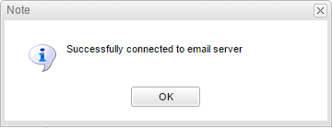
Success message
- Click OK button to close the confirmation message.

@ | Click the Close button to close the setting form details.

Chapter9

System Parameters and Rules File Deployment
This chapter explains about the system parameters and the procedure for deploying the rule file in the TFB system.

System Parameters
Following are the system parameters in the TFB system.

Parameter ID | Parameter | Description
BLOCK_DECLARATION_SUB_FOR_SUSPENDED_CREDIT_ACCOUNT | Y | Config to block declaration Submission for suspended credit account
ONLINE_PAYMENT_FILE_PATH | /crimsonlogic/trade/tfb2/rel1_0/onlinePmt | Online Payments File Upload Path
REFUND_INSTRUCTION_BUSINESS_TXN_NUMBER_VALIDATION | Y | Refund Instruction Business Transaction Number Validation
PARTY_ELIGIBLE_FOR_CREDIT | CA | Party eligible for credit
NO_OF_DAYS_TO_BLOCK_TXN | 7 | Number of days to block credit account
RELEASE_ORDER_TITLE | Release Order | Release Order Report Title
PAYMENT_INVOICE_TITLE | PAYMENT INVOICE | Payment Invoice Report Title
CUSTOM_VALUE_CONFIG | FOB | Config for Customs Value in Items Declaration
TARIFF_ROUND_RANGE | 0-2=0|3-7=5|8-9=10 | range of least significant digit to set as Lowest Currency Denomination Range. Please follow correct format
TARIFF_ROUND_MODE | HALF_UP | Rounding mode for set scale for total duty amount of each duty of each item. Possible values UP, DOWN, CEILING, FLOOR, HALF_UP, HALF_DOWN, HALF_EVEN,
TARIFF_ROUND_SCALE | 2 | Scale of total tax of each item's each duty to be rounded
NTF_BACKGROUND_START | TRUE | Check if notification background should start
SCANNING_USER_ASSIGNMENT_REQUIRED | Y | Resource Management User Assignment Required for Scanning
APPROVAL_BY_VAOS_FOR_ADDITIONAL_MASTER_MANIFEST | Y | Manual Approval by VAOS is required for Master Manifest Additional Submission
PHY_EXAM_USER_ASSIGNMENT_REQUIRED | Y | Resource Management User Assignment Required for Examination
APPROVAL_BY_CUSTOMS_FOR_ADDITIONAL_MASTER_MANIFEST | Y | Manual Approval by Customs is required for Master Manifest Additional Submission
APPROVED_BY_CUSTOMS_VO_FOR_SUBMITTED_REFUND_REQUEST | Y | Approved by Customs Verification Officer for Submitted Refund Request
BONDED_WAREHOUSE_RELEASE_GOODS_ALLOWANCE | 20 | Percentage allowance that the system can cater to strike the balance quantities between the parent declaration and removal declaration.
AIR_MANIFEST_IATA_MODULE | airIata | Air Manifest IATA File Upload Module Name
AIR_MANIFEST_IATA_FILE_UPLOAD_PATH | /crimsonlogic/trade/tfb2/rel1_0/uploads/ | Air Manifest IATA File Upload Path
TIER_MAX_ALLOWABLE_EXTENSION_NUMBER | 3 | Maximum number of allowable tier extensions
DECLARATION_GUARANTEE_AMT_TO_HOLD_IN_PERCENT | 50 | Guarantee Amount to hold for the partial clearance in percentage (Valid value is 0 to 100).
APPROVAL_FOR_PMT_WAIVE_REQUIRED | Y | Approval for Payment Waive off Transaction is required or not.
AR_MAX_ALLOWABLE_CHARACTER_SLOTCHARTER | 2 | Maximum numbers of of Slot Charterers allowed to add while creating arrival report.
AR_SUBMISSION_MAX_ALLOWABLE_DAYS | 60 | Difference between today date and Estimated time of arrival(ETA) date
DEFAULT_LANGUAGE | en | System default language setting
DEFAULT_COUNTRY | SG | System default country setting
APPROVAL_CUSTOMS_REQ_FOR_COMPLETION_OF_DISCHARGE_REPORT | Y | Approval by Customs for completion of discharge report
APPROVAL_CUSTOMS_REQ_FOR_ACTUAL_ARRIVAL_REPORT | Y | Approval by Customs for actual arrival report
APPROVAL_CUSTOMS_REQ_FOR_ARRIVAL_REPORT | N | Whether the Customs Approval is Required after submitting the Arrival Report
WF_AFTER_RELEASE_ORDER | Release Cargo | Not in use
WF_AFTER_PHYSICAL_EXAM | Release Order | Not in use
WF_AFTER_SCANNING | Physical Examination | Not in use
WF_AFTER_GREEN_LANE | Release Order | Not in use
WF_AFTER_GATEPASS | Scanning | Not in use
APPROVAL_BY_VAOS_FOR_AMENDED_MASTER_MANIFEST | Y | Approval by VAOS for Amended Master Manifest
APPROVAL_BY_CUSTOMS_FOR_AMENDED_MASTER_MANIFEST | N | Approval by Customs for Amended Master Manifest
APPROVAL_BY_VAOS_FOR_SUBMITTED_HOUSE_MANIFEST | Y | Approval by VAOS for submitted House Manifest
APPROVAL_BY_CUSTOMS_FOR_SUBMITTED_HOUSE_MANIFEST | Y | Approval by Customs for submitted House Manifest
APPROVAL_BY_VAOS_FOR_SUBMITTED_MASTER_MANIFEST | N | Approval by VAOS for submitted Master Manifest
APPROVAL_BY_CUSTOMS_FOR_SUBMITTED_MASTER_MANIFEST | Y | Approval by Customs for submitted Master Manifest
APPROVAL_VAOS_FOR_AMENDED_HOUSE_MANIFEST | Y | Approval by VAOS for Amended House Manifest
APPROVAL_CUSTOMS_FOR_AMENDED_HOUSE_MANIFEST | Y | Whether the Customs Approval is required or not.
IS_PREMISE_INSPECTION_REQUIRED | N | Providing Premise Inspection
APPROVAL_BY_CUSTOMS_FOR_SUBMITTED_AIR_MANIFEST | Y | Approval by Customs for submitted Air Master Manifest
APPROVAL_FOR_PMT_TXN_REQUIRED | Y | Approval for Payment Transaction is required or not.
ROAD_MAN_VAL_INV_AMOUNT_COUNT | Y | Validate Invoice amount and Count in Road Manifest
ROAD_MAN_UOM_DIFF | 5 | Allowed UOM difference for Road Manifest
APPROVAL_BY_CUSTOMS_FOR_SUBMITTED_ROAD_MANIFEST | Y | Manual Approval is required for Road Manifest Submission
UPLOAD_FILE_SIZE_LIMIT | 1000000 | Max file size value setting. 1MB = 1000000 (bytes)
REFUND_GUARANTEE_TAX_TYPE | 63,COMB | Refund Guarantee Tax Type Value
PAYMENT_CREDIT_MODE_ENABLED | Y | Payment Credit Mode enabled
PENDING_PAYMENT_DELETE_CONF_DAYS | 7 | Delete pending payment record earlier than configured days
REFUND_SETTLEMENT_TAB_REQUIRED | Y | Refund Settlement Tab Required
APPROVAL_BY_CUSTOMS_FOR_SUBMITTED_AIR_HOUSE_MANIFEST | Y | Manual Approval is required for Amend Air House Manifest Submission
APPROVAL_BY_CUSTOMS_FOR_AMENDED_AIR_MASTER_MANIFEST | Y | Manual Approval is required for Amend Air Master Manifest Submission
ALLOWED_CURRENCY_FOR_BOND | USD | USD
RELEASE_CARGO_REQUIRED_REGIMES_LIST | 4,5,6,7,8,9 | Release Cargo Required Regimes Configuration
DOC_CHECK_QTY_WEIGHT_EQUAL_TO_DECLARED_DEC_QUANTIT_WEIGHT | Y | The total quantity and weight of all Non-Containerized Items should be equal to the declared total quantity and weight of all the Declaration Items
APPROVAL_BY_VAOS_FOR_CANCELLED_MASTER_MANIFEST | Y | Approval by VAOS for cancelled master manifest
AR_ETA_MAX_ALLOWABLE_DAYS | 14 | It indicates the date difference between ETA and todays date
PHYEXAM_QTY_WEIGHT_SHOULD_EQUAL_TO_DECLARED_DEC_QTY_WEIGHT | Y | The total quantity and weight of all Non-Containerized Items should be equal to the declared total quantity and weight of all the Declaration Items
APPROVAL_REQ_FOR_ARRIVAL_REPORT_CANCEL | Y | Approval for arrival
SET_ID_ENABLED | TRUE | when true ui components will be assigned with ids for selenium testing
APPROVAL_BY_CUSTOMS_FOR_CANCELLED_MASTER_MANIFEST | Y | Approval by Customs for cancelled master manifest
AJAX_RELOGIN_ENABLED | TRUE | TFB will prompt a login dialog box and remain at the current webpage when relogin is successful. If ‘FALSE’, TFB will relaunch to the CMS/FRONT END homepage.
DATE_FORMAT | dd/MM/yyyy | Default date format use in TFB
AR_ETA_NO_DAYS | 2 | Date difference between IAR submission date and ETA
APPROVAL_BY_CUSTOMS_FOR_ADDITIONAL_HOUSE_MANIFEST | Y | Manual Approval by Customs is required for House Manifest Additional Submission
APPROVAL_BY_VAOS_FOR_ADDITIONAL_HOUSE_MANIFEST | Y | Manual Approval by VAOS is required for House Manifest Additional Submission
DOCUMENT_CHECK_USER_ASSIGNMENT_REQUIRED | Y | Resource Management User Assignment Required for Document Check
FRONT END_EXTERNAL_USER_IMPORT_END_POINT | BURS_FRONT ENDUSER_IMP | Importing FRONT END External User End point configuration
DECLARATION_AMENDMENT_PROC_FEE_CODE | APF | To configure the declaration amendment processing fee code
GATE_IN_PASS_QTY_WEIGHT_EQUAL_TO_DECLARED_DEC_QTY_WEIGHT | Y | The total quantity and weight of all Non-Containerized cargos should be equal to the declared total quantity and weight of all the Declaration Items
IS_HOLD_OF_DOC_CHECK_ENABLED | Y | Providing on-hold feature for Document Check.
IS_HOLD_OF_PHY_EXAM_ENABLED | Y | Providing on-hold feature for Physical Examination.
REL_CARGO_QTY_WEIGHT_EQUAL_TO_DECLARED_DEC_QUANTIT_WEIGHT | Y | The total quantity and weight of all Non-Containerized cargos should be equal to the declared total quantity and weight of all the Declaration Items
MULTIPLE_INVOICE_PER_DECLARATION | Y | Whether multiple invoices is allowed to add or not in a declaration.
MULTIPLE_DECLARATION_PER_BL | Y | Whether multiple declaration is allowed to submit or not for a manifest BL.
APPROVAL_BY_VAOS_FOR_CANCELLED_HOUSE_MANIFEST | Y | Approval by VAOS for cancelled House manifest
ROLE_BASED_PRIVILAGES_ENABLED | FALSE | Should not be changed. Used by TFB.
PMT_CREREM_INTERVAL_TIMING | 240 | Setting credit reminder background job interval. (By minutes)
PMT_CREREM_BACKGROUND_START | TRUE | Check if credit reminder background should start
PMT_CRESTAT_BACKGROUND_START | TRUE | Check if credit statement background should start
NTF_INTERVAL_TIMING | 5 | Setting notification background job interval. (By minutes)
PMT_CRESTAT_INTERVAL_TIMING | 5 | Setting credit statement background job interval. (By minutes)
APPROVAL_BY_CUSTOMS_FOR_CANCELLED_AIR_HOUSE_MANIFEST | Y | Manual Approval is required for Cancel Air House Manifest Submission
APPROVAL_BY_CUSTOMS_FOR_AMENDED_AIR_HOUSE_MANIFEST | Y | Manual Approval is required for Amend Air House Manifest Submission
APPROVAL_BY_CUSTOMS_FOR_CANCELLED_AIR_MASTER_MANIFEST | Y | Manual Approval is required for Cancel Air Master Manifest Submission
APPROVAL_BY_CUSTOMS_FOR_CANCEL_ROAD_MANIFEST | Y | Manual Approval is required for Road Manifest Cancel
APPROVAL_BY_CUSTOMS_FOR_SUBMITTED_ROAD_MANIFEST | Y | Manual Approval is required for Road Manifest Submission
UPDATE_RISK_DEC_BLACK_LIST_IMPORTERS_TO_RED | Y | The default lane for blacklist importer will be red
MANIFEST_WEIGHT_TOLERANCE | 2 | Value will be on Percentage
IS_PARTIAL_INSPECTION_ENABLED | Y | Making partial inspection configurable if Y then allow else not allowed
APPROVAL_BY_CUSTOMS_FOR_CANCELLED_HOUSE_MANIFEST | Y | Approval by Customs for cancelled House manifest
SET_ID_ENABLED | TRUE | when true ui components will be assigned with ids for selenium testing.
DEFAULT_CURRENCY | SGD | Default currency used by TFB

Rules File Deployment
This section provides the description of the steps involved in the deployment of rule files in the TFB system.
- The rule files should be deployed to following folder, “<TFB installed folder>crimsonlogic/trade/tfb2/rel1_0/drools/dtable/”.
- All rule files should be deployed to the folder listed.
- Rule files are in xls format and the first tab/sheet in the excel.
- After deploying the file, the drl files should be deleted/erased from the following folder, “<TFB installed folder>crimsonlogic/trade/tfb2/rel1_0/drools/drl/”.
- Once the drl files are deleted, a new drl will be generated on the fly when the relevant rule file is required. Until the drl is erased, the newly deployed rule file will not be executed.

BPM
Business process management (BPM) is a process that improves the corporate performance by managing and optimizing a company's business processes.[

Process Definitions
To search and view the process definitions:
- Click BPM>> Process Definitions. Process Definitions Page will be displayed.
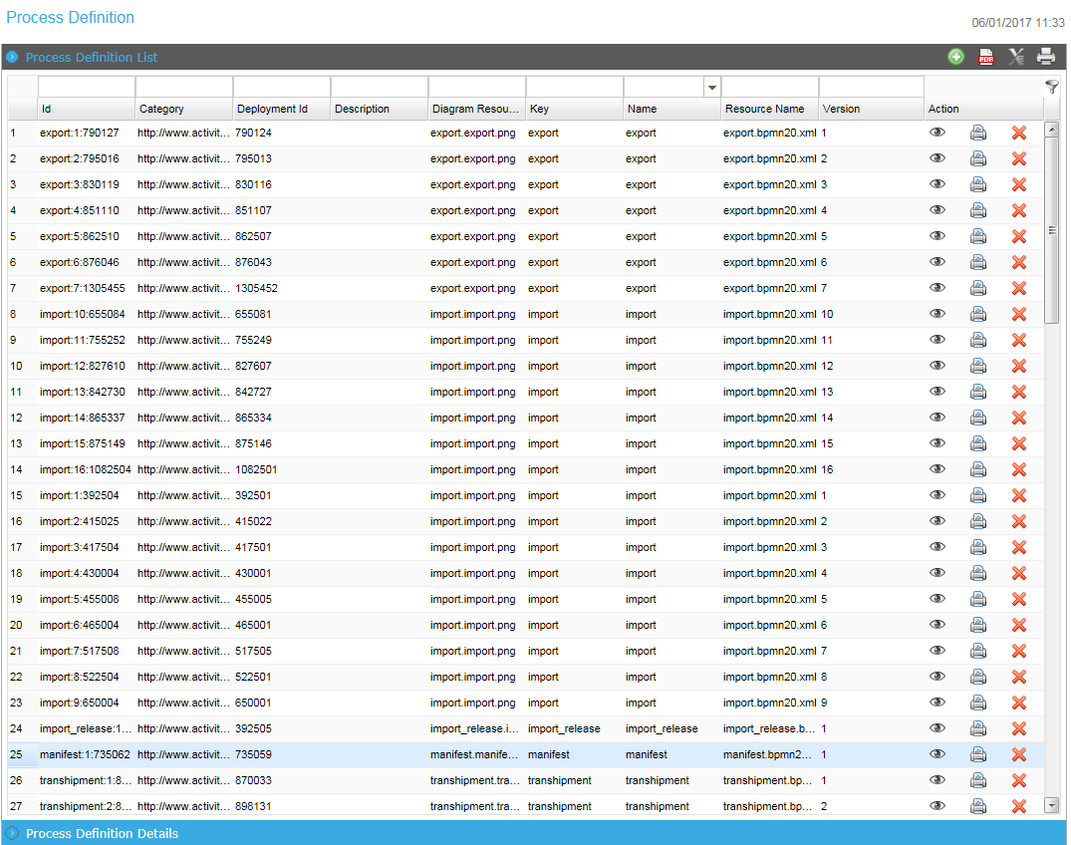
Process Definitions Search Page

Field/Button description | Action/Input Required
ID | Enter the ID
Process Instance ID | Enter the process Instance ID
Activity ID | Activity ID from BPM process
Business Key | Enter the Declaration number
Name | Enter the name of the activity
Process Definition ID | Enter the process definition ID.
Process Definition Version | Enter the version of the process definition.
Process Definition Name | Enter the name of the Process Definition.
Variables | Enter the variable value.
Actions | Select the action form the drop-down list as  - End current activity.  - End process instance
- Enter the search criteria and Click icon to view the matching results in the Search Results Page.
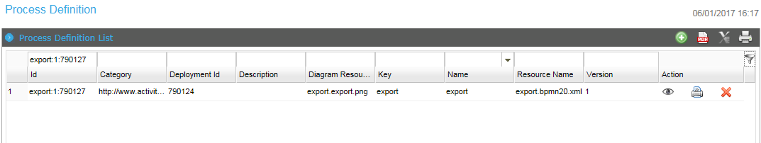
Process Definitions Search Result Page
- From the search results, click the icon. The View Details Page will be displayed.
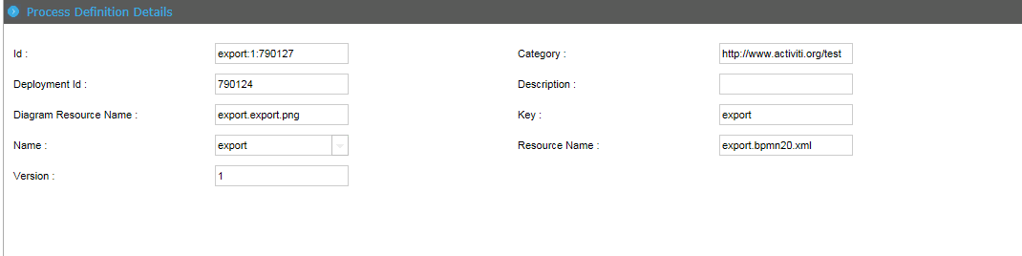
Process Definitions View Page

Print Process Definitions
This functionality allows you to print the process definitions.
To print the Process Definitions
- From the search results, click the icon. The Print Preview Page will be displayed.
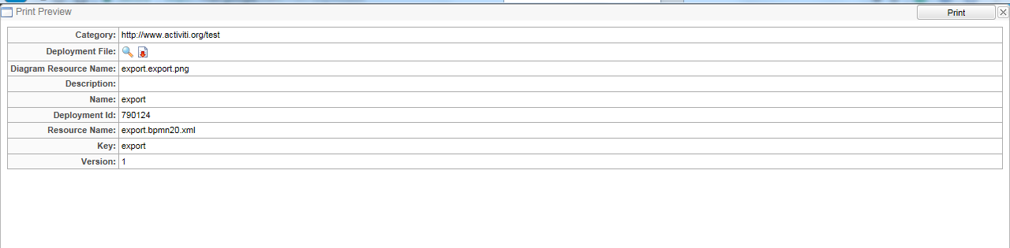
Print Preview Page
- Click Print button to print the details.

Delete Process Definitions
This functionality allows you to delete the process definitions.
To delete details:
- Click BPM>> Process Definitions. Process Definitions Page will be displayed.

Process Definitions Page
- From the search results, click the delete icon. The Pop-Up Page will be displayed.

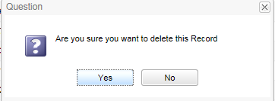
Confirmation Box

- Click Yes button to delete the detals.

Create Process Definitions
This functionality allows you to create the process definitions.
To create Process Definitions:
- Click BPM>> Process Definitions. Process Definitions Page will be displayed.

Process Definitions Page
- Click new icon to create a new process definitions. The following page will be displayed.
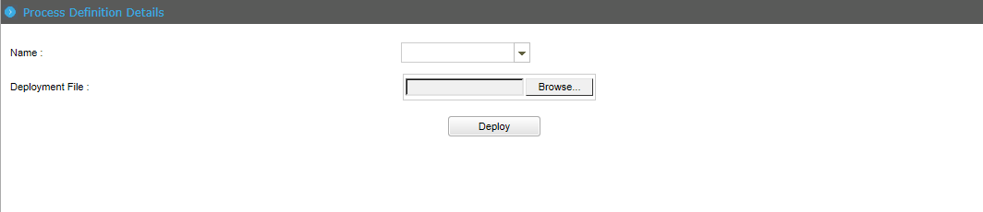
Process Definitions Details Page

Field/Button description | Action/Input Required
Name | Select the name of the process definitions form the drop-down list.
Deployment File | Click the Browse button to select the files.

- Click Deploy button to deploy the process definitions.

Process Instances
This functionality allows you to view, search, edit and create the instances for the process.

Search and view Process Instances
This section allows you to search and view the Process Instances.
To search and view the process instances:
- Log in to the application and Click BPM>>Process Instances. The following screen will be displayed.
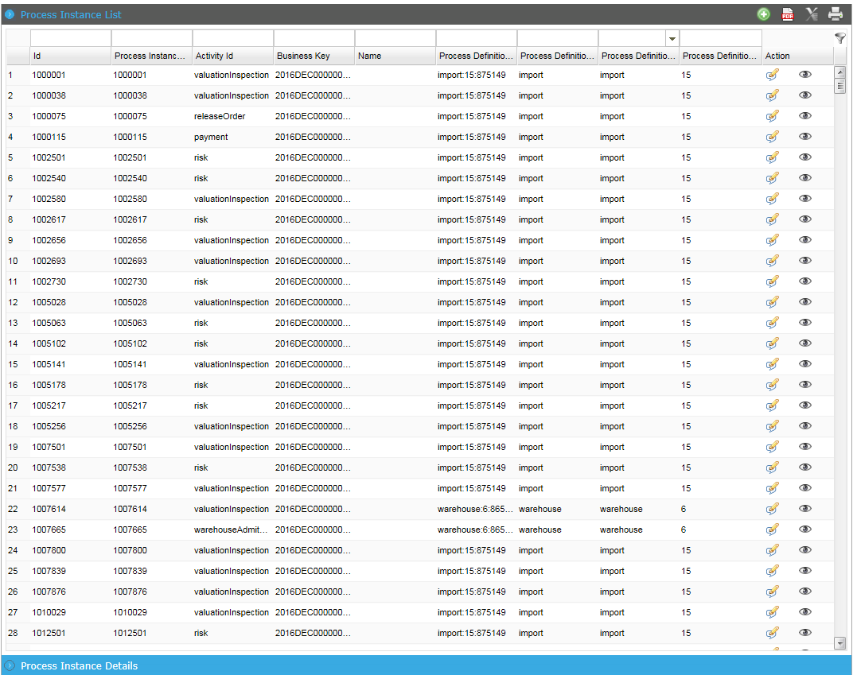
Process Instances List Search Page

Field/Button description | Action/Input Required
ID | Enter the ID.
Process Instance ID | Enter the process Instance ID
Activity ID | Activity ID from BPM process
Business Key | Enter the Declaration number
Name | Enter the name of the activity
Process Definition ID | Enter the process definition ID.
Process Definition Version | Enter the version of the process definition.
Process Definition Name | Enter the name of the Process Definition.
- Enter the search criteria and Click icon to view the matching results in the Search Results Page.
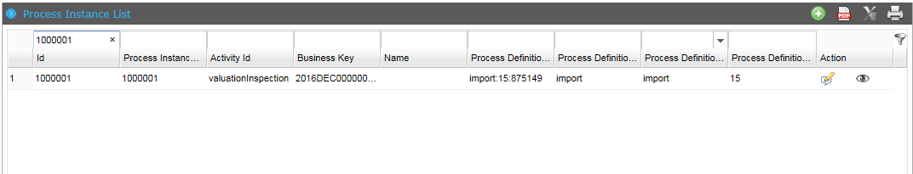
Process Instances List Search Result Page

- From the search results, click the icon. The View Details Page will be displayed.
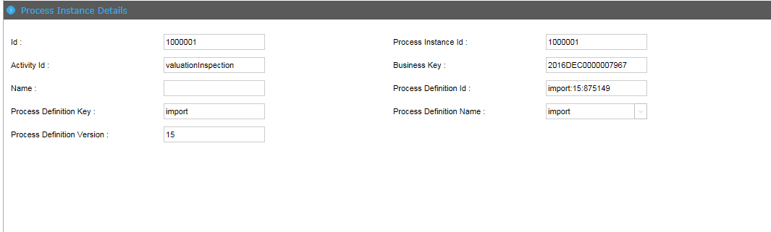
Process Instances View Page

Edit Process Instances
This functionality allows you to edit the process instances.
To edit the process Instances
- From the search results, click the icon. The edit Page will be displayed.
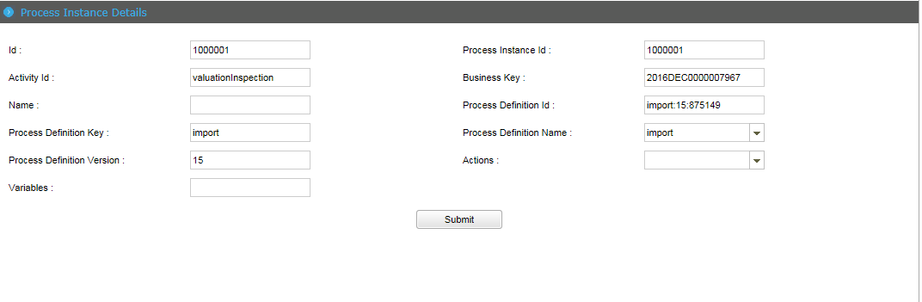
Edit Process Instances Page
Actions Select the action from the drop-down list as:
- End current activity and move to the next activity.
- End process instance and the process will stop and will not continue to next activity.
- Modify the field values and click Submit button. Success Message will be displayed.

Create Process Instances
This functionality allows you to create the process instances.
To create the process instances
- Log in to the application and Click BPM>>Process Instances. The following screen will be displayed.
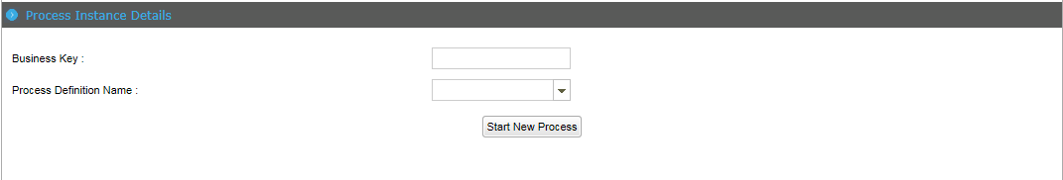
Create Process Instances Page

Field/Button description | Action/Input Required
Business Key | Enter the Declaration number
Process Definition Name | Select the process definition name form the drop-down list.

- Click Start New Process to start the process instances.

